EASTWICK AND GILSTON PARISH COUNCIL

CHAIRMAN PARISH CLERK

MARK ORSON CHRISTINE LAW

89 PYE CORNER 9 CHURCH COTTAGES

GILSTON GILSTON

NR HARLOW NR HARLOW

HERTS CM20 2RD HERTS CM20 2RH

TELEPHONE 01279 453257 TELEPHONE 01279 411646

Email: mark.orson@outlook.com Email: christine.law2@btinternet.com

Parish Council meeting of Monday 9th May 2022 at 8.00pm, At the cessation of the Annual meeting this section of the meeting started at 8.30pm.

PRESENT: Cllr Beazley, Bryant, Harvey, Jones,

In attendance: Eric Buckmaster (District & County Councillor) one member of the public. (His written report is attached).

PUBLIC PARTICIPATION
  - Sarah Bagnall informed the meeting of the preparations for the 2nd June event.

BUSINESS MEETING STARTED AT 8.30PM

- TO RECEIVE APOLOGIES FOR ABSENCE:
  - Cllr Orson, Cllr Wightwick.
  - Also from Cllr Sabrina Ahmed as she has just resigned from the council.
(post meeting note : the Clerk will now have to inform East Herts of this for them to officially give notice of the vacancy and if they have not heard from any resident by the 1st June on requiring an election for the post the Parish Council will then be able to fill the post by co-option.)Notices have been placed on the Gilston notice boards and on the parish web site.

- RECEIVE COUNCILLOR’S DECLARATION OF INTERESTS
  - No declarations of interest declared.

- MINUTES FOR APPROVAL
  - Minutes of the Annual Parish Meeting and of the business meeting 9th March 2022 were proposed by Cllr Harvey and seconded by Cllr Jones and signed as a true record by Cllr Bryant. (Appendix 1).

- ACCOUNTS
  - Clerks written report to the Council of Accounts summary (appendix 2) was proposed by Cllr Beazley and seconded by Cllr Jones
  - HAPTC annual membership of £511.67 was proposed by Cllr Harvey and seconded by Cllr Beazley. Clerk will pay by bacs.

- PLANNING AND ASSOCIATED APPLICATION
    - 3/19/1045/OUT. Outline planning permission with all matters reserved apart from external vehicular access for a mixed-use development of up to 8,500 homes for a part of the Gilston Area [Villages 1-6]. Awaiting decision
    - 3/19/2124/OUT – Outline planning application for development including demolition of existing structures, refurbishment and change of use of existing Grade II listed Brickhouse Farm Barn and structures and erection of a residential led mixed use development up to 1,500 homes [Village 7] – Awaiting decision.
    - 3/21/2453/LBC & 3/21/2452/HH – Homewood, Gilston. Single storey side extension. Has been granted.
    - 3/21/2861/HH – 5 Roseley Cottages, Eastwick. Single storey rear extension. Awaiting decision.
    - 3/22/0207/HH - 8 Bowlby Hill, Gilston. Awaiting decision.
    - 3/22/0515/FUL – former stables land adj to Eastwick Hall Lane, Eastwick . Conversion of stables to create 1. 3 bedroomed dwelling with associated landscaping and parking. Awaiting decision.
    - 3/22/0688/HH The Bungalow, Pye Corner. Alterations to roof from hip to gable with rear dormer window and front roof lights to allow for first floor accommodation. Raising of flat roof to side elevation; new front porch. Alterations to fenestration and openings and new render finish to existing walls. Awaiting decision.
    - 3/22/0779/HH – 17 Roseley Cottages, Eastwick. Construction of single storey extension and first floor rear extension (with a partial two storey rear/side element to the extension) and incorporating a first floor rear Juliet balcony. Insertion of1 first floor window to side elevation. Awaiting decision.
    - 3/22/0856/LBC – The Old Rectory, Gilston. Internal alterations to include: removal of staircase, installation of replacement lift, replacements flooring to ground floor porch and hallway, creation of new first floor shower room, block up 2 first floor doors and 1 second floor door, create 1 new door opening to second floor bedroom, install new timber frame walls on first floor and second floor. Awaiting decision.
- PARISH PATHS
  - Cllr Jones reported that the tree has been removed from the bridlepath. There will be 2 cuts this year on the footpaths within our villages.

- NEIGHBOURHOOD PLAN
- Cllr Bryants written report: Still no date for the 2 OPAs (Places for People (PfP) & Taylor Wimpey) to be considered by EHC's Development Management Committee, although PfP are hoping for early Autumn meeting.
- The value of East Herts' Gilston Area Steering Group (SG) and NPGs continued attendance at the SG are being reassessed at meetings between EHC, HGGT and members of the NPG. NPG's opinion is that the Terms of Reference are appropriate, the issue is they are not being met!
- Section 106 discussions taking place between EHC and the developers but NPG not yet given sight of draft Heads of Terms or opportunity to contribute / influence.
- PfP's Strategic Landscape Master Planning and Village 1 Master Planning still on hold. PfP tell us they are focusing on Section 106 negotiations.
- Meetings continue being held between NPG, developers and EHC Officers.
- Annual Report from HEGNPG (appendix 3).
- HIGHWAYS
  - Cllr Wightwick not at meeting so no report received.

- PLACES FOR PEOPLE
  - Report from Knight Franks if (Appendix 4)
- NEW HOMES BONUS
  - Play equipment. Cllr Wightwick written report states that all the improvements have been completed and loved and very well used by the community.
  - Notice Board – Cllr Wightwick written report states that the notice board is ready for delivery and will be installed in the next fortnight.
- VILLAGE HALL MANAGEMENT COMMITTEE
- Cllr Bryant reported that Current round of hall improvements completed.
- Hand over of Treasurer responsibilities to Linda Harvey not completed yet.
- Next Business Meeting of the Management Committee Wednesday 1st June - although focus will be hanging flags and bunting for Queen's Platinum Jubilee Weekend
- CELEBRATION – 2/3/4/5 JUNE 2022 QUEEN’S PLATINUM JUBILEE
  - It was reported that on the 2nd June a thanksgiving service with a hog roast, fireworks & beacon light along with the community choir will be taking place at St Mary’s Church, Gilston.
  - 3rd June there will be a Race Night at the village hall. 4th June an Afternoon Cream Tea event at St Mary’s along with a Platinum Jubilee community walk (maps are being prepared for this). Then on the 5th June in various locations within the two villages there will be Street Parties. More information on all of these events can be found in the June Parish Magazine.
  - Bunting has been ordered for installation before the weekend around Eastwick village, Pye Corner, Terlings Park & Gilston Lane.
- CORRESPONDENCE
  - None

- ITEMS BROUGHT FORWARD AT THE DISCRETION OF THE CHAIRMAN FOR INFORMATION ONLY
  - None

- ITEMS COUNCILLORS WOULD LIKE TO BE ADDED TO THE NEXT AGENDA
  - Zoom subscription.
  - Review Jubilee events
  - Replacement of footpath signs.
  - Tree- Terlings
  - Moorhen Walk
  - Fiddlers Brook – fence.
  - Planning protocol.
- DATE OF NEXT MEETING
  - Date of next meeting – Monday 11th July 2022 – Parish Council Business Meeting.
Meeting closed at 10.00pm


Hunsdon Eastwick and Gilston Neighbourhood Plan Group
https://hegnp.org.uk/

Annual report to Sponsor Parish Councils

- Introduction
We are pleased to present our annual report and in doing so to thank you as our sponsors for your support for our work, especially your ongoing financial support.
The last year has been an exceptionally busy year and I am grateful for the staggering amounts of time committed by the members of the NPG, including many who also hold Parish Council or other posts in our community so are putting in lots of time to support residents

Financial
The NPG opened the financial year with a cash balance of £32,811.80 and closed the year with a projected balance of: £40,246.00

Total income for the year was £16,000
£11,000 was received as annual contributions from sponsor Parish Councils (Hunsdon £3,500 and Eastwick & Gilston £7,500) £3,000.00 was given as financial support from the Harlow and Gilston Garden Town. £2,000 was given as a kind donation by a local resident.

Total expenditure for the year was £8,565.80
£6,000.00 was spent on expert consultancy to assist the NPG with its responses to the ongoing planning applications for the Central and Eastern Crossings, and new homes and infrastructure.
£1,892.50 was for administration and communications costs. £673.30 was for printing, postage, webspace and other similar expenses.

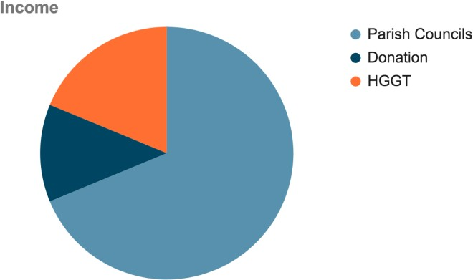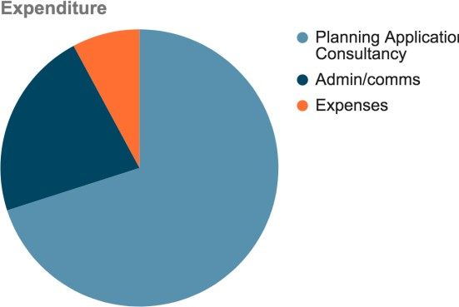

Key activities and progress over the last year
  - Neighbourhood Plan - Last year I reported on the progress in the preparation of a joint Neighbourhood Plan. East Herts Council adopted it after it passed its referendum in May last year with a 98% vote in favour, so it now forms a part of the Local Plan. Achieving this major piece of work was heavily reliant on the fantastic support from our planning advisors, Urban Silence, and the sheer hard work of the Group. Special mention should be made of two of our members who have committed vast amounts of time to the detailed negotiations and the public Examination process. The Plan has been recognised for its quality and approach with three national planning awards.
Having a Plan is one thing but ensuring that it is properly recognised is another. East Herts say they have considered its policies and “on balance” have set them aside when they did not fit in with the two detailed Highways applications, see below. We are pushing back on this treatment of what constitutes a formal part of the Local Plan.
  - Villages 1-6 & 7, Outline planning applications revisions - The two outline planning applications, (one for Villages 1-6 and one for Village 7) are still being worked on between the Developers and East Herts Planning Department. During the last half of the year the developers of villages 1-6 have raised viability concerns, in effect saying that they can no longer afford to stand by the promises made to the Planning Inspector at the time of the public Examination into the Gilston allocation and making the case for the Green Belt release. We have expressed our strong concerns on this, especially given that it was a part of the case made to release the Green Belt designation. We await the outcome of the Developers claims to see what impact this has on promised community infrastructure. East Herts Council, in the full knowledge of the viability concerns, have given consent to the Developers detailed Highway proposals in advance of understanding the financial implications for the main Housing Planning applications. We have recorded our strong objections to the principle of determining these applications out of sequence like this but the Development Management Committee approved the Planning

Department’s keenness to promote the Highways applications, especially the Eastern Crossing which puts major new infrastructure through the Stort Valley and the remaining Green Belt, years before it will be needed by the scheme.
At the time of preparing this report we have not been given, but are continuing to press for, information on; -
    - The status of the Viability assessment
    - The expected date for reporting the Housing Applications to the Development Management Committee for approval
    - The status of the critical S 106 packages covering many aspects critical to our communities
    - The role of the community in shaping the future stewardship of the land to be set aside as Country Parks around Hunsdon Airfield, Eastwick Woods and Gilston Park.
  - Landscape Master planning - Sadly, despite the Developers’ aspiration to start work on the Strategic Landscape Master Plan, this work started last autumn but then was put on hold by the Developers a couple of months later.
This is an important consultation as it will define the landscape buffers between the villages and open spaces which are supposed to be transferred to the Local Community. We hope that this consultation will recommence soon and include a proper dialogue with the community, just as East Herts Local Plan requires, , as well as having proper regard to our Neighbourhood Plan.
As a result of our representations, Places for People, the principal Developer, have undertaken some preliminary tree planting with the aim that the trees will mature and help to screen the new development better than if they are planted after the houses are built. The tree planting does not reflect the long-term planting, just the first stage of many landscape works reflecting the legal obligation of the Developers to obtain a 10% Biodiversity net gain. We continue to hold discussions with the Developers on such issues.
3.4. Master Planning for Village 1- Work on this started, with a great flourish last summer, and two meetings were held to seek community input but again the work has been put on hold! The Developers have however taken some proposals to the Quality Review Panel but without any prior community consultation. We have given feedback on this submission but after six months have no response to our observations.
We have argued that the boundaries for the Master Planning should consider the relationship of the proposed Village 1 in the context of its immediate neighbourhood and not be artificially restricted by the red lines set by the Developers. We will continue to ask for a comprehensive approach on the Communities’ behalf.

  - Village 7. As many of you may know, Taylor Wimpey have bought the Village 7 site. They are keen to press on with building 1500 houses there even though it will be many years before it can link up with the rest of the development which Places for People are planning for the Gilston Area. We have objected in the strongest terms to this “standalone” development which will amount to a separate housing estate for many years, possibly decades. We are not alone in voicing these objections and seeking to put maximum pressure on EH Planning Department to refuse consent on this basis.
  - Stewardship - While we have also tried to engage on this incredibly important issue there has been no progress over the last year. Even more astoundingly, we keep being told that East Herts Planning Department l and the Developers are ‘engaged’ in discussions but that the Community are not allowed to engage, or comment, on this part of the Local Plan which will affect all residents' futures. The EHC Community Engagement Strategy says that we should be engaged but sadly EHC are ignoring their own policy.
We are constantly being told that we will be given information soon, but the sad point is that it is not forthcoming and we fear will end up as a set of pre-agreed proposals in which the community has had no meaningful participation.
  - Roads Applications - After some legal challenges these two detailed applications went to East Herts Council’s Development Management Committee (DMC) for consideration; one application for the existing ‘Central” Stort Crossing and the other for a new ‘Eastern Stort Crossing’ (ESC).
We made strong representations to the DMC to not approve these applications because; -
    - The principles of the outline planning applications should be considered in the round, along with the Developer’s commitments to funding, and proper provision for public transport
    - ESC is not needed by the development before 2030 so there was no need to make the decision in advance of the Outline application.
    - The ESC, while providing much needed relief for the traffic conditions in Pye Corner, as proposed is over-sized and so causes unnecessary harm to the Green Belt.
    - The alternative options had not been properly considered
    - As a road scheme t it will generate more traffic so not support the transport mode shift which is a key policy for East Herts Council
    - The scheme is supported by taxpayer funding which may run out if not spent BUT that is not a reason for granting a consent.
Within the 3 hours of debate on each application, as your Parish Council representatives we were only allowed to speak for 8 minutes to get our views across on such a major application and concerned residents for only 2 minutes each. This was not a fair hearing or democratic. The applications were approved by EHC with only opposition parties voting against. The same result occurred when Harlow DC approved the applications on their
  - Gilston Steering Group - We have been a part of this Group for a number of years; the Group is designed to ‘Steer’ the Gilston project and is led by East Herts Council. At the time of preparing this report we are asking for a reset of this Group's remit and operation as key information (for example, a programme of activities over a 3–5-year time frame) is either unavailable or being withheld but seems to us to be critical. Papers concerning Gilston are prepared but not communicated to the Group so it’s hard to see what it is Steering. The concept of a strategic steering Group is a good one, we are trying to work with East Herts Council to make it an effective body.
  - Stakeholder engagement - With your respective Chairmen and Vice Chairmen we continue to represent to key stakeholders the views of the NPG alongside our request for additional funding for our work in recognition of the complexities of the issues and multiplicity of authorities involved, we have been given a modest grant from the Harlow and Gilston Garden Town Board.

Looking forward
This report makes sad reading as the ambitions by East Herts for Community Engagement in their written strategy we feel have been ignored. Central Government, the Harlow and Gilston Garden Town Board, Homes England and Hertfordshire County Council all champion Community Engagement, as do both Developers. We are hoping that all of these bodies will clarify how they want to work with the Community and the alternatives if they do not.
There are many important issues in both parishes that need resolution and the Community's voice heard. We all know of the current infrastructure failings on transport, schools, health care, emergency services and social facilities. Our neighbourhood cannot take this vast number of new homes without new infrastructure and, unless we negotiate this through the planning system, residents may face the prospects of having to pick up costs through their Community Charge (rates) payments or suffer the consequences of failure to deliver.

The following key activities we anticipate will require our attention: -
Issue | Comment | Likely timescale
Village 1 Masterplanning | Important work on setting the context for Village 1 to be done in the light of the Local and Neighbourhood Plans. Despite the two meetings we have had no proposals from the Developers | Outstanding/ started in June 21, put on hold in November - no date offered for restarting
Landscape Master Plan | Important strategy key to | Outstanding/

 | maintaining the original Developers’ promises of 7 villages separated by landscape buffers and the open areas to the Northwest. | started in June 21, put on hold in November - no date offered for restarting
Stewardship | To develop a structure for the long-term management of the areas not being developed which are due to be passed to the Community as well as the stewardship of community assets within the village areas | Outstanding/ we are assured that we will get shortly but it never seems to arrive
Section 106 Planning obligations | To comment on the proposed legal obligations on the developers for the provision of infrastructure and the trigger points by which needed infrastructure must be delivered.  The Developers for Villages 1-6 have claimed that their scheme is not viable if they have to stand by the infrastructure they said was needed and they would fund when the Gilston allocation was made at public examination. | Last summer we had a meeting on this but work has stopped as EHC wanted to advance the Highway applications before understanding the total S106 financial package. Work delayed but expected to resume in summer of 2022
Funding | To continue to seek a broad range of funding to continue the Group’s work. We have received a £3,000 grant from the Garden Town Board | Ongoing
Building and resourcing the NPG team | Reviewing our effectiveness and encouraging residents to participate | Ongoing

Anthony Bickmore, Chairman, HEGNPG

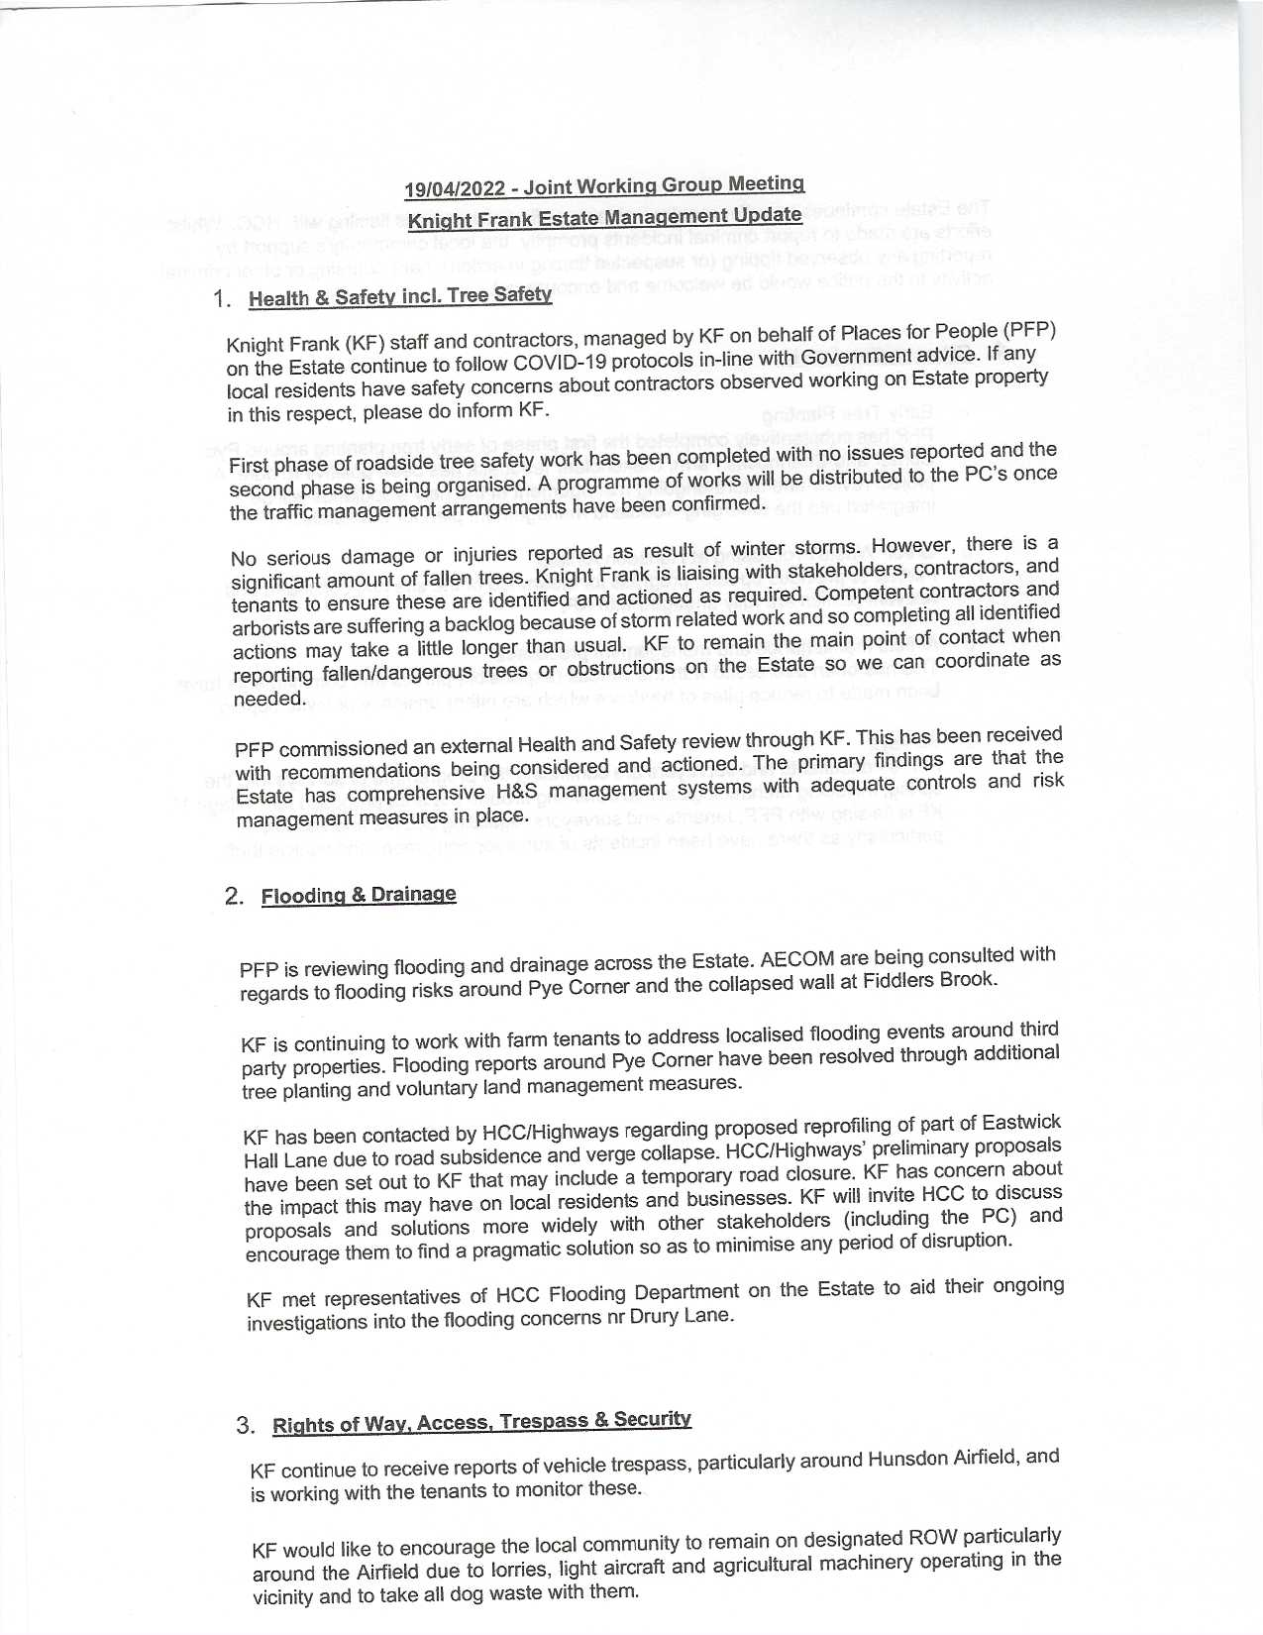

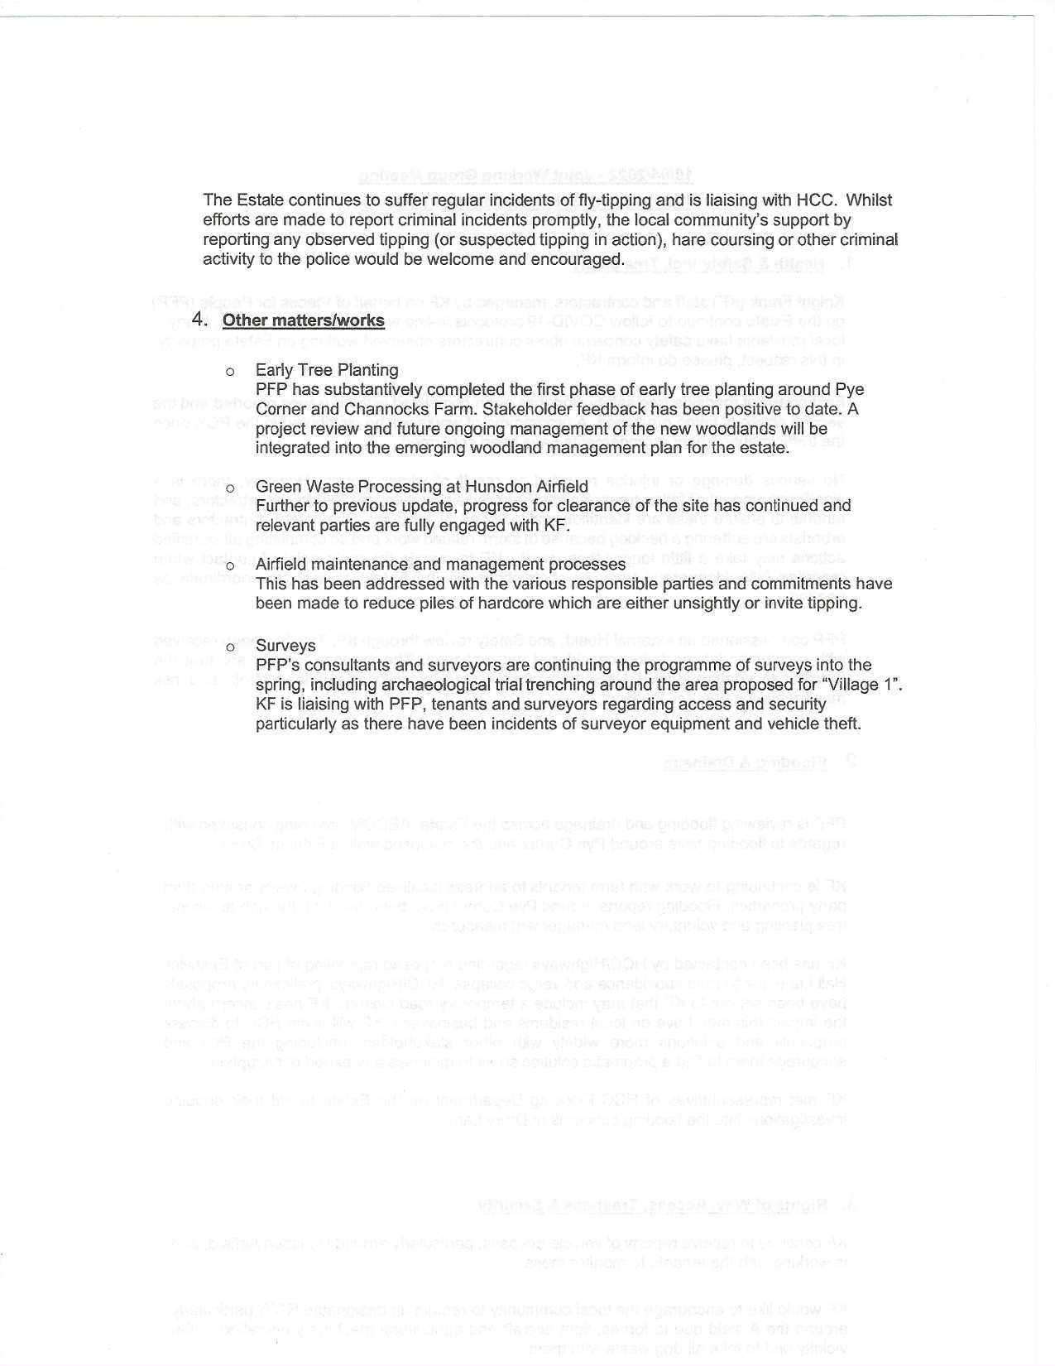

County Councillor Report for Annual Meeting
-Some Highlights April 2021 to March 2022
Decarbonisation funding. £23.5m for Hertfordshire County Council to upgrade 182 council buildings, including 74 schools and 23 emergency service buildings. This will include the installation of heat pumps, battery storage and solar panels and improving the energy efficiency of the buildings through installing double glazing and cavity wall insulation. Hertfordshire County Council is progressing the Department for Business, Energy and Industrial Strategy (BEIS), (via Salix) funded
works to decarbonise the schools and non-schools’ estate. The £23.5 million in successful grant funding will be used to deliver works such as the installation of air source heat pumps and solar panels across 149 selected sites

Progress Update Feb 2022 Most of the programme has been completed, with the remaining sites currently on track to be delivered before the agreed deadlines with issuers of the grant fund. As of the 7th February 2022, £14,312,898.49 of grant funding has been committed to the installation programme, supporting the delivery of the following completed works programmes:
- 81 sites have received solar panels, delivering direct reductions in carbon emissions, and improving the council’s portfolio of renewable energy sources. The panels have been installed across the council’s schools and non-school’s property portfolio
- 15 schools sites have received wall insulation and double glazing works, improving energy efficiency and heat retention
- Work continues on the delivery of air source heat pumps across the council’s schools and non-schools portfolio. Upon programme completion, two schools will have received air source heat pumps and accompanying heating upgrades and eight non schools sites, including Farnham and Robertson House. Once completed, these works are expected to deliver improved energy efficiency and significantly reduce carbon emissions across all sites
Low Carbon Skills Fund Hertfordshire County Council has been successful in receiving £254,270.41 in grant funding from the Low Carbon Skills Fund – Phase 2, managed by Salix Finance. This funding will be used to develop heat decarbonisation plans across the Council’s school’s portfolio, with the plans for 318 schools completed by March 2022. The heat decarbonisation plans will be used to provide an overview of the energy performance for each site, outlining recommended infrastructure upgrades to deliver carbon neutral buildings
Contracts complete for £171m investment in Harlow Gilston Garden Town. Contracts have now been signed and completed to release £171m of government funding for the Harlow and Gilston Garden Town (HGGT) project. The original bid was led by Hertfordshire County Council on behalf of local authority partners Essex County Council, East Herts, Epping Forest and Harlow District Councils, the Harlow Gilston Garden Town under the Harlow Gilston Garden Town Partnership, supported by leading affordable homes-led placemaker, Places for People.

Services for Young People (SfYP) YCH Services for Young People will now be known as Services for Young People (SfYP). The vision for SfYP is that the needs of young people who are challenged in education, their community or home life are met, to ensure a successful transition to adulthood.
The primary purpose of SfYP is “Enabling Young People to Succeed” through the delivery of targeted prevention and early intervention work to address emerging needs, improve life chances and reduce escalation to more expensive and intensive services.

Youth Workers, Personal Advisers and other practitioners work in schools, colleges, young people’s centres, access points, on the streets and in other local community venues delivering youth work, information, advice, guidance and work-related learning.

Recycling Centres
Three of Hertfordshire's largest recycling centres now open seven days a week
As reported by In Your Area, Hertfordshire’s three largest household waste recycling centres - Ware, Stevenage and Waterdale (Garston) - are now open seven days a week as the county council responds to high use of the network.

Reuse Centres go from strength to strength. The newly refurbished Harpenden Reuse Centre, located next to the recycling centre, was open in the summer. This is the third centre where residents can buy good quality items, at a reasonable price, that would otherwise have been needlessly thrown away and destroyed.

High Street Recovery schemes
Hertfordshire County Council had kept residents and its communities safe by putting in place measures to support government guidance and social distancing. The changes were made to help businesses reopen and ensure everyone could access our busier towns and high streets across Hertfordshire. These changes included footway widening, road closures, reduced speed limits and increased cycle parking provision. As we continue to follow the roadmap for easing this current lockdown, Hertfordshire County Council is reviewing with local councils each of the locations where changes were made.

Hertfordshire’s Mass Rapid Transit
Working together for sustainable growth
So that we can achieve our ambitions for the MRT, we are working together with the countywide Growth Board for Hertfordshire which is made up of the County Council, 10 District and Borough Councils and Hertfordshire’s Local Enterprise Partnership (LEP).
The MRT would form a key part of Hertfordshire’s ambitious growth agenda to support a sustainable transport network. Working collaboratively to enable a coordinated response to tackling future pressures across the A414 – both in terms of sustainability, enabling economic growth and net zero carbon – while simultaneously making the design development process more transparent.

Gilston Neighbourhood Plan wins two Awards
The HEGNP Group have won a Plan Making Award and in addition to that the Editors Award of the best overall entry. The Editor commented that Planners have 'got to work with the community to deliver development’.
The Chairman of the Neighbourhood Plan Group said ‘’We are clearly delighted as this recognises the vast amount of time our community put into this as well as the professionalism of our advisors, Urban Silence, who helped us so much on the way’’.
The task is now to use the Plan to help shape the development to be what was promised as a being development of exceptional quality.
Adopt an Area litter campaign launches in East Herts Litter-conscious residents in East Herts will now get extra support to help keep their streets and parks free of litter by signing up to our Adopt An Area scheme. East Herts District Council (EHDC) alongside North Herts District Council have launched the campaign to support both existing volunteers who have already been litter picking in the district, as well as to appeal for new volunteers to adopt an area and make a real community effort to reduce litter. Volunteers will be asked to let the council know the area they wish to adopt and will be provided with safety information and dedicated bags. Anyone who adopts an area will be able to have their litter picked waste collected alongside their normal scheduled waste and recycling collections.
Hertfordshire hits record high number of officers
Hertfordshire Constabulary now has more officers than at any time in its history.
The latest intake of 18 new recruits means there are now 2,212 officers in the county, the previous high was 2,202 in 2007.
To mark the milestone Police and Crime Commissioner David Lloyd and Chief Constable Charlie Hall welcomed the latest student officers at Police Headquarters in Stanborough, Welwyn Garden City.

The final target at the end of the uplift is planned to be even higher with 2,314 officers in post by April 2023.

Hertfordshire’s Healthy Hubs, a free local service where people can get health and wellbeing support and advice, are re-opening their doors again. The Healthy Hubs initially launched in early 2020 but Covid-19 restrictions meant they had to move online. With a number of venues beginning to re-open, the Covid-safe hubs are now able to welcome face-to-face visitors once again. Whether you need help to reach a healthy weight or want to stop smoking, become more active, get mental health support or even cut down on your drinking - your Healthy Hub can help you. To find your local hub, simply visit Healthy Hub East Herts | East Herts District Council on line.
Hertfordshire County Council is unveiling plans for a new waste and recycling transfer Station, near Ware, which will reduce lorry miles and meet the urgent need to manage waste collected from residents and business in the east of Hertfordshire. The plans, for an enclosed facility with sound and odour controls, where collection vehicles can take kerbside waste to be stored before being sent on to recovery and disposal facilities, was unveiled at a consultation event on 9 and 10 August. The transfer station will primarily accept household and business waste but will also be able to accept recyclable materials.
Broxbourne Studio Announcement. Blackstone and Hudson Pacific Properties announce that they intend to invest in building a new film, TV and digital studio in Broxbourne for the first expansion of the Sunset Studios platform outside of the US This is wonderful news for local people and our ongoing commitment to ensuring high quality local employment opportunities, with more than 4,500 permanent jobs to be created in Broxbourne which will be vital to delivering sustainable growth.This announcement is fantastic news for Hertfordshire and, together with the new Sky Studios development currently being built at Elstree, is another clear sign of our county’s continued attractiveness and status as home to the UK’s world-class creative media industry.
Hertfordshire secured over £1bn investment in its world-leading cell and gene therapy and film and TV industries, The Prime Minister visited Stevenage to open Airbus' new £35m UK space and defence headquartersWith £400m for a new life sciences campus on the GSK site and Broxbourne chosen as the location for Hollywood’s £700m Sunset Studios, investor confidence in our county has never been higher. Investments like these have a major impact on the local economy, invigorating supply chains and creating a spiral effect that continues to encourage so many major multinationals to come to Hertfordshire.
Hertfordshire County Council is asking residents, businesses, community groups, and other interested parties to join them in planting a tree for the jubilee The Queen’s Green Canopy is a national initiative which will celebrate Her Majesty’s Platinum Jubilee by sustainably planting trees, improving the environment and leaving a legacy for future generations. Residents who want to get involved by planting trees will be given advice and guidance on the correct types of trees to plant, as well as tips on aftercare to ensure they grow into healthy adult trees. Residents or businesses who are unable to plant trees on their own land can pledge funds to help facilitate planting schemes elsewhere in the county. The county council will be playing its part by creating statement planting sites at County Hall in Hertford, and Aldenham Country Park near Elstree, where large numbers of trees will be planted in eye-catching arrangements, improving the natural beauty of these locations while also tackling carbon emissions and improving air quality,
In addition to this tree and hedge planting will take place at schools and academies across the county and along the sides of highways. District and borough councils have also committed to plant trees on their own land over the next two years, as part of the project.
Hertfordshire County Council has successfully bid for £313,000 from the Department of Transport’s (DfT) Local Authority Capability Fund. The funding, which is part of the Government’s Active Travel programme, will help the council to plan, design, consult and develop more county-wide cycle and walking infrastructure schemes. The council will also work with the pedestrian charity Living Streets to support and encourage school children and parents to walk to school more often.
Several initiatives will be supported through the funding, including:
• An increase in the number of British Cycling participation schemes, offering adult and child cycle training and led rides, including free loan bikes for those who don’t have one.
• Cycle maintenance and storage facilities, for schools, cycle hubs and proposed Sustainable Travel Towns
• Working with Living Streets to employ local coordinators to support a new initiative; The School Walk, encouraging sustainable travel to and from school
• Planning, design and consultation of a trial Low Traffic Neighbourhood in St Albans and the ongoing design of extensions to a proposed cycle route along North Road in Stevenage.

New on-demand bus service launched in Hertfordshire A new on-demand bus service, HertsLynx, is launching in Hertfordshire from 19 September, as part of Hertfordshire County Council’s plans to improve transport in the county.
Residents in the east and north of Hertfordshire are able to use a new app to order a bus pick up and drop off from virtual bus stops along routes where normal bus services are infrequent.
The HertsLynx service is designed to improve connections between rural villages and larger town centres, making it easier for people to get to work or school, go shopping, or travel to appointments, without needing to use a car or taxi.
Hertfordshire unveils Blueprint to ‘Build Back Better’ after COVID-19
Cleaner, greener and healthier priorities will be at the heart of a roadmap to lead the county out of the pandemic and make it fit for the future. From helping pupils catch-up to enabling residents to be fit and healthy to supporting workers and businesses to get back on their feet, the Covid-19 recovery Strategy has something for everyone in Hertfordshire to ‘build back better’.
It is in-part under-pinned by a £9.7 million dedicated Covid-19 Recovery Fund to help drive local recovery and an ambition to be innovative in making services the best they can be for residents. The Covid-19 Recovery Strategy brings together a series of projects designed to support health and wellbeing and economic recovery over the next two years with the new funds being split across three key priority areas: Health and wellbeing, the environment and sustainable growth. Some of these projects are already up and running, and have been embedded into team practice while others are new initiatives that use the Recovery Fund.
Highlights under each of the priorities include:
Health and wellbeing. Adult Care Services projects receiving £3m, including money dedicated to fighting homelessness, alcohol, mental health and domestic abuse. £285,000 will support over 700 adults with disabilities in finding education, work and volunteering opportunities that has been more challenging through the pandemic.
Carer projects, as part of Adult Care Services, will be receiving £258,000 to counter the loneliness, digital exclusion and mental health effects heightened through the pandemic.
Expanding community protection with £60,000, enabling an increase in Safe and Well visits, targeted at the most vulnerable and disadvantaged Hertfordshire residents. There has been an increase in vulnerability, social isolation and domestic abuse during the covid pandemic. The money allocated will enable more of these ‘one stop shop’ visits to people’s homes, keeping them safer and signposting them to further support such as advice on fuel poverty, stopping smoking, weight loss and mental health.
Supporting families in or at risk of falling into poverty with joint programmes between Children Services, Public Health and Adult Care Services. One is the ‘Good start in Life’ project, receiving £228k over the next two years to develop services for vulnerable families who have become pregnant or have young children during the Covid-19 pandemic.
Helping residents stay active and maintain a healthy weight, including a new pilot linking physical activity with good mental health. The Never Too Late campaign aims to increase physical activity for those aged 55 and over, and four-hour activity sessions for young people who receive free school meals. There will also be a pilot with the NHS to explore the role hot food takeaways play in obesity.
Schools ‘coming back stronger’ and mental health support enabling additional educational psychologists’ and Speech and Language capacity to support children and young people and additional investment in counselling schemes to help address the mental health impact of Covid-19 on children and families. £1.2m will is dedicated to these projects.
Addressing inequalities across the county by offering advice on home adaptation, fuel tariffs and managing utilities. There will also be new food welfare initiatives, and work with partner organisations to increase finance/benefits advice to those leaving care of families with disabled children.
The Environment Cutting food waste disposal by raising awareness of the financial and environmental costs. Food waste disposal costs Hertfordshire’s taxpayers around £7.1 million each year. The Hertfordshire Food Waste Initiative has been allocated £65,000 as part of a campaign to promote food waste prevention measures to residents.
Restarting Environmental volunteering programmes encouraging residents to get involved to make their county a better place to live and expanding the Hertfordshire Health Walks across the county. It is anticipated this will include wood wardens, health walks and conservation volunteers.
Sustainable Growth. Supporting pupils and schools catch up after the pandemic are a number of initiatives, including £120,000 into a schools mentoring pilot and targeted work with children most at risk of exclusion.
Focussing on residents’ wellbeing when considering planning and delivery of growth projects. The initiative involves working closely with the health sector to ensure new developments are places that enhance residents’ lives.
The Government Household Support Fund (HSF)
Hertfordshire County Council will use part of The Government Household Support Fund (HSF) grant to offer families who qualify for free school meal vouchers through the holidays in Hertfordshire this winter
Announced last week, this new grant will run from 06 October 2021 to 31 March 2022 and totals £6,172,064.84 for Hertfordshire. At least 50% of the total funding must be spent on families with children. In terms of type of support, the expectation is that the Household Support Fund should primarily be used to support households in the most need with food, energy and water bills. It can also be used to support households with essential costs related to those items and with wider essential costs.
Since June 2021 the county council has provided:
- £240,000 to local food banks and food poverty organisation
- £550,000 to families using our early years and family intervention services
- allocated £464,850 into crisis support and targeted and specialist support for vulnerable families
- £1.3m spent on vouchers over the summer for eligible families.

Construction work has officially started at the new site for The Bishop’s Stortford High School in Whittington Way, ahead of the school’s move from its current London Road site in Spring 2023. Representatives from the school, Hertfordshire County Council, and local councillors gathered at the site to celebrate the start of construction works, which are being carried out by the county council’s contractor, ISG.
The move will see the secondary school relocate to a new, expanded site where it can offer additional places in a modern environment, with further potential to expand in the future to support the proposed scale of new housing growth within the area.
Review of the Library Service Cabinet agreed to commence the development of new Library Service Strategy in 2022/23, to ensure the Service is best placed to thrive and support Hertfordshire residents and communities over the next ten years.
The county council will start developing a new 10 year Library Service Strategy next year. This will build on the current Inspiring Library Strategy 2014-2024, that went on to see over £6m of capital invested in buildings and an estimated £500,000 in technology projects across the county.

Libraries and Lateral Flow test collection. Nine libraries across Hertfordshire offered assistance to Hertfordshire’s Public Health team, by becoming collection points for Lateral Flow Tests (LFT) in their local communities. The libraries which acted as collection points are Baldock, Bishop’s Stortford, Hatfield, Hemel Hempstead, Hoddesdon, Oxhey, Rickmansworth, Stevenage, and Watford. They will help ensure as many residents as possible have access to these home test kits, and can stay safe and well this winter.

Electric and zero emission equipment to carry out resurfacing and repairs.
.In collaboration with infrastructure partner Ringway, the county council is using an electric mini-excavator, a breaker and a disc cutter, together with a zero-emission staff welfare unit, on sites in Stevenage (The Willows) and Letchworth (Rookes Close).
The sites will help create a healthier environment for both residents and staff, with significant reductions in carbon emissions, improvements in air quality and lower levels of noise pollution.
The trial will enable the county council to establish the cost and practicality of using electric equipment and is part of its overall commitment to the Sustainable Hertfordshire Strategy and Action Plan, specifically to be net zero in its operations by 2030 and a net zero county by 2050.

UK Community Renewal Fund,
All five Hertfordshire bids for Community Renewal Fund successful
Hertfordshire County Council and Hertfordshire Local Enterprise Partnership have issued this joint statement.
This £3.26m funding will deliver a raft of measures to support people and communities most in need by piloting programmes and new approaches to drive innovation and productivity, champion local business and create employment opportunities within our key sectors.
Hertfordshire’s successful bids are:
Building Back Better: Inclusive business support delivery for SME business support £612,993
Community Wealth Building Together £715,673
Driving creative innovation and culture-led regeneration through the film industry £844,795
Hertfordshire Opportunity Generator £524,233
STEM City £565,175

Hertfordshire County Council has set out an ambitious vision to improve bus services across the county .In response to the National Bus strategy, the county council has published its own Bus Service Improvement Plan.
The plan outlines the county council’s vision and what needs to happen to achieve this and forms a key element of the authority’s bid for a huge £84 million of additional funding.
A county-wide review and passenger survey conducted over the summer of 2021 identified a number of key areas for improvement, such as greater bus frequencies, simpler fares and ticketing, more real time information, and transport that gets you to places you need to go.
Further work will be conducted over the coming months to develop ideas in key areas, such as rail/bus integration, decarbonising the bus fleet and improving accessibility across the bus network.

Sustainable Hertfordshire Central Fund
The purpose of the Sustainable Hertfordshire fund is to provide support
to the delivery of the Action Plan and the nine central ambitions of the
Strategy. The central fund was confirmed as £10 million from April 2021 to deliver capital programmes. An additional £2 million
was allocated for revenue expenditure to support in the delivery of the
Sustainable Hertfordshire Strategy. Available from April 2021, this fund
will be available for a two-year period or until it has been fully spent.

The project bids that have been approved are:
1) Net Zero Carbon Schools – MACE Consultancy - Commissioning of the consultancy to support the delivery of a feasibility study, establishing the strategic approach and implementation programme to deliver carbon neutral primary schools by 2030.

2)HCC Property Waste Audit - Conduct an audit on the provision of waste management services at
approximately 200 County Council properties. The results of the audit will provide the opportunity to improve the environmental sustainability of the current waste operations.

3) Queen’s Green Canopy Funding to help Hertfordshire County Council lead, enable and inspire
tree planting for the national Queens Green Canopy Project. This funding will deliver planting on HCC office sites, highways land and schools. Funding is also being allocated to deliver planting on other
land – via District/Borough Councils, Town and Parish Councils, nonHCC schools and community groups.

4) Air Quality Monitoring Software -
Funding to procure mapping software services to help map, monitor and therefore predict the air quality across the county. This data will help target and inform specific campaigns.

5) Waste Disposal Authority Carbon Baseline -
Commissioning of a consultancy service to develop the Carbon Baseline for the WDA and present options and opportunities for reducing the carbon emissions from this service.

6) Countywide Biodiversity Baseline
Commissioning of a consultancy service to develop the baseline of the countywide biodiversity level and provide insights into how to increase this. This project is being delivered via the Hertfordshire Climate
Change and Sustainability Partnership.
7) Highways Hedgerow Replacement - Funding to increase planting on Highways land and deliver hedgerow replacement over a three year period.

8) Hertfordshire Sustainable Periods -
Co-Funded project with WasteAware, Herts Waste Partnership and Public Health to provide 180 Sustainable Period Ambassadors with training and sample packs for re-usable period products in schools
across Hertfordshire.

9) Rural Estates Strategic Review - Funding to deliver the full review of the Rural Estates Improvement
Plan aimed at identifying locations which can help with the successful delivery of the nine strategic ambitions.

10) COP26 - Funding to deliver a series of events across Hertfordshire to link in with
the UN Climate Conference (COP26) event happening in Glasgow.Events will include an Eco Fair in November, a Youth COP in January 2022 and further engagement in Spring 2022.

11) Expansion of the Schools Energy project Funding to deliver low-cost, energy saving measures and LED lighting upgrades to all schools across Hertfordshire over the next two years.

12) Sustainable Hertfordshire Crowdfund Platform Funding to run a pilot project via the existing Crowdfund platform. This funding will be available to external groups and is aimed at getting local communities engaged in the successful delivery of the ‘enable and inspire’ strategic ambitions. Projects will be assessed as suitable by HCC staff and initial funds will need to be raised by the external group before HCC commits any financial support.

13) Climate Change Risk Assessment - Funding to support the commissioning of consultancy services to
provide an updated climate change risk assessment for the organisation.

14) HCC Carbon Baseline Review and Reduction Trajectory, HCC Carbon Budget Setting and Countywide Carbon Emissions reduction strategy -Funding to support the ongoing consultancy service to provide a
detailed trajectory for HCC to identify carbon reduction measures and set a carbon budget. Expansion of the HCC work to include countywide emissions, engagement with HCCSP, businesses and residents and to
identify reduction measures – including comms campaigns.

15) Zebra Scheme, Zero Emission Bus Scheme for Stevenage, £499,287 capital funding This is to support a bid where Department of Transport could fund around 75pc of the difference between diesel and electric buses and if successful we’ll fund the charging infrastructure. The ZEBRA scheme funding would see a total of 27 of Stevenage’s ageing diesel bus fleet replaced with new electric ones, which should be in service by 2024. A press release was made by Phil Bibby

£5000 in funding available for sustainable projects across Hertfordshire
Hertfordshire County Council has teamed up with Crowdfunder to create the Sustainable Hertfordshire Fund, providing up to £5,000 in funding for local projects that will contribute to tackling climate change.
Through the fund, the county council wishes to enable and inspire projects to be delivered that assist with one or more of its Sustainable Hertfordshire ambitions.
These ambitions include:
- To become a net zero greenhouse gas county before 2050
- To ensure communities are ready for future climates
- To improve wildlife across the county by 20 per cent by 2050
- To provide access to clean air for all by 2030
To qualify for funding, projects must be local to Hertfordshire and benefit people who live or work in the county. To apply for funding and see further eligibility criteria visit www.hertfordshire.gov.uk/sustainablefund
Sustainable Hertfordshire Eco-Fair a ‘storming’ success
Hertfordshire County Council’s first ever Sustainable Hertfordshire Eco-Fair proved to be a triumph as residents flocked to the event in their hundreds despite the wind and rain caused by Storm Arwen.
Over 350 residents came to the event at County Hall, Hertford, where they were treated to an inspirational day of climate action thanks to over 50 exhibitors made up of county council services, local businesses, and climate organisations leading a mixture of talks, workshops, and activities.
The feedback from residents and exhibitors has been overwhelmingly positive, as people came away from the event better equipped with the knowledge and tools needed in the fight against climate change.
A recent report from the Department for Transport (DfT) into road conditions in England for the years ending March 2020 and 2021, has shown that roads in Hertfordshire are better than or equal to the national average.
The DfT statistical release, which has been produced annually since 2007/8, categorises roads into three categories, green (good condition), amber (work may be needed) and red (roads that should be considered for maintenance). It then considers the class of road, ‘A’, ‘B’, ‘C’ and unclassified.
The DfT statistics show the roads that should be considered for maintenance and so a lower percentage is better. In 2020 and 2021, the number of roads in England classified as red was 4% of ‘A’ roads, 6% of ‘B’ and ‘C’ roads and 17% of unclassified roads. In Hertfordshire, 3% of ‘A’ roads were classified as red, 6% of ‘B’ and ‘C’ roads and 12% of unclassified roads.
Hertfordshire’s Queen’s Green Canopy takes root with 36,000 trees to be planted in the next year
The first of over 36,000 trees have been planted as part of Hertfordshire County Council’s efforts in the Queen’s Green Canopy, a project which encourages people to ‘Plant a Tree for the Jubilee’.
Currently just over 850 trees have been planted, including 100 trees at 43 Hertfordshire schools, as well as on highways verges across the county. The remaining 36,000 trees will be planted across a number of sites in Hertfordshire over the next 18 months.
This year’s planting includes a ‘statement’ site at County Hall, Hertford, where 27 trees were planted followed by a small ceremony during the Sustainable Hertfordshire Eco-Fair on Saturday 27 November.
In addition, an avenue of 30 lime trees at Aldenham Country Park make up the second ‘statement’ planting site, with 350 more trees planned for Aldenham next year as part of the park’s 100 Aker Wood.
Positive change for people the priority as innovation scheme in Hertfordshire gathers pace With significant progress being made on the ground-breaking Hertfordshire Living Lab project, our county is showing clear signs of securing a more sustainable future.
Work on Hertfordshire County Council’s pioneering Living Lab initiative, for which it received a Local Growth Fund grant of £748,000 from Hertfordshire Local Enterprise Partnership (LEP), started in 2020 – the scheme is leading the way in ultimately creating ‘smart’ towns and cities across the UK. As well as Hertfordshire LEP, the County Council’s other partners on the scheme include Ocado Group, BT and the University of Hertfordshire.
In simple terms, the project has seen Hatfield Business Park become a ‘test-bed’ for ‘smart’ living, with a variety of innovations being developed there as viable solutions to tasks and issues we all face in our everyday lives.
The Living Lab has and will continue to provide experimental services to residents, local workers and students such as the driverless delivery of goods, while people will have the opportunity to help to shape these innovative concepts through a dedicated digital engagement platform.
This cutting-edge innovation, which includes the use of drones and robots, is being developed to test the way in which technology can seamlessly interact to make life better for everyone. The Hatfield Business Park is a perfect location for these trials - being home to a range of private businesses, the university and residential properties.
Cole Green Way Geared Up for Cycling and Walking
A small group of members from Hertfordshire County Council gathered outside on Friday 17 December to celebrate the completion of a project to improve a popular local traffic-free route.
The Cole Green Way – once the railway line between Welwyn Garden City and Hertford – has had a major makeover, thanks to funding from Sustrans and the county council.
Walking and cycling charity Sustrans are custodians of The National Cycle Network which is a critical part of the UK’s active travel infrastructure. At almost four miles long, the Cole Green Way forms part of the network and provides a valued connection between Welwyn Garden City and Hertford. Sustrans were able to support the project as part of their ‘Paths for Everyone’ review and a funding package from the Department for Transport to improve the network.
Strategy to establish 1.8 million new trees in Hertfordshire recommended by councillors
Hertfordshire County Councillors today (Thursday 3 February) recommended the adoption of the county council’s first Tree and Woodland Strategy. The strategy sets out the council’s approach to improve tree and woodland management in Hertfordshire, as well as outlining ambitions to establish 1.8 million new trees in the county by 2030. (Approved by cabinet March 2022)
The establishment of 1.8m new trees will support the council’s target to improve nature across the county by 20% by 2050 as outlined in its Sustainable Hertfordshire Strategy. In addition, the 1.8m new trees will also play a role in improving air quality and reducing carbon in the atmosphere.
The strategy also outlines ways the county council will improve the management of existing trees and woodlands in Hertfordshire to ensure that they remain as healthy as possible while providing maximum benefits to landowners, wildlife, and residents.
The strategy also includes plans to allow residents and businesses to play their part in establishing and enhancing trees and woodlands in their local communities through grant schemes and volunteering opportunities.
Planning at East Herts On 22nd February East Herts Council Development Management Committee met to determine the Central and Eastern River Crossing plans connected with the proposed Harlow and Gilston Garden Town developments. The Neighbourhood Plan Group, residents and I made verbal representations. Members unanimously agreed the Central crossing. Three members voted against the Eastern crossing but the majority were in favour. The meeting commenced at 5:30pm and concluded at 12:15am. This was following a full day at County Council including agreeing the budget and precept for 2022/3
The Harlow DMC met on 23rd Feb to determine the same applications, and which were also agreed.
Hertfordshire County Council has recently submitted its bid for government funding to support the introduction of over 20 electric buses in Stevenage.
The Zero Emission Bus Regional Areas (ZEBRA) scheme is a central government initiative to help local transport authorities introduce zero emission buses, together with the infrastructure needed to support them. The county council, in partnership with bus operator Arriva, were successful with their initial proposal and have now submitted their final business plan. A decision on whether the plan has been successful should be known by March 2022.
The ZEBRA scheme funding would see a total of 27 of Stevenage’s ageing diesel bus fleet replaced with new electric ones, which should be in service by 2024.
Public consultation opens for Brookfield Riverside and Garden Village in Cheshunt
Development Partners, Borough of Broxbourne, Hertfordshire County Council and Sovereign Peveril Brookfield Limited are developing the masterplan for the new town centre and 1,500-home scheme at Brookfield.
The public consultation has launched and will close on 21 March. Three separate planning applications for the overall site will be submitted later in 2022.
Information and a feedback form are available online. A series of five events are also taking place for the local community to find out more and ask any questions they may have before giving their views. The three planning applications will comprise:
County Budget 2022/23
Environment Portfolio
Waste and recycling: there is significant investment.
- Making seven day opening at our larger recycling centres permanent
- We are working hard to ensure as little as possible of the waste we manage goes to landfill. It’s why we are investing £440,000 per year to ensure residents are able to help us recycle as much waste as possible.
- A £34.6 million new Capital investment in waste management infrastructure will allow us to manage our waste efficiently and effectively.
- We are investing in our waste services to ensure we can meet the needs of our growing communities.

Sustainability:
- £5m for decarbonisation match funding, to drive forward delivery of the Sustainable Hertfordshire strategy and enable the council to seek external funding by providing matched funding where needed.
- Remember we have already been successful in attracting over £23m of Salix funding towards decarbonisation of public buildings and schools. And we’ll continue to proactively seek external funding as it becomes available.

We are investing £600,000 in additional resources to support the delivery of the Sustainable Hertfordshire Strategy. This will provide additional staff to manage more projects and initiatives, in additional to using the balance of the Sustainable Hertfordshire Revenue and capital money to either directly fund or in seeking external match-funding. To protect our environment for generations to come, we are implementing various initiatives through the Sustainable Hertfordshire Strategy aimed at making Hertfordshire a net zero carbon county by 2050. We’ll also be undertaking a review of the Strategy over the coming months as agreed recently in panel, and in addition to the appointment of an Executive Director for Environment and Growth and Director of Environment we’ll be able to give great momentum to our sustainability objectives.

Fire service
To help tackle climate change, HFRS has switched from diesel to Gas-To-Liquid (GTL), which converts natural gas – the cleanest-burning fossil fuel – into high-quality liquid fuel that would otherwise be made from crude oil. The move reduces carbon emissions from our vehicles by up to 90% compared to diesel fuel.
East Herts Projects in my Portfolio

New Grange Paddocks now open On 23rd October we formally attended the opening of the new Grange Paddocks Leisure Centre in Bishops Stortford along with Olympic Medalist and presenter Colin Jackson. The centre includes 25mtre pool, 20mtr training pool and confidence pool along with fitness suites and studios, spacious changing areas, and separate changing for outdoor sports, plus café. Next stages this month will be the demolition of the old centre. A planning application will be presented for a 3G pitch to go on the site. The upgrade of Hartham Leisure Centre in Hertford is ongoing.

Hartham Leisure Centre Work continues on the refurbishment of the pool and is anticipated to open in the Spring. A temporary Gym has been set up and demolition and construction of the new extension should commence by the end of March.
Hertford Theatre additional funding from New Homes Bonus Reserve agreed to offset inflationary pressure of £4m since Covid.
West Road There are two sites working concurrently, Barratt David Wilson Homes on the South side of West Road, and Taylor Wimpey on the North side.
The sites have been under construction since January 2021. Early safety issues arose from contractors HGVs not observing the restricted delivery times in their Construction Management Plans in which they were supposed to prevent deliveries before 09:30 and after 15:00. There were some near misses as HGVs passed through the school crossing patrol. The Crossing Patrol lady and other residents kept me updated. I insisted that the developers put marshals at the junction with Cambridge Road at the restricted times to move vehicles on. Barratt didn’t even have an agreed Management Plan owing to difficulties over surface water arrangements on their haul road. They therefore continued in breach of planning conditions for 12 months until finally discharged in January this year.

There have also been significant safety issues arising from road closure and suspension of weight limits to enable utility work to proceed. Vehicles were entering at the wrong end of the road and dangerously reversing. My complaints to Highways Network Management resulted in a temporary suspension of the work by Gas utility Cadent. I visited the sites with the Police on several occasions.

Residents generally are understandably angry that their neighbourhood has been turned into a building site with the accompanying dust, disturbance and noise.

My experience is that of the two Taylor Wimpey has proven to be more responsive and cooperative. Barratt is a particular problem. There have also been boundary disputes with residents still ongoing. Late last year it started to emerge that they believed they could not maintain a 3 metre buffer between the existing properties and their new dwellings. They suggested they would put the buffer in the gardens of the new homes so the property owners would maintain it. I enquired further and they said they would put in covenants on the sales. They continued to sell properties without a buffer. In November and December last year I asked East Herts planning enforcement to intervene. They wrote to Barratt advising them they were in breach of planning. Barratt responded by threatening legal action. They subsequently put in an application for a non material change to try to confirm what they had illegally done. The suggested that I was in agreement ‘in principle’ a statement which was not true since I had asked East Herts to enforce against them. My experiences in West Road, and particularly with Barratt, have been a real eye opener as to how a developer can proceed with no apparent respect for residents, for planning conditions, or for the planning Authority.

Mandeville School expansion to two forms of entry This is funded by contributions from the developers but delivered by Hertfordshire County Council. Discussions have taken place between the head teacher, Governors and the education planners. Some differences in approach have been resolved, eg relocating the kitchen to be adjacent to the dining hall. A major item that the school wanted but which won’t be included is an all-weather pitch. The planning application will be determined under delegated authority. I’m not sure of the construction programme or date for opening. The school has obviously requested that safety be a priority for parents, staff, and children attending school.
The tragic situation in Afghanistan has resulted in the British government offering formal routes for certain individuals to access the United Kingdom for their own safety. A number of these individuals and families have arrived in Hertfordshire and are being housed in three hotels in the county whilst they await permanent housing across the UK.
The British Red Cross are providing initial ‘crisis’ support with the help of the local voluntary sector. Hertfordshire County Council is working to co-ordinate the efforts to meet the longer term needs of those arriving in the county. This has involved establishing a formal process for the receipt of donations and support, planning the direct provision of education, supporting the local NHS to arrange immediate healthcare provision, and working alongside District and Borough councils who are reviewing available housing and supporting the hotels in their areas.
The emerging and tragic situation in Ukraine. Strategic migration steering group is managing Hertfordshire’s response. Been in existence for some years, born out of Syrian Crisis, then Hong Kong, Afghan, and now Ukraine. County, Districts, health, LGA, and voluntary organisations involved. We have over 600 Afghans in Hertfordshire, Also the factor of small boat arrivals,
4 hotels already established but 4 more coming on track.Highest population of Ukrainians in St Albans area. That may put pressure on schools and health etc. Ukrainian embassy can provide translators
Family scheme launched on 4th March, some already received but not directly known to HCC. Homes for Ukraine scheme launched on 18th March.
There will need to be DBS checks for matches, to include all family members over 18 and needs to be in place for safeguarding, Background checks need to be taken, and up to local authority to do DBS checks, but people with visas should not be turned away.
There will need to be:
Accommodation checks
Data sharing
Administer £200interim payment to help people as they arrive
Education
Health care, some of it specialist and there will be trauma
Job centre plus, and being able to apply for benefits, maybe bus passes if needed.
NHS can support initially, but we need to train more trauma specialists
Govt is providing £10,500 per individual to support families. Support Agencies will be able to claim reimbursement against their costs from these sums.

As at March 2022 we are still waiting for more government guidance

We are encouraging monetary donations more than items, but that may change as peoples needs are known.
Meetings with voluntary sector organisations are taking place to help tailor support.
There is a Ukrainian Association of Great Britain in Waltham Cross. CVS organisations across County will help support local organisations to coordinate action.

The point of contact for any queries is Ukrainesupport@Hertfordshire.gov.uk
Triaging happens every day the forwarding to relevant body.

Grants awarded from my Locality Grant Budget 2021/22

Councillor Eric Buckmaster
March/April 2022

