EASTWICK AND GILSTON PARISH COUNCIL

CHAIRMAN PARISH CLERK

MARK ORSON CHRISTINE LAW

89 PYE CORNER 9 CHURCH COTTAGES

GILSTON GILSTON

NR HARLOW NR HARLOW

HERTS CM20 2RD HERTS CM20 2RH

TELEPHONE 01279 453257 TELEPHONE 01279 411646

Email: mark.orson@outlook.com Email: christine.law2@btinternet.com

The Parish Council business meeting of Monday 10th July 2023. Village Hall , Pye Corner, Gilston 8.00pm
PRESENT: Cllr’s Bryant, Harvey, Jones, Orson, Wighwick. Eric Buckmaster (CC), John Dunlop (DC), 4 members of the public. Christine Law (Clerk) in attendance.
Cllr Buckmaster and Cllr Dunlop’s reports are attached to these minutes.
PUBLIC PARTICIPATION
- It was asked when the aerial photographs will be made available to residents. This item is on the agenda for our Business Meeting.
- Complaints were raised about speeding traffic through Pye Corner. This is an ongoing problem that the parish council has raised with HCC Highways and the Police previously. The road has a 30mph speed limit and weight restriction but there are insufficient enforcement resources.

BUSINESS MEETING STARTED AT 8.10PM
- APOLOGIES FOR ABSENCE
  - None.
- RECEIVE COUNCILLOR’S DECLARATION OF INTERESTS
  - Cllr Wightwick item 19d. Cllrs Bryant & Harvey item 19 c.
- MINUTES FOR APPROVAL
  - Minutes of the Parish Council Annual Meeting and the Business Meeting proposed by Cllr Wightwick and seconded by Cllr Jones. Signed as a true record by chairman Cllr Orson.
- ACCOUNTS
  - Clerks report to the Council of accounts summary. This was proposed by Cllr Bryant and seconded by Cllr Harvey. Agreed by rest of council.
  - Grant – churchyard maintenance of £600.00. Was proposed by Cllr Brant & seconded by Cllr Harvey. Agreed by rest of council. The Clerk will arrange payment.
  - Village Hall – purchase of new chairs & trolley. The Village Hall Management Committee asked if the Parish Council would purchase these items on its behalf as the Parish Council can reclaim VAT. It would reimburse the Parish Council. This was proposed by Cllr Wightwick & seconded by Cllr Jones. The Clerk will work with the village hall to purchase these items.
- PLANNING AND ASSOCIATED APPLICATIONS
  - 1 Manor Cottages, Eastwick – 3/23/0481/HH – Erection of porch to front. Single and two storey rear extensions with alterations to fenestration. This application has been approved.
  - Shire Controls, Channocks Farm, Gilston – 2/23/0574/FUL This application has been withdrawn by applicant.
  - Triangle piece of land – Gilston Lane, Gilston – 2/23/0923/FUL – Construction of stables and associated use of land for equestrian use with grasscrete yard, parking area and creation of access. Awaiting decision.
  - Eastwick Manor, Eastwick – 3/23/0892/HH – New timber framed single storey garage, fence and gate. New fishpond. Alteration to barn roof finish. Awaiting Decision.
  - 2 The Old School, Eastwick – 3/23/0991/HH – Single storey rear extension with roof lantern. Replace door with a window. Awaiting decision.
  - Village Hall, Pye corner – 3/23/1025/FUL – Installation of solar panels to roof. Awaiting decision.
  - Keeper, High Wych, Sawbridgeworth – 3/21/2694/HH – first floor side extension ( part retrospective) – was refused March 2022 has gone to appeal. Awaiting Decision.
  - 17 Roseley Cottages, Eastwick – 3/23/1035/HH – Retrospective removal of wall. Construction of a front porch and retaining side wall with associated hard standing and patio work. Awaiting decision.
  - 17 Roseley Cottages, Eastwick. – Erection of first floor rear extension, insertion of first floor side window and alterations to first floor rear fenestration This has been refused by planning. Now gone to appeal. Awaiting decision.
  - 37 Pye Corner, Gilston – 3/23/1058/HH – Single storey and two storey side extension. Awaiting decision.
  - Grassland, Pye Corner, Gilston – 3/23/1110/FUL – Retrospective change of use of buildings A (Class e). B (class B8), c (Class B8), D (Class B8), E (Class B8) and F (Class E). Awaiting decision.
  - Hertfordshire Draft Minerals & Waste Local Plan 2040. Awaiting decision.
  - Unlawful tip in Eastwick – E/21/0057/ENF. Awaiting decision.
- PARISH PATHS
  - Cllr Jones reported that all footpaths in our area have been cut and that Cock Robin Lane is in good order.
  - Burnt Mill Lane – Japanese knot weed – It was reported that the Japanese knot weed seems to have been eradicated. If this has not reappeared by the end of the year it will be taken off HCC’s register.
- NEIGHBOURHOOD PLAN
  - Cllr Bryant did not have a report for this meeting.
  - Create Street Presentation – Whatever the outcome of the Call-in request to the Secretary of State for the Villages 1-6 and Village 7 Outline Planning Consents granted by East Herts Council and recognising that if nothing changes the next stages of the planning process include landscape and village master planning. We need to explore, without commitment or preconceived ideas, what a good masterplan might look like with a community-backed alternative plan that should feed key inputs into the developers’ master planning for the project.
The session hosted by Create Streets [sponsored by a Hunsdon resident at no cost to the parish councils or Neighbourhood Plan Group] was a possible starting point with an example alternative approach to generate feedback and ideas as the basis to present back conclusions for comment / review at a second session, still to be scheduled.
The Parish Council and Neighbourhood Plan Group have concerns about the approach presented so far as it is divergent from our Neighbourhood Plan that went through a rigorous external review and was then subject to a local referendum that achieved a substantial majority vote by residents in favour. There are similar concerns regarding the risk of leaving a large tranche of land that could be developed in the future.
- HIGHWAYS
  - Cllr Wightwick did not have a report for this meeting. He advised that Terlings Park Management Company are in communication with Bloor Homes regarding roads within Terlings Park that are still to be adopted.
  - Cllr Buckmaster informed the meeting that he has followed up with Ringway [HCC Highways’ Contractor] about outstanding railing repairs on Pye Corner. Works will be paid from Cllr Buckmaster’s 2021/22 locality budget. He will keep us informed.
- KNIGHT FRANK ESTATE REPORT
  - Nothing has been received. Clerk will chase.
- NEW HOMES BONUS
  - Coronation of King Charles III - Cllr Harvey reported that a successful Race Night had been held at the Village Hall, money raised has gone toward the roof repair fund. An evening of celebration took place at Eastwick village and all residents of our parishes were invited to a firework display to end the day.
  - Gazebo – Update was given by Cllrs Wightwick and Jones. Storage for the gazebo and specific requirements for its use to be identified for review at our September meeting.
  - Aerial Photographs – Cllr Wightwick is investigating options for making these available to residents for review at our September meeting.
  - Terlings Park – Tree – Cllr Wightwick presented a funding request from Terlings Park Management Company appendix 3. This was discussed and more information was requested for review at our September meeting.
- VILLAGE HALL MANAGEMENT COMMITTEE
  - Cllr Harvey informed the meeting that.
    - the bank account is healthy, and the hall has a good level of bookings but there is still capacity to improve, and they are exploring different ways of increasing bookings.
    - Assessing Martyn’s Law which is a pending UK wide legislation that will place a requirement on those responsible for certain publicly accessible locations to consider the threat from terrorism and implement appropriate and proportionate mitigation measures.
    - Planning to purchase new chairs with a trolley.
    - Made a planning application for the installation of solar panels on the roof.
- CORRESPONDENCE
  - HGGT – Stewardship Charter Consultation, The Neighbourhood Plan Group will respond on behalf of the Parish Council.
- ITEMS BROUGHT FORWARD AT THE DISCRETION OF THE CHAIRMAN FOR INFORMATION ONLY.
  - Clerk to advertise for new Councillors on the village WhatsApp groups as we have two vacancies.
- ITEMS COUNCILLORS WOULD LIKE TO BE ADDED TO THE NEXT AGENDA.
  - None
- DATE OF NEXT MEETING
  - Date of next meeting is Monday 11th September 2023 – Parish Council Business meeting.
  - Cllr Orson and Jones give their apologies. Cllr Bryant will chair this meeting.

E Buckmaster report for July2023 
Update on some of the schemes using my Highways locality budget.

Eastwick Village | Eastwick |  |  | Traffic Speed and Volume Surveys |  | WSP Data Team |  | Surveys Completed – Data to be analysed
Pye Corner |  | Gilston | Footway Siding Out / Pedestrian Guardrail Replacement |  | Ringway |  | Ordered

New primary school 'tops out' and moves a step closer to welcoming pupils
A key milestone has been achieved as the new Avanti Brook Primary School, located just north of Bishop’s Stortford.
Avanti Brook Primary School is the second new primary school being built to accommodate the growing population of Bishop’s Stortford.
The construction of the new £14.5m primary school is being funded by Hertfordshire County Council and built by Hertfordshire-based ASHE Construction. The school will be operated by the Avanti Schools Trust which also operates the Avanti Grange Secondary School and Avanti Meadows - another primary school which opened in September 2021 within the Stortford Fields development.
The new primary school, due to open in September 2023, will eventually provide school places for 420 children living locally. The school’s first year of operation will see pupils in Nursery and Reception classes join the school; the school size will increase year on year as the school’s first pupils’ progress.
Stevenage’s state of the art school for SEND pupils 'tops out' as it nears completion
On Monday 26 June, pupils from the Valley School joined county councillors, school staff, contractors and project officers to get a unique view of Stevenage from the top of their new school.
The celebratory ‘topping out’ event, marks the completion of the roof, which is a significant milestone in the development this multi-million-pound school for children with special education needs and disabilities (SEND).
On the day, pupils from the school mingled with county councillors who’d had a role in planning and allocating the funding required to invest in Stevenage’s new SEND school, as well as project officers and architects. The children were excited about being allowed on the roof of their new school and shared their excitement about their new school which is due to open during the Autumn Term.
Hertfordshire to lead new SEND pilot for East of England
The Department for Education has selected Hertfordshire County Council to lead the East of England Regional Partnership for its £70 million change programme to improve outcomes and experiences of children and young people with SEND (special educational needs and disabilities) or in Alternative Provision (AP).
The East of England RP is one of nine regional partnerships in the country. As part of the change programme, the partnership will work with the Department for Education to implement, test and refine longer-term plans – including new digital requirements for local authority EHCP processes and new national inclusion standards.
During the summer months, the county council will work alongside the Department of Education to develop a working partnership in the East of England. In the role of lead local authority, Hertfordshire County Council will be responsible for:
- Providing leadership across the RP
- Driving change and sharing practice and learning
- Delivering and monitoring progress
SEND is a key priority for Hertfordshire. It is owned strategically and politically across the system by senior leaders who are collectively ambitious for our children and young people with special needs and disabilities and their families. Indicative of this ambition is the council’s commitment to invest an additional £5 million into the SEND services on an ongoing basis. The impact of this will be an improvement to the quality and effectiveness of support for children and young people with EHCPs and their families.
The investment will allow the county council to:
- Build capacity in the statutory SEND Service to reduce caseloads by around 30%.
- Recruit up to 80 new frontline staff
- Improve the quality of EHCPs and the support provided as a result
- Develop a strong and consistent approach to decision-making about EHCPs with our partners
- Develop trusted relationships with families and partners and improve communications
This work is happening alongside our other ambitious transformation programmes across SEND services, and together, these will allow us to develop a new delivery model that enables us to better support all children and young people in the right way, at right time and in the right place, through a truly inclusive system.
Active Travel Strategy
We want everyone to feel welcomed on our streets. Developing spaces that make walking, wheeling and cycling safer for everyone has many benefits for residents, communities and businesses.
The aim of Hertfordshire’s draft Active Travel Strategy 2023-2031 is to create places where walking, wheeling and cycling are safer and so convenient that they become the natural choice for short trips.
Consultation start date: 25 May 2023
Consultation closing date: 21 August (11.45pm)
Respond to the consultation about Active Travel
Our survey is asking for views on what matters to you and how we can support you to leave your car behind and travel more actively more often. We share the benefits, challenges and opportunities of our approach in the draft Active Travel Strategy 2023-2031.
We encourage Hertfordshire’s residents, representatives of organisations and anyone who works, travels through, visits or is connected with the County to take a few minutes to complete the survey on our proposals.

HAPpy camps are back this summer. Hertfordshire County Council is launching its free summer activity camps for children and young people in Hertfordshire
Fully funded holiday activity camps return for the summer holidays, providing eligible children and young people with the chance to meet friends, learn new skills and enjoy nutritious food.
The HAPpy programme, funded by Hertfordshire County Council and the Department of Education (DfE) via the government’s Holiday Activity and Food programme, and coordinated by Herts Sports Partnership and the Hertfordshire Community Foundation, is running approximately 180 activity camps from 24 July – 31 August 2023 (not bank holiday).
With over 40,000 free activity camp places available, eligible families are being encouraged to get their booking code from their school and reserve a place at a camp near them as soon as possible. Booking opens at midday on Monday 26 June.
As part of its commitment to help residents manage the cost of living, Hertfordshire County Council provided funding for more than 69,000 places last year for children to attend free activity camps.
Eligible families should have already received their booking code from their school. They can book their free place at a camp near them by visiting
https://sportinherts.org.uk/booking. Parents/carers who have not received the code should contact their school office or email haf@herts.ac.uk
Hertfordshire County Council also provides food vouchers during holiday periods to eligible families which are distributed through schools.
The council has dedicated advice and support for those who need it. Get in touch with HertsHelp on 0300 123 4044 to find out what support is there for you. For more information, visit: hertfordshire.gov.uk/hereforyou
Government announces Environmental Improvement Plan with £14 million Local Nature Recovery Strategy
As reported by, They Work for You, Lord Benyon, The Minister of State, Department for Environment, Food and Rural Affairs announced on Friday that the Government is committing to delivering large scale, widespread nature recovery across England.
48 local authorities will lead on the preparation of localised, tailored strategies to support and recover nature. Hertfordshire County Council will receive £240,793. Local Nature Recovery Strategies will be key to our drive to restore nature. They will lead on the preparation of localised, tailored strategies to support and recover nature, using the best of local expertise in the community. These Responsible Authorities, supported by £14 million government funding, will now begin to engage across their areas to prepare the strategies, working closely with landowners, farmers and land managers. Regulations and statutory guidance setting out the process responsible authorities must follow and what they should include in the strategies were published in March 2023
Our Tree Your Future campaign
The response to this year's 'Your Tree Our Future' tree giveaway has been very positive, with almost 60,000 trees given away. The campaign has been seen over 400,000 times across our channels, as well as across all ten district and borough partner's channels.
Sustainable Hertfordshire Youth COP, 6th July 2023, North Herts College, Hitchin Campus.
On 6th July I helped Host a conference of 14 of Hertfordshire Secondary Schools at North Herts College. The conference was held in two parts split into morning and afternoon sessions. One part was to take part in a Climate Debate (En Roads model) which enabled students to take on different roles in the global economy and to see the impact of their decisions on global warming. It helped them understand the competing interests including how national and international economies are impacted. There were also workshops on Climate Adaptation, Carbon Neutrality, Cleaner air, and Enhancing Nature.
Just two days before the news said that we had experience the warmest average global temperature on record. There was also a surprise when a scientist joined us by video link from the arctic and told us the temperature there was a warm 17 degrees.
In my opening and closing remarks I emphasised that while we rely on decisions made by national governments and big business we all have a role to play in local behaviour change. Particularly around keeping our environment litter free, increasing recycling especially reducing wasted food, more active travel, and helping air quality through not idling in cars when stopped.
Hertfordshire and west Essex Integrated Care System Work is underway in Hertfordshire and west Essex to develop a proposal for a clearly defined role for local government within the Hertfordshire and west Essex Integrated Care System (HWEICS). There is an opportunity for our system to make more visible the existing contribution that local government has as health promoting organisations and create a shared vision for the future role of local government for strategic decision-making and operational delivery within the Hertfordshire and west Essex ICS.
The work intends to draw out specific proposals for the role of district and borough councils, working with health partners, within the ICS. Over the next six months a newly established Task and Finish group of Local Government, NHS and Integrated Care Board (ICB) representatives will work to coproduce a proposal for presentation to system partners in November 2023. The work programme, initiated by the Hertfordshire & west Essex Integrated Care Partnership, is being led by Sarah Perman, Director of Health and Care Integration at Hertfordshire County Council and Richard Cassidy, Chief Executive, East Herts Council.
This new Task and Finish group will:
- connect with national policy work
- review good practice within our system and elsewhere
- plan a facilitated workshop in September for a wider stakeholder group
- develop a written proposal for the ICB
Hertfordshire County Council proposal to move staff from County Hall in Hertford in bid to save £3m, Hertfordshire County Council has drawn up plans to relocate staff from its landmark County Hall headquarters. The changes in Hertford could cut the authority’s costs by £3m a year. Staff could start moving to the council’s Stevenage office campus from September, with only a small part of County Hall remaining in use as a “democratic and civic hub”. The proposals say employees now travel to Hertford less often as part of a post-Covid pandemic move to hybrid working.
Ready, Set, Read! The Summer Reading Challenge comes back to Hertfordshire
Hertfordshire libraries has teamed up with the Reading Agency and Children’s Charity, Youth Sports Trust and are preparing to launch this year’s Summer Reading Challenge, a completely free, summer activity for children aged four to 11, which runs from Saturday 8 July to Saturday 24 September when there will be a Prize Draw Event at Welwyn Garden City Library with Loretta Schauer (illustrator and creator of this year’s characters and mascots).
The Summer Reading Challenge is Hertfordshire Libraries’ single biggest promotional campaign of the year aimed at keeping children’s minds and bodies active over the summer break, and this year’s theme is ‘Ready, Set, Ready’ empowering young people to forge new connections with others and unleash the power of play, sport and physical activity through reading.
Involving all 46 libraries, children of all ages are encouraged to sign up for FREE, borrow and read six library books over the summer holidays.
The Summer Reading Challenge shines a light on the power of public libraries as a hub for local communities and this year brings together the benefits of sport, play and creativity. The Youth Sport Trust has developed fun family activity cards, which alongside the official 2023 Summer Reading Challenge book collection, will aim to keep imaginations moving over the school holiday.
This year children can join the challenge at their local library to take part in person. The library will give the children a special collector folder, stickers, and other special incentives, and help them find books. Alternatively, children can take part in the Challenge online by signing up here.
Children are invited to set their own reading goals, review their books and add them to their profiles. They can also earn digital rewards such as online badges and certificates.
SEGRO buys £120 million worth of land Warehouse space developer SEGRO has completed a £120 million acquisition of 419 hectares of land in Colne Valley, Hertfordshire. The £120 million that was spent on the three sections of land that make up the entire site (of which 50% is deferred for 12 months), were bought from Hertfordshire County Council, Tarmac, and Gorhambury Estates Company. SEGRO received planning permission from the Secretary of State for the development, which is recognised by the Government as ‘nationally significant’ infrastructure which will deliver ‘major’ benefits on a national, regional, and local scale.
Eastwick and Gilston Parish Council report July 2023
Cllr. John Dunlop

Matters arising
- Gilston development. I have wri5en to SoS suppor8ng the HEGNP request for a call-in. Other work ongoing regarding possibility of 106 DMC oversight.
- Eastwick 66/68 land use. A report is with Head of Planning for her considera8on.
- Ci8zens Advice Bureau are keen to meet with Parish Councils

1. East Herts Council has marked this year’s Clean Air Day (Thursday 15 June) with the launch of Breathe Clean, a clean air initiative which will run across the district over the next twelve months.
The project will work with schools, workplaces and community groups to highlight things we can do to protect ourselves from air pollution while reducing our personal contribution to the issue.
The launch took place at Abel Smith School, Hertford, at a clean air workshop for 30 Year 5 children. The session aimed to raise their awareness of topics such as air quality and the benefits of walking and cycling. The youngsters also helped create a short film about air quality to be shared with parents and the wider community.
Using government funding that East Herts Council successfully bid for, Breathe Clean will run in collaboration with Hertfordshire County Council’s ‘Let’s Clear the Air’ campaign so as to spread information about clean air as widely as possible. In addition to workshops, there will be an inter-school competition and opportunities for schools to get involved in outdoor classroom days, car free days, walk to school weeks and scientific experiments to measure air quality.
Working with businesses, the Breathe Clean project will focus on how workplaces can encourage greater use of public transport and higher levels of walking and cycling to work. The project team will also work with community groups to help them raise awareness of air pollution through their own networks and neighbourhoods, and set up sustainability events.
Councillor Tim Hoskin, Executive Member for Environmental Sustainability at East Herts Council, said: “Air pollution causes avoidable deaths across the UK every year and children are particularly at risk as their immune systems, lungs and brains are still developing. Improving air quality across East Herts is going to be a key priority for the council over the next four years so it is particularly timely that the launch of this new initiative coincides with Clean Air Day 2023.”
Daniel Hewitt, headteacher at Abel Smith School, said: ‘We are very pleased to be the first school to take part in the Breathe Clean project. The workshop captured the imagination of our Year 5s today and really improved their understanding of this increasingly important environmental issue.”
Schools, businesses and community groups who are interested in taking part in Breathe Clean should get in touch with the specialist organisation, MP Smarter Travel, who are running the programme with the council, by emailing info@mpsmartertravel.co.uk
- Healthy Start Low uptake
Healthy Start is a means-tested scheme for low income pregnant women and young children, providing vitamins and payments which can be used for foods to support basic nutrition, including milk, fruit and veg. It is available to pregnant women and children under 4 years old who are receipt of qualifying benefits.
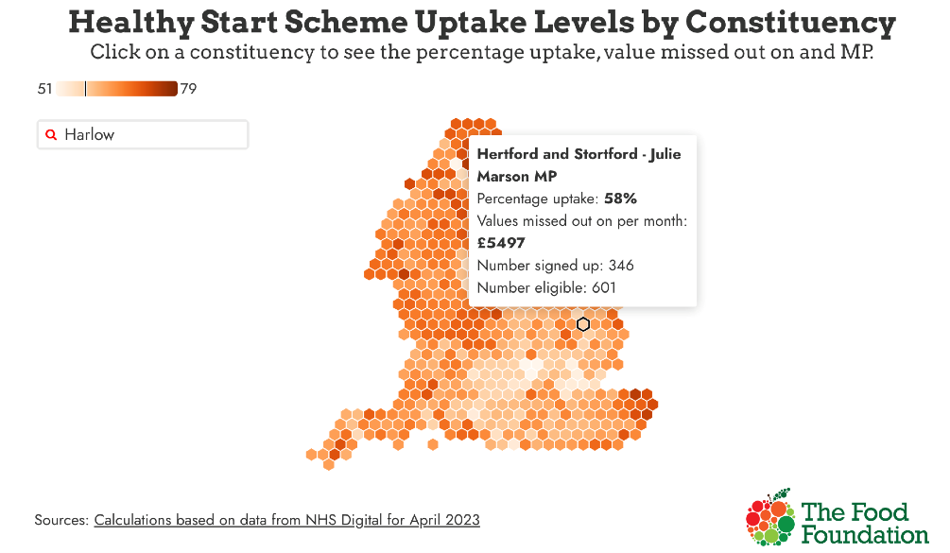
- Transforming East Herts Update
On Wednesday 7 June, we enter the first phase of our new Customer Relationship
Management (CRM) system rollout. The rollout is a significant milestone in our Transforming East Herts journey, which is about us becoming a more modern, forwardthinking council – performance-driven, digitally enabled, and customer focussed.
During this first phase, over 100 online reporting forms will be switched over to the new Granicus platform and residents subscribed to our weekly email newsletter will be encouraged to register and create an East Herts MyAccount.

Once registered, East Herts MyAccount will remember their details for the next time they need to get in touch and keep a case log so residents can view all of their requests in one place. We appreciate Members’ support in the coming months in directing residents towards the East Herts MyAccount, which will enable quicker and more efficient communication with council teams.

This first phase is about us gathering feedback and ironing out any issues, so please do let us know if you receive feedback from residents or businesses.
The next phase will see us launch a dashboard that will give residents status updates on their requests and carry out key integrations with other council software and payment systems. We will share more on this important work soon.
- Committee dates
Committee dates for 2023/2024 have been published, and are on the website - http://democracy.eastherts.gov.uk/mgCalendarMonthView.aspx?GL=1&bcr=1
- Forward Plan of Key Decisions and Major Decisions - May - September 2023
(01/06/2023 to 30/09/2023)
Available at - http://democracy.eastherts.gov.uk/mgListPlanItems.aspx?
PlanId=321&RP=119&J=3
Of note
Harlow and Gilston Garden Town - Draft Stewardship Charter for Consultation
Seeking Executive resolution endorsing the draft Harlow and Gilston Garden Town
Stewardship Charter for consultation
Decision type: Key
Reason Key: Affects two or more Wards;
Decision status: For Determination
Wards affected: Hunsdon; Sawbridgeworth;
Notice of proposed decision first published: 22/05/2023
Decision due: 11 Jul 2023 by Executive
Lead member: Leader of the Council
Lead director: Head of Planning and Building Control
Contact: Kevin Steptoe, East Herts Garden Town Lead Officer Email: kevin.steptoe@eastherts.gov.uk.
6. Culture Mapping Initiative

East Herts Council is inviting organisations involved in culture and the arts to participate in an asset mapping project.
The aim is to achieve a clear picture of the cultural and artistic offer across East Herts. Using this information, the council will develop new ways of supporting the arts and encouraging residents’ involvement.

The project is funded through the government’s UK Shared Prosperity Fund and will be managed by partnership organisation, Broxbourne and East Herts Community Alliance on behalf of the council.

The first step in the project is for arts organisations to connect with the council by completing a short survey. Through getting involved, participants will have opportunities in the future to apply for funding support, benefit from free promotion and tap into network and peer support opportunities.
Liz Crowther
Communications Officer
East Herts District Council
Tel 07512 303187
7. East Herts Council joins national campaign to tackle anti-social behaviour (ASB)
East Herts Council has worked with the police and partner organisations during ASB Awareness Week 2023 to encourage communities to take a stand against anti-social behaviour by reporting it rather than suffering in silence.
Organised by Resolve, the UK’s leading ASB and community safety organisation, ASB Awareness Week features a series of events across the UK involving councils, police forces, housing associations, charities, community groups and sports clubs.
East Herts Council’s ASB officers teamed up with the police, Herts Fire & Rescue and local housing associations to visit towns and villages across East Herts to speak to residents about their experiences. Residents were encouraged to take part in a short online survey which will help the council identify local concerns.

ASB relates to a wide range of behaviours which can blight the quality of life of individuals, families and communities. It includes excess noise, vandalism, neighbour disputes, fly tipping and abandoned or nuisance vehicles. Members of the public should report ASB to the anti-social behaviour team at East Herts Council via the council’s website, or report it directly to the police if they feel they are at immediate risk or danger. The link below takes you to the relevant page within EHDC website. https://www.eastherts.gov.uk/community-and-health/anti-socialbehaviour#:~:text=How%20to%20report%20ASB,9.00am%20
==================================================
TERLINGS PARK – TREE – 10TH JULY PARISH COUNCIL MEETING
Dear Councillors
I’m writing on behalf of Terlings Park Management Company in relation to a nationally rare species of tree that has been discovered within our Estate Land. Early this year whilst undertaking a large-scale programme of tree surgery within the Estate, our Contractors Maydencroft alerted us to the presence of a True Service Tree (Sorbus Domestica) which we understand to be an extremely rare species of tree and critically endangered in the UK (source Red Data Book of rare plant species, under the Joint Nature Conservation Committee).
The True Service Tree is located an area of woodland that we refer to as Turvin Woods and can be seen (with a keen eye) from the southern pathway, approx. 25m from edge of path. Currently, the tree is heavily overgrown with ivy and other climbers and is surrounded by oversailing trees that limit the amount of light that get to this light loving species.
An old noticeboard can be seen near the base of the tree, suggesting that its importance was one recognised by the previous landowners.
Given it’s importance on a national and local level, the TPMC board of directors want to do everything we can to secure the long term future of the True Service Tree, and so works to remove the ivy and to cut back surrounding trees in planned in Autumn 2023. However, TPMC doesn’t have means to fund the works ourselves as the TP estate service charge can only be used for “essential maintenance activities”. In this case tree preservation works would fall outside of this description given the location of the tree, and so we seek the Parish Councils support to fund the works.
Further details on the funding proposal are provided below for councillor’s consideration:
Location:
Terlings Park Estate, approx. 25m from lower footpath (tree is visible from the footpath)
Proposed Scope of Works:
- Works required to the True Service Tree itself, include removal of ivy, removal of all deadwood and clearance of surroundings to remove weed growth and mulching (circa 5m radius around tree)
- Pollarding works / reduction works required to 5-6 surrounding trees which are currently overhanging and restricting light.
- Proposal to renew tree plaque / sign (existing sign can be seen in photo 1). Maydencroft ecology team can provide input.
- To include reference to Eastwick & Gilston Parish Councils as project Sponsor
Cost:
- Tree Surgery * - £2,300.00 ex Vat
- Signage - £548.00 ex Vat
- Contingecy** - £1,000 excl.
- TOTAL £3,848 excl VAT

*All arisings will be left on site, either spread around the base of the tree and eco stacked in the woodland.
** All payments under contingency require prior approval of PC.
Site Visits –

- We’d be happy to facilitate a site visit by the Parish Council to come and have a look at the tree and to help understand our proposals further.

Further Reading -
https://www.wbrc.org.uk/worcrecd/Issue7/whittyp.htm

https://herbaria.plants.ox.ac.uk/bol/plants400/Profiles/ST/Sorbusd#:~:text=In%201983%20a%20small%2C%20service,trees%20occur%20they%20are%20rare.
https://www.forestresearch.gov.uk/tools-and-resources/tree-species-database/true-service-tree/
We’d be grateful for an opportunity to present this funding proposal to Councillors at the upcoming PC meeting.
Kind Regards

Robert Wightwick
Terlings Park Management Company
+++++++++++++++++++++++++++++++++++++++++++++
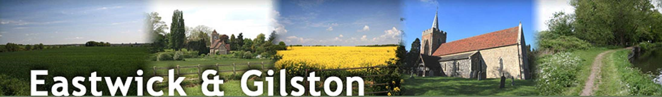
Parish Council - Gazebo proposal
Project Sponsor: James Jones I Author: Rob Wightwick
Date: March 2023

Introduction & Background
1.1 Eastwick and Gilston Parishes benefits from a vibrant and active community that organises and facilitates a range of community events, via the many local community groups, including;
- Parish Council
- Parish Hall Committee
- Hunsdon and Eastwick Neighbourhood Plan group
- Local Church
- Terlings Park Management Company

1.2 Examples of the types of community events arranged in recent years include:
- Queens Jubilee Celebrations
- Christmas Carol services
- Summer Fete
- Various Church led events

  - Many of these community events are held outdoors taking advantage of the wealth of open space available within the parish and so a form of cover or shelter is often required for persons and equipment.
  - To date the community has had to rely on loaning a gazebo from other affiliated organisations free of charge however this cannot be relied upon and is not sustainable in the long term.
  - Hire costs for gazebos of various types and sizes have been explored and an indication of hire costs is provided below for context.

Type / Size | Collection | Delivered | Delivered & Pitched
1.5m x 1.5n | £40 | £50 | £65
3.0m x 3.0m | £65 | £85 | £105
3.0m x 4.5m |  |  | £175
4.0m x 4.0m |  |  | £400
6.0m x 3.0m |  |  | £195
6.0m x 4.0m |  |  | £220
8.0m x 4.0m |  |  | £295
Globe lights (x8) |  |  | £30 per string
Floor Weights |  |  | £2 each
Ground Bars |  |  | £15 each
Reference: https://www.gloriousgazebos.co.uk/prices/

  - Given the limited budgets available to support events, ad hoc hiring of a gazebo is not cost efficient and, in many cases, would be prohibitive.
  - Accordingly, it is proposed that Eastwick & Gilston Parish Council purchases their own Gazebo(s) (complete with associated fixtures and accessories) and make this available for hire by local groups for a nominal fee.

Specification Requirements
2.1 The selection of a robust and high-quality Gazebo is important to ensure it can withstand regular use by a diverse range of users and community groups in non-domestic settings. The following flow chart has been used to consider appropriate specifications.
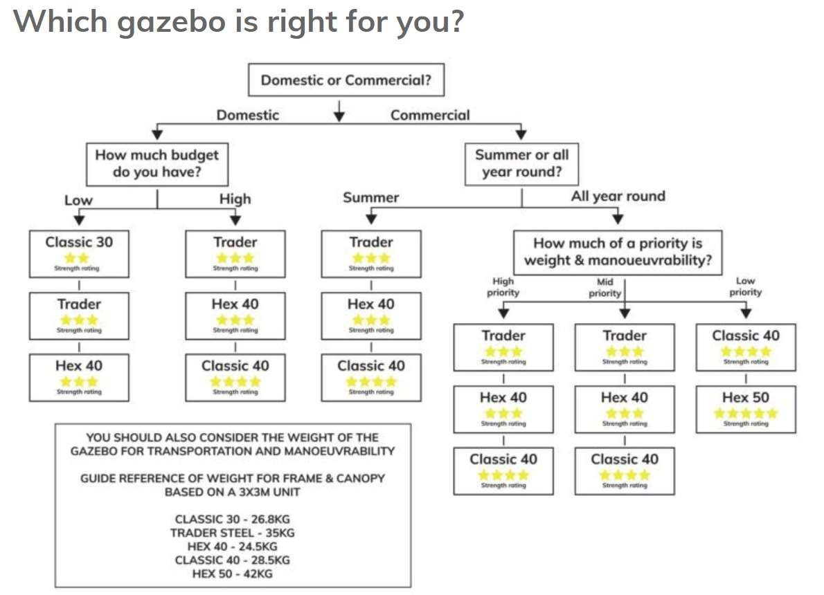
2.1.1 Using the flow chart as a guide it has been determined that the Gazebo should meet the following criteria:
- Must be suitable for regular commercial use ▪ Can be used all year round
- Is lightweight and manoeuvrable.
2.1.2 Based on the products available from Gazeboshop.co.uk the Extreme 40 Series and Classic 40 Series gazebos are deemed to be suitable options. Further details on specification can be found below:
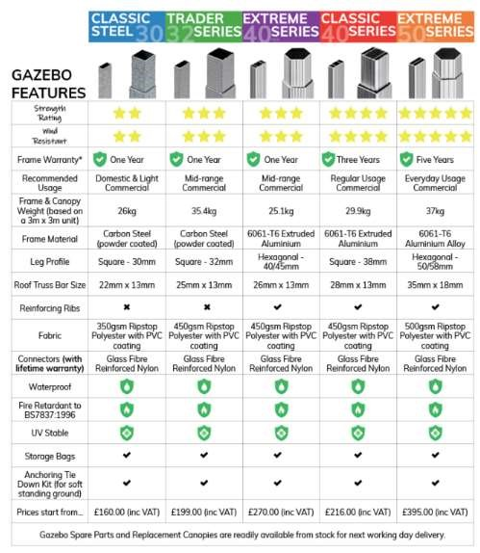

  - Size – Historically the Parish Council has loaned 3.0m x 3.0m and 3.0m x 6.0m Gazebos from affiliated groups to cater for the requirements of different events. Whilst a larger footprints may be desirable the weight and manoeuvrability of the
Gazebos should be considered in decision making. Where a greater footprint is required the Parish Council may wish to consider purchasing two small gazebo’s which can be combined to achieve larger footprint.
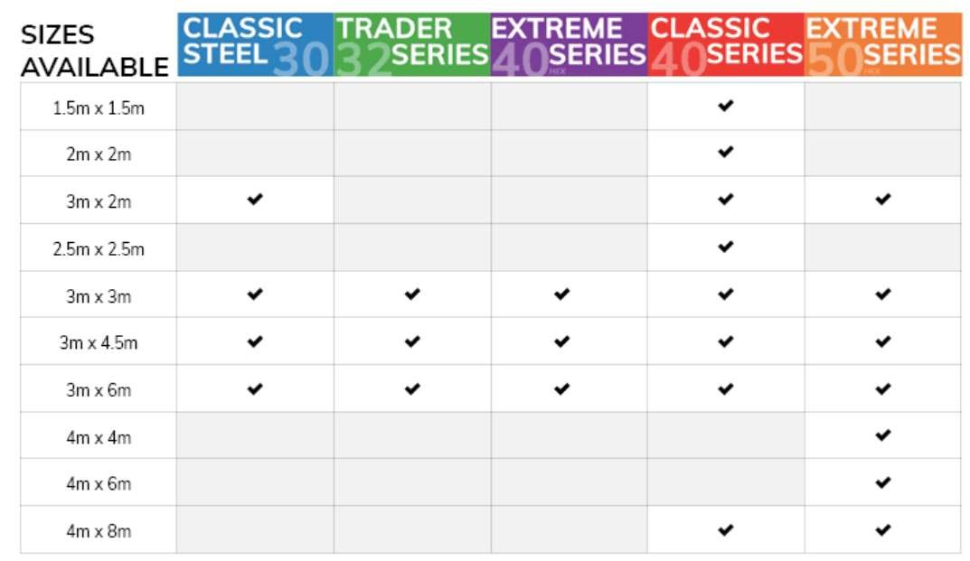
  - Accessories – To supplement the Gazebo and to increase useability throughout the seasons the following accessories are proposed.
- Walls
- Lights
- Weights

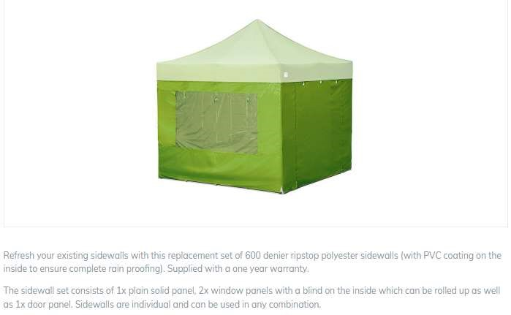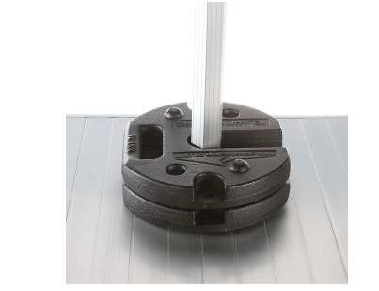

Budget
3.1 The following section provides indicative product selections from the Gazeboshop.co.uk range to help inform a budgets. 3.1.1 Classic 40 Series (3.0 x 3.0m – 29.9kg
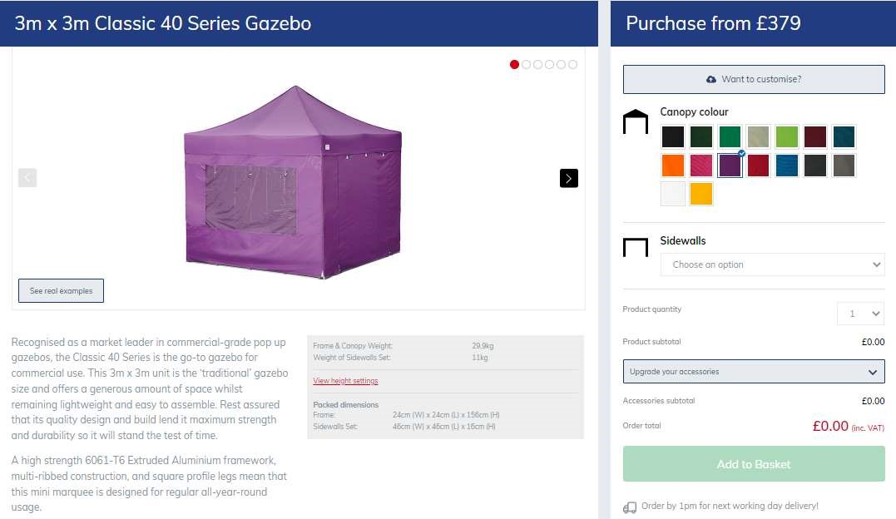

3.1.2 Classic 40 Series (3.0 x 4.5m) - 37.5kg
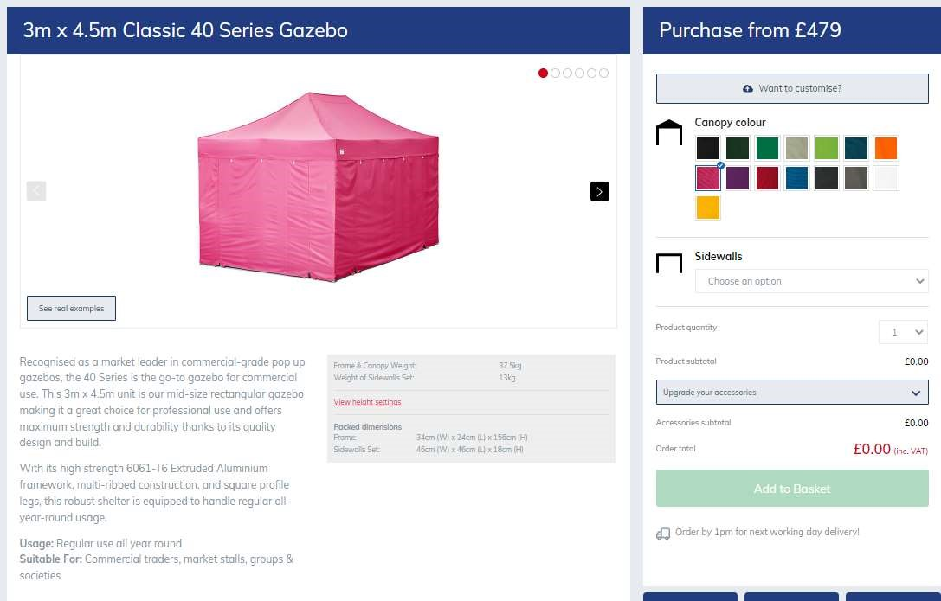

3.1.3 Classic 40 Series (3.0 x 6.0m) - 56.7kg
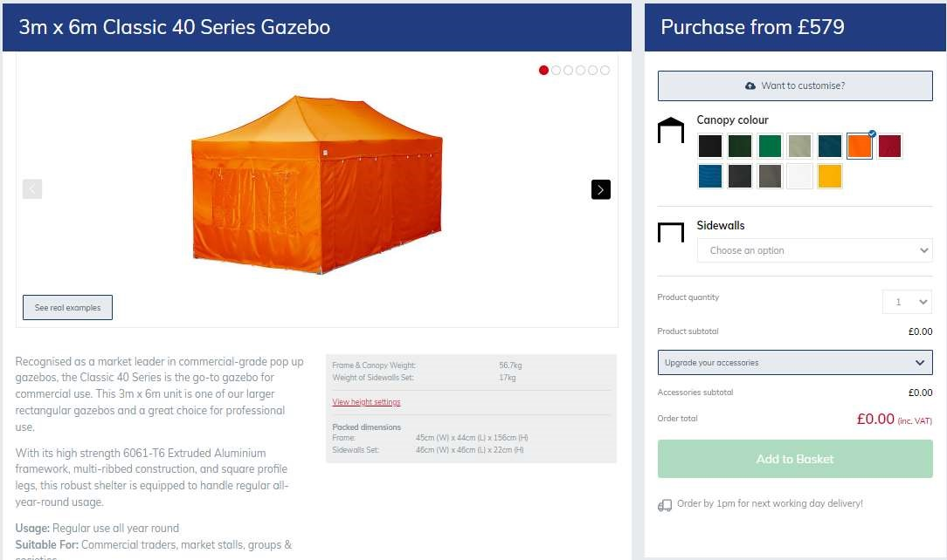

  - Budget Summary
Item | 3.0m x 3.0m | 3.0m x 4.5m | 3.0m x 6.0m
Gazebo | £379.00 | £479.00 | £579.00
Walls | £120.00 | £120.00 | £160.00
Heavy Duty Tie Down Kit | £20.00 | £20.00 | £20.00
Leg Weights 12.5kg Steel Stacking (Pair) x 2 | £130.00 | £130.00 | £195.00
3 way Mains LED Gazebo Lighting Kit | £115.00 | £230.00 | £230.00
TOTAL | £764.00 | £979.00 | £1,184.00

3.3 Total anticipated budget range to purchase a high quality gazebo complete with walls, additional tie down kit, leg weights and lighting is £764 - £1184 + VAT subject to preferred size.
3.4 Subject to budget approval the project sponsor will seek competitive prices from other suppliers for product of a similar specification and quality to assure value for money.

Terms of Use and Management
4.1 Rules of use – It is proposed that the use of the gazebo would be limited recognised community groups only support ‘open’ community events, with exceptions granted on a case-by-case basis by the Parish Council.
4.2 Hire Fees – It is proposed that a small fee will be payable to cover any wear and tear with an appropriate deposit taken at the point of hire. Proposed fees provided below:
• Hire Fee - £20/day • Deposit - £200
4.3 Hire Process – Groups wishing to hire a gazebo should apply directly to the Parish Council or their nominated person to arrange hire. A hire form will need to be drawn up to set out the terms and conditions of hire. Hire will be offered on a collection only basis and so users will need to make their own arrangements for collection, pitching and return. A manufacturers / suppliers guidance document should be provided at the point of hire giving user instructions. It is proposed that all fees & deposits are paid to Eastwick & Gilston Parish Council by Cash or bank transfer, with the payment process administered by the Parish Clerk.
4.4 Management & Oversight - It is proposed that a minimum of two Counsellors become nominated persons who will facilitate the hire and returns process, including facilitating access to the Parish Hall on collection days and checking the gazebo upon return check for any damage prior to deposits being returned.
4.5 Storage – The Gazebo and associated fixtures are to be storage securely at the Parish Hall. The gazebo should not be stored in open air or in external stores to avoid corrosion and mould growth. A dedicated space within the Parish Hall should be identified to prevent the gazebo being moved around which will increase the likelihood of damage. Consideration is to be given to making the loft space available, however manual handling implications may need to be considered.
4.6 Other Considerations – the Parish Council is asked to consider the requirement for insurance on the gazebo if appropriate and any other insurance implications associated with the hire process and the PC’s obligations with regard to Health & Safety.

Conclusion and Recommendation
5.1 In summary this proposal seeks the following confirmations and decisions from the Parish Council;
1. Confirm whether the benefit case is sufficient to justify the purchase of a Gazebo using New Homes Bonus monies.

If point 1 above is agreed then;
- Confirm agreement with the following specification criteria:
  - Suitable for regular commercial use; ▪ Can be used all year round; ▪ Is lightweight and manoeuvrable.

- Confirm preference in respect of the size, specification, accessories (i.e walls, weights, tie down & lighting) and number of Gazebo’s to be purchased.
- Subject to confirmation of preferred size, approve a total maximum budget commitment of between £764 - £1184 + VAT per Gazebo funded from the New Homes Bonus monies.
- Consider and provide feedback on the Terms of Use and Management proposals including but not limited to:
  - Hire Process
  - Hire Fees and Deposits
  - Nominated persons ▪ Insurances

