EASTWICK AND GILSTON PARISH COUNCIL

CHAIRMAN PARISH CLERK

MARK ORSON CHRISTINE LAW

89 PYE CORNER 9 CHURCH COTTAGES

GILSTON GILSTON

NR HARLOW NR HARLOW

HERTS CM20 2RD HERTS CM20 2RH

TELEPHONE 01279 453257 TELEPHONE 01279 411646

Email: mark.orson@outlook.com Email: christine.law2@btinternet.com

The Parish Council business meeting of Monday 10th March 2025. Village Hall , Pye Corner, Gilston 8.00pm
PRESENT: Cllr’s Beazley, Bryant, Harvey, Marx, Orson, Cllr Eric Buckmaster (CC), Cllr John Dunlop (DC), 2 members of the public. Christine Law (Clerk) in attendance.
Cllr Buckmaster and Cllr Dunlop’s reports are attached to these minutes.
ANNUAL PARISH MEETING

This part of the meeting gives registered electors of the parish an opportunity to come and discuss any matters of importance within the community.

- Litter Bin – Gilston Lane (adjacent to Cumberland Lodge). The council were informed that very morning the litter bin was removed by East Herts/North Herts waste department. This has been done with no consultation with the Parish Council. Cllr Dunlop and Cllr Buckmaster said that they would investigate on our behalf. The Clerk will e-mail them about the matter. The email if anyone else would like to email and complain is : wasteandrecycling@north-herts.gov.uk. (Post meeting note – we have now heard from the council waste management department have now reconsidered and will be return the litter bin).
- Notice Board, Eastwick – The notice board in Eastwick one of the doors has broken off and we are in need of the carpenter to make us a new one. The Clerk will see if she can find someone that will be able to mend this for us.
- Dusty Miller public house – enquiries were asked about what was happening to the pub as it does not seem to be open at the present time. Cllr Beazley said that he would make enquiries. (Post meeting note has contacted McMullen Brewery about the matter and they advised that there are several large renovations that require attention and repair before they can look for a new tenant. He asked to be kept in the loop.)
BUSINESS MEETING STARTED AT 8.30PM
85)APOLOGIES FOR ABSENCE
None.

86)RECEIVE COUNCILLOR’S DECLARATION OF INTERESTS
- None.
87)MINUTES FOR APPROVAL
a. The minutes of 13th January 2025 two items were missed off they are: -
i. Within item 76 Knight Frank. A discussion has held about the tree work proposed to take place in Burnt Mill Lane. Cllr Beazley said Terlings Park MC had concerns with the tree cutting along their boundary, which they were discussing with the developers.
ii. Cllr Dunlop’s report included an item about the devolution of local government . A discussion on Local Government devolution and HCC & EHC's decision to not apply to be in the initial group was held.
Both these items will be added as an appendix to those minutes as draft copies have already been published.
- Minutes of the Parish Council Business Meeting of 13th January 2025 with the above as an appendix to the minutes. The minutes were signed by Cllr Bryant after they were proposed by Cllr Marx and seconded by Cllr Harvey.
88) ACCOUNTS
a. Clerks report to the Council of accounts summary (appendix 1).
b. Defibrillator – Village Hall & Terlings Park are in need of new pads etc. Cllr Bryant informed the
council that these will need to be purchased within the next few months and the approximate price.
- New Homes Bonus – Cllr Orson informed the meeting that the interest that we receive from the CCLA investment is quite substantial and need to discuss further on what to do with the interest do we invest more which will give us more interest or ideas on what to spend it on. To be put on agenda for our next meeting for further discussion.
- VE Day – It is with regret due to not be able to find anyone to organise this event we are sorry to say that there will not be an event held in our villages. We are informed that are other events being held locally.
a-d proposed by Cllr Marx and seconded by Cllr Harvey.

89)PLANNING AND ASSOCIATED APPLICATIONS
a. Grassland, Pye Corner, Gilston – 3/23/1110/FUL – Retrospective change of use of buildings A
(Class e). B (class B8), c (Class B8), D (Class B8), E (Class B8) and F (Class E). Awaiting
decision.
b. The Old Rectory, Gilston – 3/24/0068/FUL – Installation of 100 ground mounted PV Cell Solar
Panels on the paddocks to the north of the Old Rectory. Awaiting decision.
- 2-7 Kirkpatrick Place, Gilston – 3/24/2151/FUL – New application – Replacement of 6 number Juliet balcony’s with new cantilever balcony’s new balcony’s to measurer 3.0m wide, 120mm deep, 1200mm high. Awaiting decision.
- 95 Pye Corner, Gilston – 3/23/2463/HH – Has been refused by planning but applicant has gone to appeal. Appeal has been dismissed 10.1.2025.
- Land Adj. to 66 Eastwick Road, Eastwick 24/00065/Refuse. The applicant has taken this to appeal. Appeal has been dismissed 10.2.2025.
90) PARISH PATHS
Cllr Orson reported:
Various works have been completed recently by HCC Rights of Way contractors:
  - The alignment of the signs on footpaths 29 and 30 at Pye Corner have been corrected
  - The alignment of the signpost on footpath 20 has been corrected to match the corrected route
through the wood.
  - The collapsed waymark posts on footpaths 3, 4, and 5 have been replaced.

  - The vegetation encroaching on footpath 4 has been trimmed back by Knight Frank’s contractors on behalf of Places for People.
  - Cllr Orson was asked if the bench which is situated at the footpath on Eastwick Road could be moved as PfP have relocated the footpath.
  - It was also asked as the Parish Council are still holding grant money for footpath benches could one be installed on footpath E20. This will be investigated.

91)COMMUNITY FORUM/ NEIGHBOURHOOD DEVELOPMENT
a. Cllr Bryant report is attached as appendix 2.
Neighbourhood Planning Group – The following information and purpose of the HEGNPG will be published onto our web site.
The Hunsdon, Eastwick, and Gilston Neighbourhood Plan Group (HEGNPG) plays a
crucial role in shaping and overseeing the Gilston Area development, to ensure it
aligns with community values and sustainable development principles. After
successfully completing the award winning Gilston Area Neighbourhood Plan (GANP),
the HEGNPG continues to jointly represent the two directly affected Parish Councils
of Hunsdon and Eastwick & Gilston. It seeks to coordinate engagement with
developers, Places for People and Taylor Wimpey, and local authorities especially
East Herts Council.

The HEGNPG is involved in reviewing planning applications and master plans for the
proposed villages, ensuring they meet the expectations of Local Plan policy and the
GANP. Our primary goals are to advocate for high standards in urban design, proper
and timely infrastructure, environmental responsibility and community-focused
We believe we have influenced the quality of green space and community land,
promoted biodiversity and landscape integration, and continue to press for better
interface with the existing communities, sustainable transport solutions, and “village
master planning” principles where each village within the development retains
distinct features. Additionally, we will actively monitor the agreements related to
infrastructure, affordable housing, and the long-term governance of community
In summary, the HEGNPG acts as a voice for residents, holding developers
accountable to promises for the delivery of a of sustainable, high-quality
development that respects both local heritage and environmental goals. Through this
active oversight, we aim to be the voice of the two directly affected Parish Councils
and so keep the development aligned with community’s hopes and aspirations and
ensure it remains adaptable to future needs.

92)HIGHWAYS
A. Cllr Harvey reported the following:
1. Road works through Pye Corner towards High Wych have been completed .
2. Works are planned at the bridge to Fiddlers Brook .
3. Eastwick Hall Lane continues be ridden with holes and excess mud . Reports have been sent
to highways and PFP . Some work is scheduled for March 17th.
- I have not been given any information on Terlings Park . The meeting was informed that two of the street lamps within Terlings are not working. We believe this is a highways matter. Also part of the roads within Terlings still have not been adopted. This is work in progress.
5. Current works in Harlow and numerous diversions to A414 have contributed to regular
congestion at the A414 roundabout by Eastwick Lodge Farm. This affects everyone in
Eastwick and Gilston Parish and continues.
6. PfP seem to have completed their initial tree felling .
7. It remains difficult to track completion of reported works through the highways portal .
8. PFP have created a web site (gilston.info) to report fallen trees etc on roads and byways . This has yet
to be advertised to the local inhabitants.
9. Fiddlers Brook wall – Gilston Lane. This matter still to be resolved.
10. Cllr Buckmaster informed the meeting that the following should be approved at cabinet on 17th March
Eastwick Hall Lane Local Carriageway Reconstruction 24 Eastwick 3U875/10 Eastwick Hall Lane A414 Eastwick Road To Eastwick Hall Farm NCM250245-1 CRC Apr25 - Mar26 - -
Pye Corner Local Carriageway Reconstruction 24 Gilston C161/8 Pye Corner 30mph Signs To Derestriction Signs CWY250189-1 CRC Apr25 - Mar26 - -
A414 Eastwick Road Carriageway Surface Dressing 24 Stanstead Abbotts A414/836 Eastwick Road C15 Church Lane to start of Roydon Road Slip ARP240002-2 ASD Qtr-1 - -
A414 Eastwick Road Carriageway Surface Dressing 24 Eastwick A414/846 Eastwick Road U875 Eastwick Hall Lane to C15 Church Lane ARP240002-2 ASD Qtr-1 - -
A414Eastwick Road Carriageway Surface Dressing 24 Eastwick A414/856 Eastwick Road Eastwick Lodge roundabout westwards to Eastwick Hall Lane ARP240002-2 ASD Qtr-1 - -
11. A discussion was had with Cllr Buckmaster about a possibility of 20mph speed restrictions on the sharp bends on Pye Corner within the 30mph limit. As this is a matter he is investigating he will keep us informed.
92 B. GILSTON VILLAGE ADDITIONAL SIGN
Cllr Bryant reported:
Potential project / expenditure of some of the New Homes Bonus (interest accrued and possibly small
amount of capital).
Background
The village of Gilston is intersected by 2 through roads:
- C161 (also referred to as Pye Corner & Eastwick Road) running east - west
- Gilston Lane running north from Pye Corner
Entering the village of Gilston from the east and west, on the C161, are “village destination signs”, no sign informs anyone entering the village from the north, along Gilston Lane,

Locating a new GILSTON sign, near Church Cottages, would help establish the village as a defined entity before it is subsumed within the circle of new villages. Including the words “Please drive carefully” may help reduce the speed along the lane.
Plus the action that further cost implications required.

93) KNIGHT FRANK
Communication received from Joel Fayers:
As we have recently discussed, we will now be circulating a monthly update email to keep you informed with key matters relating to Gilston Villages 1-6. Naturally, the content of each email will be led by what has taken place over recent weeks and what is scheduled to be happening later in the month, so if there is a particular topic or area you would like a future email to focus on, please do let me know.
Planning update
- Judicial Review - We were delighted to announce the signing of Gilston’s Section 106 agreement earlier this year. The forecasted £6bn of economic impact demonstrates the scale of benefits this multi-tenure thriving community will deliver and our commitment to making a positive difference in the places we serve. PfP remains fully committed to Gilston - we have full confidence in the processes carried out.

- Thank you again to those who attended the Village 1 Masterplan Community Working Group 4 session and the public event in late January/early February. Copies of the materials that were on display and a summary interim report can be found here.

- In terms of a high-level programme for the upcoming works, please find below a rough guide to anticipated timings as things stand. As you can imagine, these are subject to change, and we will of course keep you updated once we have more news. Once we are in a position to do so, we will look to produce a more in-depth programme as has been requested.
Activity | Approx. timings
SLMP submission | March 2025
V1MP submission | April 2025
CSC enabling works | Underway
V2MP, V5MP & V6MP workstreams begin | Later in 2025
CSC construction & associated works | 2025 - 2029/30
V1 Reserved Matters Applications | TBC
First homes being built in Village 1 | Circa 2028-2030
Estate comms website
- The new estate and construction comms website is now live - www.gilston.info. Thank you to those of you who have already used the platform.
- The purpose of the website is to allow updates to be provided to local residents about work being undertaken across the estate. At the same time, it will make reporting an issue or asking a question much easier through the pin-drop system. This generates an accurate What3Words reference which will speed up the time taken to identify the location of the issue.
- How to report an issue:
You are able to drop a pin on the location of the issue and provide a description of what you would like to report. Villages 1-6 are transparent in colour, whilst Village 7 (Taylor Wimpey) has been shaded yellow to differentiate the two sites. This will be your opportunity to flag issues without worrying if the land belongs to Places for People or Taylor Wimpey.
· New pins will be marked as red and will be passed onto the corresponding team.
· Issues that are in progress and are being investigated by the team will be marked in orange.
· Once the team has resolved the issue, this will be marked as green.
- The website functions will evolve over time. If you have any suggested improvements or features you would like to see added, or would like a copy of the recorded session we held in February, please email gilston@meeting-place.uk.
Estate management
- Gilston Lane flooding - It is important to note that this is an historic problem whereby the roadside bank, which is the responsibility of Hertfordshire Highways, has subsided into the river. There is a lot of mature tree growth on the riverbank, as well as fly tipping which contributed to the recent flooding. The above factors combined resulted in reduced holding capacity of the river and therefore flooding post rainfall. In that instance, in effort to assist residents, PfP instructed contractors to remove the fly tipping debris and tree limbs which were obstructing the river course over a 200m length. This has already reportedly reduced the flow rate and local residents have acknowledged this. As I'm sure you can appreciate, PfP cannot be considered responsible for flooding which already exists in flood zones, but we will be taking steps in agreement with Hertfordshire County Council to ensure any future development doesn’t make the issues worse. We understand that progress is being made on this behind the scenes at HCC, so hopefully a positive update from them will be provided in due course.

- Eastwick Hall Lane flooding - As you'll be aware, PfP has previously instructed a contractor to undertake ground works to improve drainage including ditch clearance, culvert clearance, dredging and digging out the spring to facilitate under road drainage. Subsequently, Herts County Council have had surveys carried out along the length of the lane to identify ineffective gullies and whether pipeline infrastructure is functional with a view to having all inadequate parts replaced. The team remain in conversation with Herts County Council and are awaiting an update on their proposal. Once we've heard back, we will of course be back in touch to advise on next steps and timings.

Additional vegetation clearance has taken place at Roseley Cottages and along the H5 footpath. Please see the attached document for photos of the work undertaken.
Gilston Stakeholder Liaison Group
- As the project evolves to the next stage, PfP would like to establish a liaison group with key local stakeholders. This will allow us to provide updates on estate management and planning matters at quarterly in-person meetings, outside of the EHDC Gilston Area Community Forum and masterplanning process.
- A copy of the Terms of Reference and the date of the first meeting will be circulated next week.

94)VILLAGE HALL MANAGEMENT COMMITTEE
1.A grant from East Herts for the supply of Golden Zumba and chair Pilates terminates in March .
2.The chair Pilates will continue as a regular self funding project as it has proven to be very
popular .
3.A grant also from East Herts for heating management has been received and utilised to install a
Hive system .
4.Meanwhile it is clear there have been cost benefits from the solar panels provided by money from
East Herts. We received a cheque for over £600 last month in payment for energy sold back to the
grid.
5.The hall electricity had its 5 yearly EICR check last month and this has been communicated to our
insurers . The few small suggestions for update will be adopted this month.
6.There will be a fund raiser for the hall on May 2nd in the form of the usually very popular race
night . A poster will go out for the next parish magazine and the various what’s app groups.
7.No further planned improvements are scheduled for the coming year.

95) NEW WEB SITE
Cllr Orson read through his written report on the proposal of getting a new web site. His report states:

We are currently using ParishCouncil.net to host and support our Parish Council / Community website EastwickandGilston.org that was established in 2010 and currently costs £300 per annum plus VAT to run.
We are not demanding in terms of our support needs from ParishCouncil.net however whenever we have needed help in any way their response has been slow or required us to chase for a response. This has been a major problem with our recent attempts to set up an email box named for our Parish Clerk which is now a mandatory requirement for the Parish Council to meet. ParishCouncil.net has failed to provide the necessary support despite several promises to do so and we have been unable to make progress. Consequently, we have looked for an alternative supplier.
The Parish Council already subscribes to Parish Online’s digital mapping service, and they also offer Website Hosting, gov.uk domains and emails for Town, Community and Parish Councils. See https://www.parish-online.co.uk/website for details of website facilities and a live demo. The website hosting functions can include support for access and storage of our high-resolution aerial photographs. Please note that in addition to those standard functions shown on the live demo other standard functions include Village Hall Booking and Defibrillator locations map.
The subscription package includes:
- Website - a modern, accessible and responsive website using the Government design guidelines
- Email - up to 20 mailboxes with 5GB storage each which are accessed through the provided apps for windows, mac or phone, via webmail, or you can connect it to your own phone or computer mail apps.
- Gov.uk domain - we register your new gov.uk domain and pay the fees instead of you having to pay for it. The domain is owned by you, but we manage it.
- Hosting - the servers where your website live
- Ongoing Maintenance and Upgrades - we may have a slightly higher ongoing cost than other providers, but we invest in your service to make sure it's always the latest new features, security upgrades or updates to align to new legislation
- SSL Certificate - this keeps your site encrypted and safe for visitors
- Content Migration - we port over as much content from your current site as possible at no extra cost.
- Accessibility - our sites always follow the latest Web Content Accessibility Guidelines (WCAG). Our sites already conform to WCAG 2.2 AA which is a requirement from October 2024 onwards.
- Support - we have a bank of knowledge base articles available to help you with managing your website. We also provide email support.
The associated costs are:
- £315 plus vat per year for the website, email and domain service.
- £42 plus vat per year for Workplace for 1 user (needed to provide 10GB of date storage for our aerial photographs)
- Year 1 = £257 plus vat (£100 introductory discount will be applied for year 1)
- Year 2 and onward = £357 plus vat
The available new domain choices are:
- eastwickandgilstonparishcouncil.gov.uk
- eastwickandgilstonparish.gov.uk
- eastwickandgilston-pc.gov.uk
Conclusion
- It is proposed that the Parish Council should change our website supplier to Parish Online from ParishCouncil.net. This will mean that the Parish Council has one supplier providing a supported solution that meets our current requirements with the following costs:
- Year 1 = £257 plus vat (£100 introductory discount will be applied for year 1)
- Year 2 and onward = £357 plus vat
- That the new domain should be eastwickandgilstonparish.gov.uk
This will also provide the opportunity to review and update website content.
His proposal was proposed by Cllr Bryant and seconded by Cllr Marx.

97)CORRESPONDENCE
a. Cllr Buckmaster report is attached to these minutes. He talked about the upcoming school places. Also about the work he is doing about reducing speed limits in places in Sawbridgeworth to 20mph. He was asked is something could be done about the 30mph speed limit through Pye Corner and reducing in places to 20mph. He will investigate.
b. Cllr Dunlop report is attached to these minutes. He talked about the devolution of councils, which will not effect us at this present time. Also about the new bin collections, which the magazine editor will put in the upcoming village magazine. He also talked about the call for sites which can be read in his report attached.

98)ITEMS BROUGHT FORWARD AT THE DISCRETION OF THE CHAIRMAN FOR INFORMATION ONLY.
a. None.
99)ITEMS COUNCILLORS WOULD LIKE TO BE ADDED TO THE NEXT AGENDA.
None.

100) DATE OF NEXT MEETING
a. Date of next meeting –
12th May – Annual Meeting of the Council followed by business meeting (Cllr Orson will be absent). Cllr Bryant will chair the meeting.
14th July – Council Meeting
15th September – Council Meeting
10th November – Council Meeting

Meeting closed at 9.55pm
+++++++++++++++++++++++++++++++
Appendix 2 - Item 91 EHC Community Forum and Neighbourhood Development

EHC Gilston Area Community Forum was held 27th February 2025
The number of residents attending this forum was disappointing, particularly as the main agenda item gave a useful overview of the Gilston Area Stewardship proposal. The presentation was given by Sally Ann Logan, senior Associate Consultant Trust Development & Management at Community Stewardship Solutions. The Forum offered plenty of opportunity to ask questions & discussion.

As usual, the presentation is available at the East Herts Gilston Area Community Forum webpage
https://www.eastherts.gov.uk/planning-and-building/community-forums/gilston-area-community-forum
under the 27th February 2025 tab.

Meeting Place demonstrated a new website application found at gilston.info which will go live shortly.
The website has 3 headings:
Current Works – a map of current and planned works in the Gilston Area.
Report an Issue – a map where any issues, eg tree fallen across a RoW, fly tipping, etc., can be reported
News – at the moment this simply provides an option to submit an email address to receive future updates.

Dates for the next forum:
Tuesday 13th May 2025
As usual, the venue is Manor of Groves, High Wych.

We urge residents to attend these forums and, if possible, submit questions, via email, at least 10 days before to community.forum@eastherts.gov.uk

You can also ask for specific topics you want to learn more about to be included in future meetings.

Neighbourhood Development
Stewardship, the Section 106 states “Start Date: no later than [3] months of Grant of Planning Permission for the V1-6 Outline Planning Permission and/or V7 Outline Planning Permission”
As the Section 106 was signed 9th January 2025 this means a Shadow Board for the proposed Gilston Area Community Trust needs to be operational by early April 2025.
This is a very challenging objective, for which we have, as yet, very little knowledge & understanding.

A meeting is being scheduled between East Herts Council, Places for People, Taylor Wimpey, Hertfordshire County Council, councillors of Eastwick & Gilston and Hunsdon to help improve understanding of the process.

New gilston.info website demonstrated at the February Community Forum – see above.

We are being told that the Strategic Landscape Master Plan, SLMP, (which must be completed and approved before Village Master Plans can be submitted) is considered nearly ready for submission and likely to be submitted to EHC by end March 2025.
As previously reported, to the January 2025 Parish Council, this is very disappointing as we have still not had an opportunity to review the SLMP for many months and, at that time, we were limited to which parts of the Gilston Area we were shown.
The following is repeated from the January 2025 Parish Council Update report, as nothing has changed.

The Interim Report for the 4th Workshop, held July 2024, states
A full report is being compiled by Grants Associates which builds on this interim report, but also sets out the ways in which feedback has been considered in design
We have not yet seen a “full report”.

Nor have we been offered the opportunity to explore and discuss proposals for all areas of the SLMP, in particular the corridors between the villages including:
Fiddlers Brook Corridor
Golden Brook Corridor
Eastwick Brook Corridor
and how the Strategic Transport Corridor, STC, interfaces with existing public roads which are critical access for a significant number of existing residents.

Judicial Review – applications for a Judicial Review of the 2 Planning Applications for the Gilston Area (Villages 1 – 6 and Village 7) have been submitted.

Roadworks update.
Places for People gilstonparkestate website NEWS page
https://www.gilstonparkestate.com/news/enabling-works-for-gilston-underway/
Nothing new on roads since 20th December 2024

Useful websites:
Village 1 and Strategic Landscape Master Plan
https://www.gilstonparkestate.com/get-involved/

Section 106 docs Villages 1 - 6
https://publicaccess.eastherts.gov.uk/online-applications/applicationDetails.do?activeTab=documents&keyVal=PRSRKCGL00V00

Village 7 https://www.village7.co.uk

Section 106 docs Villages 7
https://publicaccess.eastherts.gov.uk/online-applications/applicationDetails.do?activeTab=documents&keyVal=PZKRYCGL05I00

East Herts Community Forums
https://www.eastherts.gov.uk/planning-and-building/community-forums/gilston-area-community-forum
Appendix 3 – Item 93 Report from Joel Fraa- on behalf od Knight Frank

As we have recently discussed, we will now be circulating a monthly update email to keep you informed with key matters relating to Gilston Villages 1-6. Naturally, the content of each email will be led by what has taken place over recent weeks and what is scheduled to be happening later in the month, so if there is a particular topic or area you would like a future email to focus on, please do let me know.

Planning update
- Judicial Review - We were delighted to announce the signing of Gilston’s Section 106 agreement earlier this year. The forecasted £6bn of economic impact demonstrates the scale of benefits this multi-tenure thriving community will deliver and our commitment to making a positive difference in the places we serve. PfP remains fully committed to Gilston - we have full confidence in the processes carried out.

- Thank you again to those who attended the Village 1 Masterplan Community Working Group 4 session and the public event in late January/early February. Copies of the materials that were on display and a summary interim report can be found here.

- In terms of a high-level programme for the upcoming works, please find below a rough guide to anticipated timings as things stand. As you can imagine, these are subject to change, and we will of course keep you updated once we have more news. Once we are in a position to do so, we will look to produce a more in-depth programme as has been requested.
Activity | Approx. timings
SLMP submission | March 2025
V1MP submission | April 2025
CSC enabling works | Underway
V2MP, V5MP & V6MP workstreams begin | Later in 2025
CSC construction & associated works | 2025 - 2029/30
V1 Reserved Matters Applications | TBC
First homes being built in Village 1 | Circa 2028-2030

Estate comms website
- The new estate and construction comms website is now live - www.gilston.info. Thank you to those of you who have already used the platform.
- The purpose of the website is to allow updates to be provided to local residents about work being undertaken across the estate. At the same time, it will make reporting an issue or asking a question much easier through the pin-drop system. This generates an accurate What3Words reference which will speed up the time taken to identify the location of the issue.
- How to report an issue:
You are able to drop a pin on the location of the issue and provide a description of what you would like to report. Villages 1-6 are transparent in colour, whilst Village 7 (Taylor Wimpey) has been shaded yellow to differentiate the two sites. This will be your opportunity to flag issues without worrying if the land belongs to Places for People or Taylor Wimpey.

· New pins will be marked as red and will be passed onto the corresponding team.
· Issues that are in progress and are being investigated by the team will be marked in orange.
· Once the team has resolved the issue, this will be marked as green.
- The website functions will evolve over time. If you have any suggested improvements or features you would like to see added, or would like a copy of the recorded session we held in February, please email gilston@meeting-place.uk.

Estate management
- Gilston Lane flooding - It is important to note that this is an historic problem whereby the roadside bank, which is the responsibility of Hertfordshire Highways, has subsided into the river. There is a lot of mature tree growth on the riverbank, as well as fly tipping which contributed to the recent flooding. The above factors combined resulted in reduced holding capacity of the river and therefore flooding post rainfall. In that instance, in effort to assist residents, PfP instructed contractors to remove the fly tipping debris and tree limbs which were obstructing the river course over a 200m length. This has already reportedly reduced the flow rate and local residents have acknowledged this. As I'm sure you can appreciate, PfP cannot be considered responsible for flooding which already exists in flood zones, but we will be taking steps in agreement with Hertfordshire County Council to ensure any future development doesn’t make the issues worse. We understand that progress is being made on this behind the scenes at HCC, so hopefully a positive update from them will be provided in due course.

- Eastwick Hall Lane flooding - As you'll be aware, PfP has previously instructed a contractor to undertake ground works to improve drainage including ditch clearance, culvert clearance, dredging and digging out the spring to facilitate under road drainage. Subsequently, Herts County Council have had surveys carried out along the length of the lane to identify ineffective gullies and whether pipeline infrastructure is functional with a view to having all inadequate parts replaced. The team remain in conversation with Herts County Council and are awaiting an update on their proposal. Once we've heard back, we will of course be back in touch to advise on next steps and timings.

- Additional vegetation clearance has taken place at Roseley Cottages and along the H5 footpath. Please see the attached document for photos of the work undertaken.

Gilston Stakeholder Liaison Group
- As the project evolves to the next stage, PfP would like to establish a liaison group with key local stakeholders. This will allow us to provide updates on estate management and planning matters at quarterly in-person meetings, outside of the EHDC Gilston Area Community Forum and masterplanning process.
- A copy of the Terms of Reference and the date of the first meeting will be circulated next week.

Cllr. John Dunlop District Councillor report for 10th March meeting

- Gilston Park Estate
I had my monthly update with Officers. I asked questions on behalf of the NPG and have provided answers received from officers to those.
Some highlights:
Main works for Phase 1a and 2a will commence from March 2025 through to spring 2027. Phase 1a and 2a comprises
the V1 STC access and V1 All modes access.
Based on current understanding although a JR could change these dates is:
Phase 1b is land south of the district boundary and is currently going through the detailed technical highways approval stage with a proposed commencement date of Spring 2027 to avoid clashing with ECC works on the STC from Burnt Mill Roundabout southwards.
Project 5 which is the internal STC link in V1 and the internal all modes junction will commence summer 2027.
Project 7 V1 primary school commencement summer 2027
Residential commencement in V1 during late 2027
Condition 4 of the V7 permission limits the extent of works in V7 before V1 has made a substantial commencement. There are requirements in the s106 to ensure that linking infrastructure is delivered very early on which TW have to implement. The condition allows enabling works to take place in V7 and those works are reasonably broad such that V7 can get on site and start preparing the site while early works take place in V1. So yes, TW can start preparing the site on the same timetable as V1, they cannot however commence above ground construction of homes before V1 has commenced.
- Devolution update
The Government has just written to all council leaders in Herts to lay out the timetable for when County and the Districts have to respond to the govt request for proposals for how we would like to see local gov reform in the county - how many unitaries and why... with outline proposals due to Gov by March 21st 2025 and more detailed proposals in November 2025.
There are 2 main competing factors to consider -
1) The proposal is designed to save money, which in theory pushes towards larger unitaries with each one covering more people (hence in theory savings from things like fewer CEOs and senior council officers and more widely shared services should be larger).
2) On the other hand, larger unitaries means the loss of local democratic representation - i.e. fewer councillors per 100,000 residents, with council offices becoming a distant thing.
There are a lot of meetings between leaders and Chief Execs across the County to come up with a proposal which could be agreed.
This is still in discussion and several options have been proposed between 1 and 4 unitaries. We expect feedback in April and anticipate that public consultation will happen later in the year.

- Call for Sites
It is the first piece of work to do in preparation of reviewing the District Plan.
The Call for Sites responses were published in the East Herts Executive Agenda meeting on 11th February. The paper and Appendices are Item 9 of this - https://democracy.eastherts.gov.uk/ieListDocuments.aspx?CId=119&MId=5383&Ver=4&J=9 .
The video of the meeting for this agenda item starts at 07:00 on this video - https://www.youtube.com/watch?v=AI6VVJWsQT8&t=6193s
In short summary:
The Call for Sites consultation took place in the 2nd half of 2024.
Submitting a site does not determine that it will be used.
283 sites were submitted - details in Appendices
Next step is the Strategic Land Availability Assessment. Sites are assessed against planning criteria e.g. flood risk, character setting, access, etc.
Also they are assessed against - deliverability, viability and availability of sites
Once this is completed then the Executive Member of Planning and Growth will bring back a report to the Exec Committee.
Some FAQs
Last time approx. how many sites submitted as part of the call for site were not suitable for development?
A similar number of sites were submitted last time (288) to the Call for Sites and were considered through the SLAA process.
The District Plan only allocated 18 strategic sites for development. Some of the other sites may also have come forward for development separately through submission of planning applications outside of the District Plan process.
At what stage during the last Dist Plan was there a consultation with the public on the sites?
There were three public consultations:
- Issues and Options Consultation (2010) [no suggested sites at this stage]
- Preferred Options Consultation (2014) [draft proposed sites]
- Submission Consultation (2016) [final proposed sites]
When are we likely to be consulting on the site selection if we start the District Plan review in Sept?
Under the new planning system it is currently anticipated there will be two mandatory public consultation periods.
Prior to these taking place we will also be engaging on the Vision document (Spring 2025) – giving an opportunity for early participation on matters that might shape the direction of the plan.
The first public consultation (currently programmed for Summer 2026) will build on outputs from the early participation on the vision and will identify and test spatial options and local priorities.
The second consultation (currently programmed for Summer 2027) will seek views on the draft plan including proposed site allocations which the planning authority intends to submit for examination.
- District Plan
The District Plan hasn’t started because of the Government's delayed secondary legislation from Sept 24 to late Spring/Summer 2025. Two pieces of public preparation work are being undertaken, the Call for Sites and Visioning. It is intended to carry out some engagement on the Visioning around Spring of this year which would be a public consultation.
The Development Plan https://www.eastherts.gov.uk/planning-building/planning-policy/development-plan has the programme for the District Plan including consultations in outline. It should be on the website by 21st Feb.
It will run for 15 years from being made.
- Waste Services changes note
Garden Waste Services
Garden waste subscriptions will look a bit different this year as we transition to bringing payment management in house for all new subscribers and those that pay annually by card. The new system for Direct Debits will be completed in May when we move over to Veolia. The cost of the service has increased to £59.
Three-cycling update (Three weekly collections)
We are currently working on a final draft of a small flyer to accompany residents’ council tax bill. The flyer is predominantly to advise residents they will be receiving a purple lidded bin for their non-recyclable waste, a 23l outside food caddy and a 5l kitchen caddy, with instructions that they should not be used until August 2025 as well as details on where to go for more information. We have taken this opportunity now to share the details of the deliveries that will commence at the beginning of May whilst we prepare the communications that will accompany the bin (stickers and an instructional guide) and whilst we create a more detailed service leaflet that is anticipated to go through letter boxes.
The flyer will introduce some residents to our plans, who may not yet have been aware of the changes in August 2025. We are also preparing for an increase in enquiries and will be updating a dedicated webpage with further details and FAQs in anticipation of March, when the council tax bill arrives.
Identifying residents who need alternatives to bins
We recognise that not all households are able to accommodate the full suite of bins required for Three-cycling. We have identified therefore, all the households we believe would require a collection sack, instead of a bin. These would be limited to houses that we know do not have the space to accommodate bins or other operational restrictions (recycling bags are not optional for residents). We would also appreciate your insight into the areas we have identified and using your knowledge of your areas, if there are properties we may have overlooked. We will be providing the current list to your group leaders and urge you to support us and residents by checking it. (Not received yet)
Litter bin removals
After further consultations with Cllrs and parishes, we will look to commence the removal of those litter bins identified under the criteria of the project in the coming weeks. We will look for this to be carried out on a town by town basis, however cannot confirm exact dates of when specific towns/villages will start to see the removal of some litter bins. We will be looking to have completed the whole project and removal by the end of April.
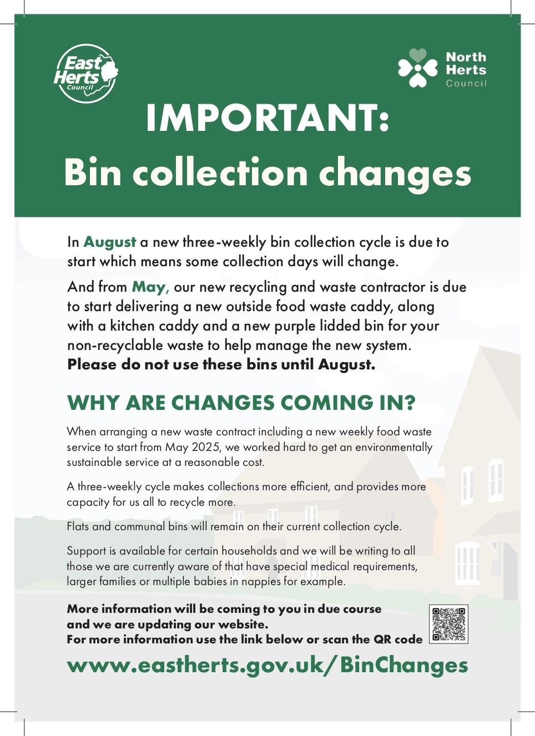
The below are are previews of a flyer to be distributed with this year's Council Tax bill.

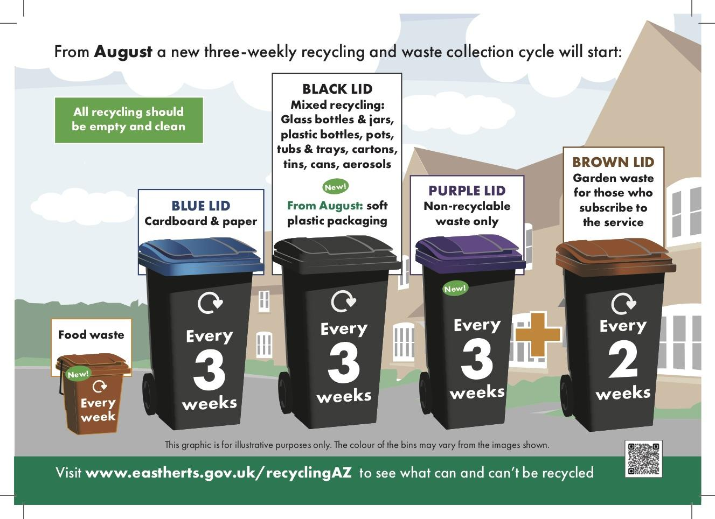
++++++++++++++++++++++++++++++++
E Buckmaster County Councillor Report March 2025
Some Planned Highways works Eastwick and Gilson and High Wych
West Road | Sawbridgeworth | Carriageway Resurfacing - Micro | Framework | Ordered
High Wych Lane | High Wych | Carriageway Resurfacing – Micro (including Gully Emptying / Jetting as part of Prep Works | Framework | Ordered

The following will be approved at cabinet on 17th March
Eastwick Hall Lane Local Carriageway Reconstruction 24 Eastwick 3U875/10 Eastwick Hall Lane A414 Eastwick Road To Eastwick Hall Farm NCM250245-1 CRC Apr25 - Mar26 - -
Pye Corner Local Carriageway Reconstruction 24 Gilston C161/8 Pye Corner 30mph Signs To Derestriction Signs CWY250189-1 CRC Apr25 - Mar26 - -
A414 Eastwick Road Carriageway Surface Dressing 24 Stanstead Abbotts A414/836 Eastwick Road C15 Church Lane to start of Roydon Road Slip ARP240002-2 ASD Qtr-1 - -
A414 Eastwick Road Carriageway Surface Dressing 24 Eastwick A414/846 Eastwick Road U875 Eastwick Hall Lane to C15 Church Lane ARP240002-2 ASD Qtr-1 - -
A414Eastwick Road Carriageway Surface Dressing 24 Eastwick A414/856 Eastwick Road Eastwick Lodge roundabout westwards to Eastwick Hall Lane ARP240002-2 ASD Qtr-1 - -

£5,814,232 of additional funding to support active travel initiatives across Hertfordshire has been allocated by government and Active Travel England (ATE).
The funding will enable the development and delivery of local walking, wheeling, and cycling schemes, alongside community engagement initiatives. This supports the objectives in our Corporate Plan and a number of key policy areas including transport the environment, public health and the economy. Making it easier and safer to walk, wheel and cycle can help to improve health, improve air quality, support the local economy and manage traffic congestion on the road network. The funding comes as part of a nearly £300 million national initiative to enhance walking, wheeling, and cycling infrastructure across England.
Secondary school places announced for 2025
94 per cent of children have been allocated a place at one of their preferred secondary or upper schools by Hertfordshire County Council. Of the 14,703 Hertfordshire children who applied this year, 76 per cent gained a place at their first preference school.
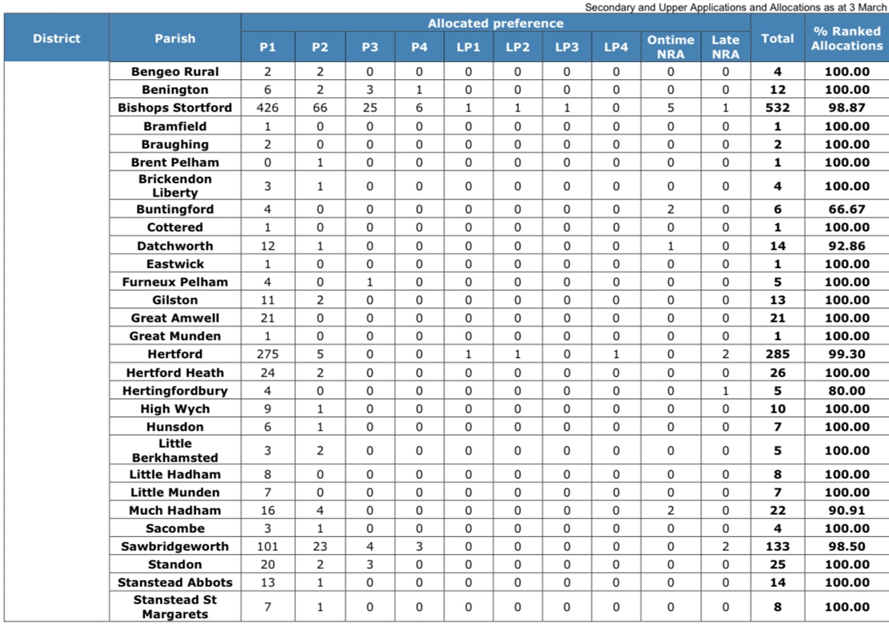
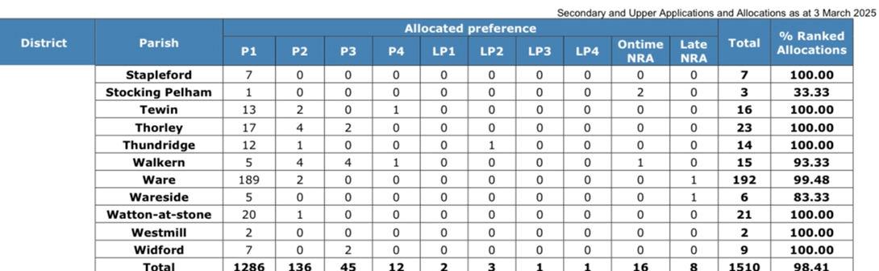

My Locality Grant applications for past year
Council tax to increase 4.99 per cent as over £1bn to be spent on public services
At a full meeting of Hertfordshire County Council on Tuesday 25 February 2025 councillors have agreed a budget for 2025/26 of just over £1bn. The agreed Integrated Plan will see Council Tax increase by 4.99 per cent in April, which equates to a £1.62 increase per week for a typical Band D property.
The difficult decision to increase Council Tax was taken as the council’s costs will rise over the next twelve months if inflation continues its upward trend and the imposition of higher employer National Insurance contributions.
Agreed as part of the 2025/26 budget, investment in services includes:
- Nearly half a billion pounds will be spent supporting 30,000 adults to live well for longer, including £30 million investment to support those providing care, ensuring that caring staff receive a living wage and to offset the increased National Insurance costs.
- £26m of additional investment will be spent to ensure that the council can meet the expected increase in demand from older adults requiring care.
- Just over quarter of a billion pounds will be spent on children’s services, including £28m of additional investment to ensure we can continue to support Children Looked After and children with disabilities. A further £2.8m of funding on top of the previous £7m investment will be made towards our SEND improvement programme ‘Making SEND Everyone’s Business’.
- £100m will be spent on highways maintenance, allowing the council to repair and improve our roads and keep the county moving.
- Funding will be made available to improve flood protection and investigations.
Mindful of the need to keep the burden on taxpayers to a minimum, the council will continue to drive down internal costs by £42m next year with £16m of savings delivered by the ongoing Organisational Resourcing programme.
Help for families to have fun in Hertfordshire
Families whose children are eligible for free school meals are now able to claim discounts in shops, sports clubs and children’s activities with a new Herts Card. They can also book their free school holiday activity HAPpy camps, from 13 March, when bookings open.
The Herts Card is designed to give discounts to children and young people, for lots of activities and days out that they might not be able to access otherwise. Local wildlife parks, football clubs and holiday activity camps are already part of the scheme, offering discounts to Hertfordshire’s families who might benefit from additional support.
The idea for the card builds on the success of the HAND card, which was used by young people and families of children with special educational needs and disabilities (SEND) to gain exclusive access and discount prices to events and activities in Hertfordshire.
Now families who are eligible for free school meals can also take advantage of pre-negotiated discounts with local businesses and activity providers. Families of children and young people with SEND who have an existing HAND card can download the new version of the Herts Card and continue to enjoy all of the discounts they previously accessed, and more.
It's easy for eligible families to get their new Herts Card; those already in receipt of free school meals will be contacted by the council with a link to sign up to the card. Anyone newly signing up for free school meals will also be sent a link to get their card.
The council has made it easy for local businesses and organisations to register their discounts and help make sure children do not miss out due to financial stress. Local businesses can email: hertscard@hertfordshire.gov.uk and include details of what they’re able to offer.
HAPpy camps
HAPpy activity camps are returning this Easter, providing eligible children and young people with the chance to meet friends, learn new skills and enjoy nutritious food during the Easter break.
The HAPpy programme is funded by Hertfordshire County Council and the Department of Education (DfE) via the government’s Holiday Activity and Food programme and coordinated by Herts Sport and Activity Partnership and the Hertfordshire Community Foundation.
Children and young people who are in school years Reception to Year 11, who attend a Hertfordshire school and are in receipt of benefits related free school meals can attend the HAPpy Easter camps. Eligible families should already have been given their booking code from their school. Parents/carers who have not received the code should contact their school office.
Every camp is inclusive and able to meet the needs of most children and young people with special educational needs and disabilities (SEND), provided the right information is supplied with their booking. There are also SEND-specific camps which are better for children with higher support needs.
Bookings open at 12pm on Thursday 13 March. For further details of the programme, the camps available and to book places visit: HAPpy Activity Camps
Families eligible for free school meals will also be given supermarket vouchers for during the Easter holiday by their school.
Hertfordshire County Council approves project to create 820 new supported living homes:
Plans to create 820 ensuite bedrooms for working age adults with care and support needs were approved by Hertfordshire County Council’s Cabinet on 24 February, following discussion at the Adult Care, Health and Wellbeing Cabinet Panel on 29 January and Resources & Performance Cabinet Panel on 14 February.
Over the next five years the county council will work with registered housing providers to deliver new homes and redevelop existing supported living units for people with a learning disability. The programme will create 820 homes in the form of ensuite bedrooms in self-contained flats or shared living for individuals currently in supported living and those who could move into supported living.
The proposal will increase the supply and quality of affordable supported living homes in Hertfordshire, and in doing so will improve the health and wellbeing of those impacted by the scheme, as well as deliver savings for the county council.
The programme is estimated to cost over £400m, including a contribution of £47.7m from the county council’s existing adult care capital budget, as well as investment from Homes England and registered housing providers.
The Environment
New 2024 Air Quality Status Report reveals lower pollution levels in Stortford and Sawbridgeworth
As reported by Bishops Stortford Independent, air quality in Bishop’s Stortford and the rest of East Herts has improved, according to a new report. Pollution at trouble spots in Sawbridgeworth, Hertford and in the town decreased with just one recorded nitrogen dioxide (NO₂) breach in London Road. The newly published 2024 Air Quality Status Report is based on the most up-to-date, full-year validated statistics from 2023 and attributes improvements to factors including greener vehicles, more flexible working patterns and targeted local policies.
At Ware recycling centre we have been routinely assisting a multi-agency operation called Agrarian. Police, EA and other authorised parties have used the upper shunt area of the recycling centre to carry out checks on vehicles travelling along Westmill Road.
24/02/2025
115 Cars stopped.
1 x Arrest for drug driving.
Traffic papers issued for No Seatbelt and use of a mobile phone.
Male dealt with for possession of cannabis.
Vehicle seized for No Insurance.
10/12/2024
100 Cars stopped.
Vehicle seized for No Insurance.
Traffic papers issued for a bald tyre, expired MOT.
Words of advice given regarding correct waste licencing.
Words of advice given regarding safe loads.
19/07/2024
80 Cars stopped
2 x Vehicles were seized for No Insurance.
8 x Traffic papers issued for various offences.
3 x Vehicle Defect Rectification Scheme notices were issued.
36 x Vehicles were checked for red diesel
The electric bus journey starts here
(5 March), local bus company Uno, owned by the University of Hertfordshire, officially launched the first five of its zero-emission electric buses on its newly branded Electric Shuttle. The five buses, which will run on the route between campuses at the University of Hertfordshire and the site’s park and ride, are the first of 27 being delivered over the next 12 months. A special launch event was held at the University to mark the start of a journey that is set to transform public transport across the region.
The investment, being delivered under the Zero Emission Bus Regional Areas (ZEBRA) funding scheme, is a collaboration between Hertfordshire County Council, the Department for Transport (DfT) and Uno. The joint effort is dedicated to improving air quality and reducing carbon emissions across the county.
While the primary benefit of electric power is the delivery of cleaner air, it also enhances the passenger experience with a smoother, more comfortable ride. Additionally, the buses are quieter, which not only improves the journey for customers but also reduces noise pollution in the communities they serve.

