EASTWICK AND GILSTON PARISH COUNCIL

CHAIRMAN PARISH CLERK

MARK ORSON CHRISTINE LAW

89 PYE CORNER 9 CHURCH COTTAGES

GILSTON GILSTON

NR HARLOW NR HARLOW

HERTS CM20 2RD HERTS CM20 2RH

TELEPHONE 01279 453257 TELEPHONE 01279 411646

Email: cllr.m.orson@eastwickandgilstonparish.gov.uk Email: clerk@eastwickandgilstonparish.gov.uk

The Parish Council Business Meeting of Monday 12th May 2025. Village Hall , Pye Corner, Gilston 8.00pm
PRESENT: Cllr’s Beazley, Bryant, Harvey, Marx, Cllr Eric Buckmaster (CC), Cllr John Dunlop (DC), 10 members of the public. Christine Law (Clerk) in attendance.
Cllr Buckmaster and Cllr Dunlop’s reports are attached to these minutes.
PUBLIC PARTICIPALTION
This item was chaired by Cllr Marx as Cllr Bryant declared an interest in the matter.
- The landowner of the triangle piece of land, land registry ref 39178645, off Gilston Lane attended the meeting to inform and reassure the Parish Council and residents of his intention to submit a planning application for residential use.
Cllr Marx thanked the landowner for coming to the meeting and updating us on this matter.
- It was asked what has happened to the suggestion from a group of residents that the Parish Council buy this plot of land. The meeting was reminded the residents concerned were asked to put together a proposal to present to the council. The following is from May 2024 Parish Council minutes:
It was asked if the Parish Council could assist funding purchase of this land. The Parish Council would need a comprehensive proposal to be submitted to consider this possibility and given the possible scale of the expenditure would require a parish referendum to reach a conclusion.
The meeting is now chaired by Cllr Bryant.
- A resident enquired when the tyres on footpath 28 were going to be replaced as it was thought that a grant was being applied for to replace an old gate located near Church Cottages. The tyres have been positioned on private land as obstacles to prevent motor vehicles entering that section of footpath 28, with full permission from N. Maddex, Herts County Council RoW Officer, and Gilston Park House Management Company, to reduce the risk of further fly tipping. The Parish Council was not involved with the sourcing of the tyres and is not aware of any grants available for private landowners.
- Concerns were raised about the speed barriers in front of The Plume of Feathers as they are in need of replacement. Cllr Buckmaster said that he would look into this matter.
- It was reported to the meeting that some residents in Terlings Park are concerned about the noise of speeding / racing cars that can be heard at times from Harlow. It was suggested concerned residents could raise this with Essex Police or Harlow’s MP.

BUSINESS MEETING STARTED AT 8.15PM
1)APOLOGIES FOR ABSENCE
Cllr Orson & John Dunlop (EHDC).

2)RECEIVE COUNCILLOR’S DECLARATION OF INTERESTS
- Cllr Bryant.
3)MINUTES FOR APPROVAL
a. The minutes of 10th March 2025 were proposed by Cllr Harvey and seconded by Cllr Beazley
b. The minutes of 1st April 2025 were proposed by Cllr Bryant and seconded by Cllr Marx
Both signed by Cllr Bryant (Vice Chair) as a true record.

4) ACCOUNTS
a. Clerks report to the Council of accounts summary (appendix 1).
b. Parish Council Financial Regulations has been put back until our July meeting.
c. A funding request has been received from Terlings Park MC for two benches on the site.
This was discussed and approved a grant for £850.00. Clerk will write to the MC about this matter.
d. Investment Account – Has been put back until next meeting.
e. Gilston Village Sign – Cllr Bryant explanted next steps as included in proposal to March 2025 PC meeting. Step 1 to commence.
f. HAPTC membership £574.02 this is just for information as invoice has already been paid.
a-f proposed by Cllr Marx and seconded by Cllr Harvey agreed by all council.

5) PLANNING AND ASSOCIATED APPLICATIONS
a. Grassland, Pye Corner, Gilston – 3/23/1110/FUL – Retrospective change of use of buildings A
(Class e). B (class B8), c (Class B8), D (Class B8), E (Class B8) and F (Class E). Awaiting
decision.

b. The Old Rectory, Gilston – 3/24/0068/FUL – Installation of 100 ground mounted PV Cell Solar
Panels on the paddocks to the north of the Old Rectory. Awaiting decision.

- 2-7 Kirkpatrick Place, Gilston – 3/24/2151/FUL – This application has been withdrawn.
- 2-7 Kirkpatrick Place, Gilston – 3/25/0705/FUL – New application – replacing 6 juliet balconies with new cantilever balconies (to measurer 3.0metres wide, 1200mm deep, 1200mm high). Balconies to be grey aluminium frame and glazes to the front and sides. This was discussed at the meeting and no objections were raised. Clerk to write to Planning with these comments.
- Plume of Feathers P.H. – 3/25/0545/LBC & 3/25/0546/FUL – Proposed external hot food hut positioned in garden seating area. Parish council discussed this at our meeting and response has been sent to Planning – Awaiting decision.
- Hodgson House, Gilston – 3/25/0543/HH – Demolition of outbuilding. Erection of a single-storey rear extension with green roof and roof lights and alterations to fenestrations. Erection of a single-storey outbuilding with green roof. Awaiting decision.
- X/25/0215/CND – Discharge condition 6 (Strategic Landscape Masterpaln) attached to 3/19/1045/OUT – Land North of the Stort Valley and the A414 Gilston, Herts. Awaiting decision.
6) PARISH PATHS
Cllr Orson not at meeting but Cllr Harvey reported that she had been in contact with Nicholas Maddex
about footpath 16 where there is a damaged kissing gate. It is likely this will be removed as there are
no longer livestock in that field.

7)COMMUNITY FORUM/ NEIGHBOURHOOD DEVELOPMENT
a. Cllr Bryant report is attached as appendix 2

8)HIGHWAYS
a. Cllr Harvey verbally reported:
Eastwick Hall Lane improvements have made it safer. Further work likely but no detail yet.
Various road works happening, related to the Gilston Area development and Harlow’s STC, which disrupt local traffic.

8 b. GILSTON VILLAGE ADDITIONAL SIGN
This was discussed at the meeting (paper submitted to March 2025 meeting) and was agreed to go ahead with step 1.

9) GILSTON STAKEHOLDER LIASION GROUP (Knight Frank)
See Appendix 2

10) NEW HOMES BONUS/ INVESTMENT ACCOUNT
a. New web site: It was reported that it should work better once the current website has been migrated to it.
All councillors now have new email addresses that are being used.

11)VILLAGE HALL MANAGEMENT COMMITTEE
Cllr Harvey reported:
  - The village hall is maintaining a balance of £20,000 whilst also covering various maintenance requirements. Most recently we had to replace the projector .
  - We have no current grants.
  - Our only outstanding difficulty is that we still do not have access to the hall deeds.
This matter is being endlessly pursued and hopefully we will have them soon and the hall registered with the Land Registry.
  - We are anxious to recruit more people to help with the running of the hall as we are an aging body
of people and need fresh blood and frankly more help

12)CORRESPONDENCE
a. Cllr Buckmaster report is attached to these minutes. Eric reported that with the elections just taking place no overall group has control of the County Council.
b. Cllr Dunlop report is attached to these minutes no update given as not with us this evening.

13)ITEMS BROUGHT FORWARD AT THE DISCRETION OF THE CHAIRMAN FOR INFORMATION ONLY.
a. None.

14)ITEMS COUNCILLORS WOULD LIKE TO BE ADDED TO THE NEXT AGENDA.
a. Purchase and Planting of Spring bulbs.

15) DATE OF NEXT MEETING
a. Date of next meeting –
14th July – Council Meeting
15th September – Council Meeting
10th November – Council Meeting

Meeting closed at 9.40pm

• Appendix 2
Item 7 EHC Community Forum and Neighbourhood Development

EHC Gilston Area Community Forum Tuesday 13th May 2025, from 6:30pm
As usual, the venue is Manor of Groves, High Wych.
The Agenda includes:
from 6:30pm | Drop In Sessions | An opportunity to speak to developers and Council Officers - go along with any specific questions  you would like to ask.
From 7:00pm approx. | Master planning | Update in relation to the current position on master planning work.
 | Programme and Phasing | Places for People and Taylor Wimpey to provide outline of forthcoming actions.

The presentation will be made available at the East Herts Gilston Area Community Forum webpage
https://www.eastherts.gov.uk/planning-and-building/community-forums/gilston-area-community
forum under the 13th May 2025 tab.

We urge residents to attend these forums and, if possible, submit questions, via email, at least 10
days before to community.forum@eastherts.gov.uk
You can also ask for specific topics you want to learn more about to be included in future
meetings.

Neighbourhood Development
- Gilston Stakeholder Liaison Group
Meeting between the parish councils of Eastwick & Gilston and Hunsdon, Places for People, PfP, and East Herts Council, EHC, took place 30th April 2025.
Items discussed:
- The Strategic Landscape Master Plan, SLMP, has been submitted to EHC
The plans can be found on the EHC Planning website – X/25/0215/CND
- The Neighbourhood Planning Group, NPG, supported by Urban Silence, is reviewing the plan on behalf of the 2 parish councils and will be submitting a response later in May, in particular the corridors between the villages including:
  - Fiddlers Brook Corridor
  - Golden Brook Corridor
  - Eastwick Brook Corridor
  - and how the Strategic Transport Corridor, STC, interfaces with existing public roads which are critical access for a significant number of existing residents.
- The Village 1 Masterplan, V1MP, is nearly ready for submission. We have received a draft V1MP design code for final comments by 21st May

- Estate Management –
• The new gilston.info website, where residents can report issues, eg flytipping, issues with RoWs, etc., is up & running
• Reinstatement of Permissive Footpath E7
• Flooding along Eastwick Hall and Gilston Lanes - ongoing
• Extensive repair works to Fiddlers Brook Bridge, funded by PfP, completed.
RoW waymarker posts are being re-installed after dialogue with Nicholas Maddox, Hertfordshire
County Council.
Next meeting – July??

- Stewardship,
The Shadow Advisory Group, SAG, a S106 requirement, has agreed its membership:
Chair | Ben Stephen | Places for People
 | Helen Puddle | Places for People
 | Mark Orson | Eastwick & Gilston Parish Council
 | Janine Bryant | E&G PC ‘substitute’
 | Frank O’Shea | Hunsdon Parish Council
 | Bob Toll | H PC ‘substitute’
 | John Dunlop | East Herts Council, district councillor
 | Jenny Pierce | EHC Planning Dept observer
 | Tony Bradford | Hertfordshire County Council
 | Matthew Wood | HertsCC

Facilitated / led by Mark Patchett & Sally Anne Logan, Community Stewardship Solutions, CSS.
2 “introductory” meetings have been held, presentation and notes of 8th May meeting circulated to councillors separately by Cllr M Orson.
Next meeting 22nd May 2025.

An interesting dilemma – to establish a name for the Gilston Development Area that is relevant to the whole area that can be seen to be inclusive of existing villages and the new.
Ideas welcomed.

Village 7, Taylor Wimpey have submitted their Village 7 Master Plan, to be found by searching the EHC Planning website, X/25/0089/CND
SLMP can be found by searching X/25/0225/CND

Chairman’s Report 2024 / 25 – to be circulated separately

Judicial Review – applications for a Judicial Review of the 2 Planning Applications for the Gilston Area (Villages 1 – 6 and Village 7) have been submitted. EHC has submitted their response. No further information available. Timescale for determination unknown.

Reminder
Places for People’s gilston.info website demonstrated at the February Community Forum
The website has 3 headings:
- Current Works – a map of current and planned works in the Gilston Area.
- Report an Issue – a map where any issues, eg tree fallen across a RoW, fly tipping, etc., can be reported
- News – at the moment this simply provides an option to submit an email address to receive future updates.

Roadworks update.
Places for People gilstonparkestate website NEWS page
https://www.gilstonparkestate.com/news/enabling-works-for-gilston-underway/
Nothing new on roads since 20th December 2024

Useful websites:
Village 1 and Strategic Landscape Master Plan
https://www.gilstonparkestate.com/get-involved/
Section 106 docs Villages 1 – 6
https://publicaccess.eastherts.gov.uk/online-applications/applicationDetails.do?activeTab=documents&keyVal=PRSRKCGL00V00

Village 7 https://www.village7.co.uk
Section 106 docs Villages 7 https://publicaccess.eastherts.gov.uk/online-applications/applicationDetails.do?activeTab=documents&keyVal=PZKRYCGL05I00

East Herts Community Forums
https://www.eastherts.gov.uk/planning-and-building/community-forums/gilston-area-community-forum

E Buckmaster County Councillor Report May 2025
County Elections May 1st 2025
It is a real privilege to have been re-elected as County Councillor for Sawbridgeworth Division. Which includes the 8 parish councils of Sawbridgeworth, High Wych, Eastwick and Gilston, Hunsdon, Widford, Wareside, Stanstead Abbotts and part of St Margaret’s. It is one of 10 Divisions for East Herts but it is a large area which on District level is served by 9 District Councillors, 45 percent of the total.
These local elections were different in that now 5 main political parties contest them, as they do at national level, Labour, Conservative, Liberal Democrat, Green and Reform. It is very likely that a certain proportion of people were voting on national issues, perhaps as a protest, although many of the traditional parties were campaigning just on local matters and achievements and intentions of the candidates in delivering local services.
in the attached tables you can see the results of the local election for the Sawbridgeworth Ward along with the results for County as a whole. There are 78 councillors for Hertfordshire County Council.
The countywide table shows the number of seats won by each party and the proportion of votes. Of note is the fact that the Liberal Democrat’s in total polled a similar percentage to the Conservatives but achieved 9 more seats. Since no party achieved an absolute majority of seats the Council is now in No Overall Control. As I write the expectation is that the Liberal Democrat’s will come to an arrangement with the Green Party and Labour which will provide a slim majority of just two. Absences from Council, eg through ill health, will then prove challenging, so there will there need a good deal of cross party support to proceed with important business. This will be of great importance too as we prepare for the National Governments aim for devolution and local government reorganisation, which is intended to replace the existing two tier system of County and Districts with one or more unitary councils. Interesting and challenging times ahead.
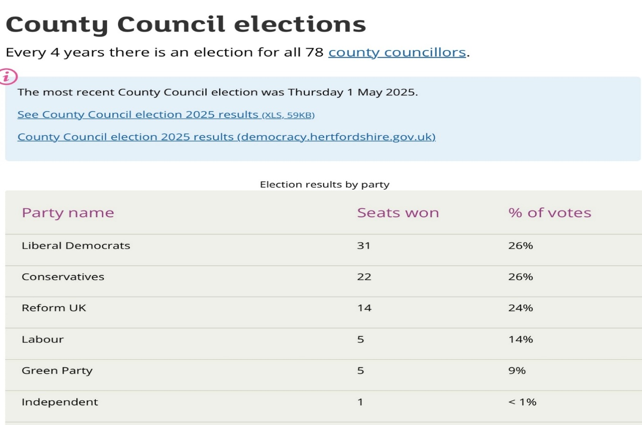
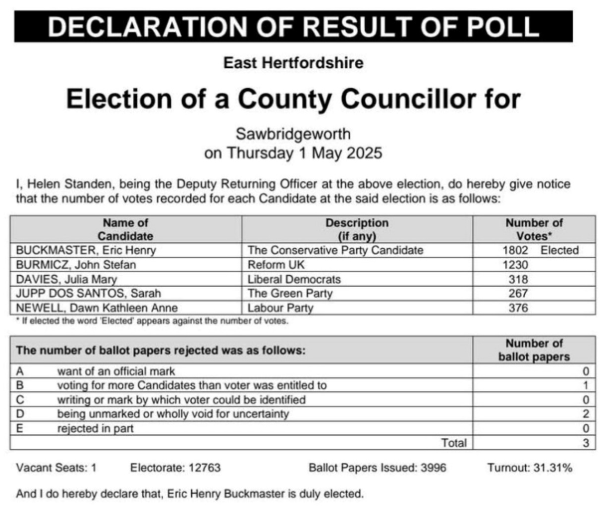
Local Nature Recovery Strategy
I have been chairing the Board for this Strategy and Plan. we are now in Pre-Consultation!
Pre-consultation is the 28 day period in which the Supporting Authorities (10 districts and Natural England) are provided with the draft LNRS and provided with an opportunity to object to Hertfordshire County Council taking this draft out to public consultation. Pre-consultation is a legal requirement that Hertfordshire County Council must fulfil. A number of Steering Groups including various agencies and Authorities across Hertfordshire worked towards bringing the plan together. Once approved by supporting authorities it will go out to public consultation.
Winter service 24/25 comes to an end - 60% more gritting than last year
Hertfordshire County Council’s highways team have drawn their winter seasonal work to an end and their fleet of 70 gritters and crews are no longer on standby for sub-zero temperatures.
The highways winter season runs from 1 October to 30 April each year and over the course of the 2024/25 winter season, gritters were out 61 times, up from 38 the year before.
These runs covered nearly 150,000 km, the equivalent of travelling three-and-a-half times around the Earth, and over a third of those runs were in just 13 days, at the start of January, during this winter’s most severe cold snap.
Over the course of the season, more than 15,000 tonnes of salt was used on Hertfordshire’s roads, and just under 100 new salt bins were added to the road network, which means we now have approximately 1,500 located across the county.
Our teams processed nearly 300 Winter Self-Help salt orders, providing salt for community organisations to grit their own area, this included almost 200 schools.
Over 400 residents took part in our social media competition to name our first electric gritter. The winner ‘Claudia Sprinklevan’ has been out on all 61 runs this year and has proven to be as reliable as the rest of our gritters at a fraction of the carbon output.
This vehicle is known as an Electric Quick-Change Body (EQCB) with a gritter, tipper, and cage body, which means that out of winter season, you will still see Claudia out and about on general highways maintenance duties.
Subsidence of Highway Officers will be touring East with one of the Geotech experts, looking at a number of sites where ditches have started to encroach and undermine the carriageway. This tour will be including the one at St Georges Cottages at Babbs Green.
The whole idea is to get a more educated idea on how these can be fixed easily, rather than take a more prolonged investigative route which would only inconvenience the local population. Obviously, each site will have its own issues, but it’s a starting point.
Reminder
Minerals and Waste update
HCC Minerals and Waste Local Plan
- The March 2025 Forward Plan contains an item for the Minerals and Waste Local Plan to be taken to Sustainable Economic Growth Panel on 11 July, and Cabinet/Council on 21/22 July.
- The item will seek approval to publish a Regulation 19 Plan for formal consultation, and to subsequently submit the Plan to the Planning Inspectorate with a view to hosting an Examination in Hearing to consider whether the Plan can be adopted as a Development Plan Document.
- To accompany this, there would be an update to the Minerals and Waste Development Scheme, a statutory requirement setting out the timeframe for Plan production/adoption.
A013/25 Minerals and Waste Local Plan Proposed Submission (Regulation 19) Publication for Formal Representations; Subsequent Submission to the Secretary of State; and Publication of a revised Minerals and Waste Development Scheme Cabinet 21/07/2025 Council 22/07/2025 Sustainable Economic Growth Christopher Stanek 01992 658398 Report of the Executive Director of Growth & Environment
Artistic collaboration creates showpiece for new foster carer recruitment campaign
Children in Hertfordshire are using textile art to share their foster care experiences, kicking off a community quilt project as part of Hertfordshire County Council's new campaign to recruit more foster carers.
The campaign, called HELP, aims to amplify the voices of children and young people in foster care, inspiring more people in Hertfordshire to consider this rewarding role. The HELP campaign also seeks to spread the word about the positive impact foster caring can have on the lives of children who can't live with their birth parents.
Hertfordshire County Council has teamed up with local textile artist Connie Deans-Harding, from Maker & Mind, as part of the HELP campaign. Connie is providing therapeutic art experiences for children in the council's care, helping them express their feelings about foster care through art.
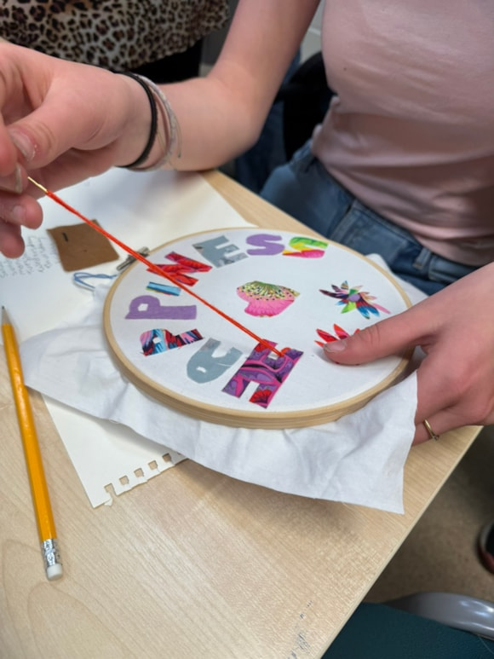
Eric Buckmaster County Councillor Report May 2025
+++++++++++++++++++++++++++++++++++++++++++++

Eastwick and Gilston Parish Council - District Councillor report for 14th April meeting

Cllr. John Dunlop

- Gilston Park Estate
A Judicial Review has been received.
There are multiple steps which can be gone through starting with a gathering of evidence and a judge determining if there is a case.
It is unclear how long this will last but 9-12 months would not be unreasonable. At the Community Forum Helen Puddle of PfP seemed to be relaxed about the outcome, saying that they would continue with works. It awaits one of the 2 ½ judges in the country to review the evidence.

The SLMP has been published on the Planning Portal as condition X/25/0215/CND and Village 7 Master Plan as X/25/0089/CND. They can be found using the simple search on the East Herts planning portal -
https://publicaccess.eastherts.gov.uk/online-applications/applicationDetails.do?activeTab=documents&keyVal=PRSRKCGL00V00

It is anticipated, although not decided when, that there will be a Master Planning Forum for each of the Gilston Master Plans allowing the local community, Council officers and developers to have an open presentation and discussion.

- Devolution update
The White Paper on the East Herts position on Devolution will come to Exec on Tuesday night 18th March.
The timetable is:
- 5 Feb 2025 Statutory invitation received from the government to submit local government reorganisation proposals.
- 21 Mar 2025 Submit interim Local Government Reorganisation proposal.
- 1 May 2025 Hertfordshire County Council Elections.
- 28 Nov 2025 Submit full Local Government Reorganisation Proposal
- Proposed May 2027 Elections (Shadow authorities)
- Proposed Apr 2028 Vesting day for new unitary councils

The current position of councils in Hertfordshire can be summarised as follows:
- The County Council has set out the case for a single county unitary authority for Hertfordshire. Nine out of the ten District and Borough Councils do not support this proposal.
- All Councils have agreed that there is a single viable proposal for two unitary authorities and agreed that further work should be undertaken on this option.
- All Councils have agreed that further work should be undertaken on three and four unitary models and have identified three representative options for further analysis.
- All Councils have collaborated on an exercise to assess the value for money and financial resilience of this range of unitary authority options.
- The District and Borough Councils have undertaken a detailed appraisal of two, three and four unitary authority options, and with the County Council are engaged in further assessment of these models.

The proposal is available at https://democracy.eastherts.gov.uk/documents/s68933/Appendix%20-%20Hertfordshires%20proposed%20response.pdf?J=1

I noted a paragraph in the report
which will be interesting to see the answer - Recognising the Government’s desire to see stronger community arrangements when reorganisation happens, we will also work with the county’s town and parish councils to explore what elements of service delivery and influence could be devolved to ensure they are responsive to local need.

The proposal has been submitted and we now await feedback. expected in April and anticipates that public consultation will happen later in the year. UPDATE: from 9th May onwards, probably the following week.

- District Plan and East Herts Vision Report
The District Plan hasn’t started because of the Government's delayed secondary legislation from Sept 24 to late Spring/Summer 2025. Two pieces of public preparation work are being undertaken, the Call for Sites and Visioning. It is intended to carry out some engagement on the Visioning around Spring of this year which would be a public consultation.
The Vision Report is available at -
https://democracy.eastherts.gov.uk/documents/s68716/Appendix%20A%20-%20East%20Herts%20Strategic%20Vision.pdf?J=4

At the Exec meeting on 18th March it was agreed that:

a) The East Herts Strategic Vision is made available to stakeholders and the wider community to begin a discussion about the new District Plan, and to seek comments on the Vision;
b) Engagement on the Strategic Vision should commence, and take the form of a six week period of activity during Spring / Summer 2025 through a range of different forums, including online and in-person; and
c) A further report detailing any feedback is prepared following engagement to agree a final version of the Strategic Vision, and to set out the next stages of plan-making.

- Out of Hours Emergencies
Please note that out of hours cover is being reviewed and further information will be provided once that review is complete. In the mean time, the following telephone numbers should only be used in an emergency:
- For serious incidents that require the police, fire service or an ambulance please call 999.
- Housing repairs including drainage matters, please contact your landlord.
- Thames Water and public sewers please ring 0800 714 614.
- Highways emergencies: If the highway fault poses an immediate threat to life or limb, please call the Police. Otherwise please report a fault on the road or pavement on the Hertfordshire County Council website.
- Adult Care Services ring 0300 123 4042
- Children Schools and Families ring 0300 123 4043
- For Environmental Health emergencies such as a serious accident at work or noise affecting more than one household please telephone 01279 655261 outside normal office hours (Monday - Friday 08:30 - 17:00). To report a noise directly affecting a single household (which is not already being investigated by the Council) please telephone during office hours when we will be pleased to discuss the complaint with you. Alternatively you can email enquiries@eastherts.gov.uk
- In an emergency homeless situation, you should contact 01279 655261 and an answer phone message will direct you to the emergency out of hours service for housing assistance.
- Waste, Recycling and Street Cleansing Contract
The Shared Waste Service confirmed that the waste, recycling and street cleansing contract was signed and completed on the 2nd May. As I’m sure you are aware, with operational services continuing FCC undertook a swift demobilisation from the depots and Veolia took the keys on 4th May to bring in vehicles ready for operations. Street cleansing was undertaken by Veolia from 4th May and collection operations began on 6th May following the bank holiday.
New containers for East Herts:
An FAQs we will be loaded onto the council’s website in anticipation of deliveries starting in East Herts, which we anticipate being early June. We will have had the benefit of learning from deliveries in North Herts so will be able to cover most issues that have cropped up.

We do not yet have details of where deliveries will start, but will publish once confirmed. Residents will receive two stickers to assist them in identifying the change of use of the bins which starts in August.

Full details are at: https://www.eastherts.gov.uk/bins-waste-and-recycling/bin-collection-changes
Along with FAQs at: https://www.eastherts.gov.uk/bins-waste-and-recycling/bin-collection-changes/faqs-bin-collection-changes

- East Herts Strategic Vision report
This is available at: https://democracy.eastherts.gov.uk/documents/s69319/East%20Herts%20Final%20Vision%20Report_V.6%20-%20New%20Version.pdf?J=5
A public consultation will start towards the end of 2025. It will form a key part of the revised District plan.

