EASTWICK AND GILSTON PARISH COUNCIL

CHAIRMAN PARISH CLERK

MARK ORSON CHRISTINE LAW

89 PYE CORNER 9 CHURCH COTTAGES

GILSTON GILSTON

NR HARLOW NR HARLOW

HERTS CM20 2RD HERTS CM20 2RH

TELEPHONE 01279 453257 TELEPHONE 01279 411646

Email: cllr.m.orson@eastwickandgilstonparish.gov.uk Email: clerk@eastwickandgilstonparish.gov.uk

EASTWICK AND GILSTON PARISH COUNCIL ANNUAL MEETING

Parish Council meeting of Monday 12th May 2025 at 8.00pm, Village Hall, Pye Corner

PRESENT: Cllrs Beazley, Bryant, Harvey, Marx,

In attendance: Christine Law (Parish Clerk), Eric Buckmaster (CC), 9 members of the public.

ANNUAL MEETING STARTED AT 8.00PM

AGENDA

- TO RECEIVE APOLOGIES FOR ABSENCE:
  - Cllr Orson, John Dunlop (DC).

- OUTGOING CHAIRMAN’S ANNUAL REPORT FOR 2024-25

Cllr Orson annual report was presented to the meeting in his absence. The full report can be found in the July edition of the parish magazine and parish web site and the Parish Council’s Annual Report.

Election of Chairman - Cllr Mark Orson was proposed by Cllr Bryant and seconded by Cllr Marx. Cllr Orson had accepted this post via email.

To receive the Declaration of Acceptance of Office from the Chairman – This will be on the agenda of our July meeting for Cllr Orson to accept.

Election of Vice Chairman – Cllr Janine Bryant was proposed by Cllr Orson via email and seconded by Cllr Beazley. Cllr Bryant accepted the post.

2024-2025 ACCOUNTS
  - Cllr Bryant presented the 2024-25 Receipt and Payment accounts (Appendix 2).
  - Annual Governance Statement 2024/2025.(Appendix 3).
  - Accounting Statements for the year ended 31 March 2025. (Appendix 4).
This were proposed by Cllr Bryant and seconded by Cllr Marx and accepted by full council.

- NEIGHBOURHOOD PLANNING GROUP ANNUAL REPORT
Annual report is attached to these minutes and also can be found on the web site and Parish Council’s Annual Report. (Appendix 5)

Meeting closed at 8.15pm.

Appendix 1
CHAIRMAN’S REPORT 2024/25

The purpose of this report is to give a summary of what the Parish Council has been doing during the last year and to comment on the major issues that we are facing as a parish. There is more information available on our community website at www.eastwickandgilston.org.uk and our Neighbourhood Plan website at www.hegnp.org.uk.

During the year, the Parish Council has held six Parish Council meetings and an Annual Parish meeting. Individual Parish Councillors took the following responsibilities.
Mark Orson – Chairman - Neighbourhood Plan Group representative and Parish Paths
Janine Bryant – Vice Chair - Neighbourhood Plan Group representative
Linda Harvey – Highways and Village Hall Management Committee representative
Werner Marx
James Beazley
Christine Law – Parish Clerk

Jim Jones and Rob Wightwick both long standing councillors left the parish council during last year and I would like to thank them for their valuable contributions.

James Beazley was co-opted as Parish Councillor in January. We now have two parish councillor vacancies and if you are interested in joining the parish council or at this stage would just like to find out more, please contact Christine Law our Parish Clerk or come along to the Parish Council meetings to see and meet your councillors

District Plan and Neighbourhood Development
The Parish Council has channelled our engagement with East Herts Council [EHC], Places for People [PfP], the primary landowner for Villages 1-6 and Taylor Wimpey [TW] who are the landowners of Village 7, through the Hunsdon and Eastwick & Gilston Neighbourhood Plan Group [HEGNP] chaired by Anthony Bickmore. Anthony makes an annual report to the Parish Council that provides an update and comment on all the issues and is published in the Parish Magazine, the community website www.eastwickandgilston.org.uk and the HEGNP website www.hegnp.org.uk.

The role of the HEGNPG is to:
- Jointly represent Hunsdon and Eastwick & Gilston Parish Councils, and.
- Give a voice for residents, holding developers accountable for promises to deliver a sustainable, high-quality development.
- Aims to oversee and shape the Gilston Area development to ensure it aligns with community hopes, values and future needs.
- Seeks to coordinate engagement between the developers and local authorities, especially East Herts Council.
- Is involved in reviewing planning applications for the proposed villages.
- Advocates for high standards in urban design, proper and timely infrastructure, environmental responsibility and community-focused planning.
- Continues to press for better interface with the existing communities, sustainable transport solutions, and “village master planning” principles.
- Actively monitor the agreements related to infrastructure, affordable housing, and the long-term governance of community assets.
The Parish Council is very keen for residents to be involved in HEGNPG activities - if you are interested or just want to find out more, please contact Christine Law, Parish Clerk in the first instance - clerk@eastwickandgilstonparish.gov.uk.
I would like to take this opportunity to thank Anthony and the HEGNP team for their hard work and diligence. They are all unpaid and contribute massive amounts of time.
PfP is establishing a new liaison group to meet regularly to discuss progress on the project as well as estate management and enabling works. The aim is for the group to meet three/four times a year with the first meeting scheduled for 30 April 2025. The invitation for attendees includes Places for People, East Herts District Council ward member, Hertfordshire County Council division member, Eastwick & Gilston Parish Council, Hunsdon Parish Council, Harlow Council, Member of Parliament for Hertford & Stortford, Member of Parliament for Harlow.
PfP and TW will create a new stewardship and legacy organisation prior to first occupation of the new development to own and manage all the public facilities which will ensure they are fully maintained in perpetuity. This organisation will be created as a charitable trust and will use those facilities to help build a sense of community by hosting events, activities, and encourage new community groups.
A presentation was made by PfP’s appointed consultants Community Stewardship Solutions (CSS) to explain the process and organisation for establishing the charitable trust at the 27 March 2025 Community Forum. Their presentation can be viewed at http://www.eastherts.gov.uk/planning-and-building/community-forums/gilston-area-community-forum
CSS will write the business plan and supplementary documents on behalf of the developers. As part of the overall process a Shadow Advisory Group [SAG] has been established whose members role is to input to, assess, critique and comment on the draft Outline and Detailed Business Plan that will include.
- Strategic vision, principles and objectives
- Governance, roles and responsibilities
- Finance
- Resourcing
- Branding, marketing and communications
- Community wellbeing and development
- Community asset development and design
The Parish Council is represented on the SAG by Mark Orson and his alternate Janine Bryant with other stakeholders; the Outline and Detailed Business Plan is scheduled to be completed in July 2025.
Community Forums
EHC has established quarterly Community Forums as a channel of communication for residents and the Parish Councils that represent them with EHC and the Gilston Area developers PfP / TW. These have become useful sessions for residents to be briefed on key aspects of the development progress and to ask questions. The Community Forums should be supported, not least as residents of Eastwick and Gilston will be living in the middle of construction work for the next 15-20 years plus with the associated risk of disruption to our daily lives and these meetings provide the opportunity for residents to directly raise any concerns and to better understand the developers plans and timing of changes.

Estate Communications Website
PfP has recently launched a new website to allow updates to be provided to residents about work being undertaken across the estate. At the same time, it will make reporting an issue or asking a question much easier through the pin-drop system. This generates an accurate What3Words reference which will speed up the time taken to identify the location of the issue. The new estate and construction comms website can be found at www.gilston.info.

How to report an issue:
- You can drop a pin on the location of the issue and provide a description of what you would like to report. Villages 1-6 are transparent in colour, whilst Village 7 (Taylor Wimpey) has been shaded yellow to differentiate the two sites. This will be your opportunity to flag issues without worrying if the land belongs to PfP or TW.
- New pins will be marked as red and will be passed onto the corresponding team.
- Issues that are in progress and are being investigated by the team will be marked in orange.
- Once the team has resolved the issue, this will be marked as green.

The website functions will evolve over time. If you have any suggested improvements or features you would like to see added, please email gilston@meeting-place.uk.

Planning
We have had several planning applications to comment on during the year and most have been reasonably straightforward and non-contentious changes to existing properties. The major planning issues affecting our area are addressed by our Neighbourhood Plan Group that is mandated and sponsored by this Parish Council. Please see the HEGNP website www.hegnp.org.uk and Anthony Bickmore’s Chairman’s Report for a full update on the status and issues.

Highways
We continue to work closely with Highways to ensure that Highway’s maintenance activities are carried out effectively and meet our local needs. As with all local services Highways work is governed by budget and availability of resources and getting work carried out in a timely manner can sometimes be a struggle. A status report on all current Highways issues is made at each parish council meeting and published in our parish magazine and community website.

It is important that potholes and other damage to our local roads are reported as soon as possible. There is an easy-to-use pro-forma at hertfordshire.gov.uk Report a street light or pothole | Hertfordshire County Council. Please also inform Christine Law so that the Parish Council can include this information in the Highways issue status report that we use for overall monitoring and review with Highways.

Parish Paths
The parish footpath network is a real asset. Copies of the parish paths brochure/map are available from St Mary’s Church porch or Christine Law, our Parish Clerk. You will also find several display maps of the footpath network located around the parishes including both the Eastwick and Gilston War Memorial sites.

If you are aware of any parts of our footpath network that need maintenance including overgrown vegetation or fallen trees, please inform Christine Law our parish clerk and we will follow up with HCC Countryside & Rights of Way. Issues can also be recorded on PfP’s new estate and construction comms website at www.gilston.info.

New Homes Bonus
In previous years, the parish has received what amounts to windfall payments from the New Homes Bonus scheme. The New Homes Bonus is a government scheme which is aimed at encouraging local authorities to grant planning permissions for the building of new homes in return for additional revenue. Under the scheme, the Government matches the council tax raised on each new home built for a period of 6 years. The parish council has received a proportion of this funding totalling around £220,000 which is invested through Churches, Charities and Local Authorities (CCLA) Investment Management Limited, see www.ccla.co.uk. EHC has since changed arrangements for distributing the New Homes Bonus monies which are now held by them in a central pot and Parish Councils can apply for funding for specific projects that are individually assessed before funding is granted.
The investment income from the received New Homes Bonus capital is being used to pay for additional items that are not included in our parish precept funding. For example, regular maintenance of the 4 defibrillators located strategically around the Parishes and the extensive aerial photography of the Parishes.
We welcome suggestions and ideas for how this money could be spent for the benefit of the community but are excluding any items that should be paid from District or County Council budgets. We will provide updates as matters progress via the parish magazine and website but if you have any ideas and suggestions for how this money should best be spent, please contact Christine Law, Parish Clerk, on 411646 or email clerk@eastwickandgilstonparish.gov.uk.
Aerial Photography
The Parish Council used New Homes Bonus monies to fund a comprehensive set of aerial photographs of the Eastwick & Gilston Parish in Spring 2023. The purpose was four-fold:
- To capture the Parish as it looks in 2023 as close as possible to the Coronation of King Charles III and prior to the commencement of development activity. This was an outstanding opportunity to capture this point in history and the efforts made by resident to make the Parish look it’s best with flags flying.
- To provide a valuable resource / reference tool for use by the Parish Council, Village Hall Committee, HEGNPG and other community groups to support discussions in meetings and aid other activities.
- For use in publications, including the newsletters and other collateral produced by the various groups.
- For display purposes in the Village Hall and community website.
This included some 360-degree images taken in the following locations across the parish:
- Terlings Park
- Pye Corner
- Eastwick
- Gilston Park Estate
- Gilston (St Mary’s Church)

These photographs are available on our community website at Photo Gallery | Eastwick & Gilston Parish Council in Hertfordshire for residents to view and download in high resolution.

Parish Precept
You will have recently received the booklet from East Herts Council outlining your Council Tax payments for 2024/25. Part of the Council Tax is made up of the Parish Precept which is set by the Parish Council to cover small running costs and several initiatives we undertake. The amount attaching to your Council Tax for the parish is a function of what we spend and the number of properties and their valuation bands in the area.

We have reduced our parish precept for 2025/26 as we have not needed to contribute to funding of the HEGNPG that has sufficient reserves to meet currently planned future expenditure. If you have views on how we should spend our money and if we should spend more or less, then let one of the Parish Councillors know or attend a Parish Council meeting. We are always keen to hear views and enjoy the interaction with members of the public at the meetings – all are welcome.

Conclusion
Overall, planning matters and engagement with the Gilston Area developers, PfP the landowners for villages 1-6, TW, the landowner of village 7 and EHC our planning authority have been the parish council’s majority activities this year, other parish council matters that have been relatively quiet.

As noted, we now have two parish councillor vacancies and if you are interested in joining the parish council or at this stage would just like to find out more, please contact Christine Law our Parish Clerk

I would like to thank our District Councillor John Dunlop and Eric Buckmaster, our County Councillor, for their continued help and support.

We are fortunate to have a dedicated and hardworking team of Parish Councillors. They devote a lot of their time for the benefit of the community which is unpaid, and they claim no expenses. Thanks also to Christine Law, our Parish Clerk.

Mark Orson

Appendix 5

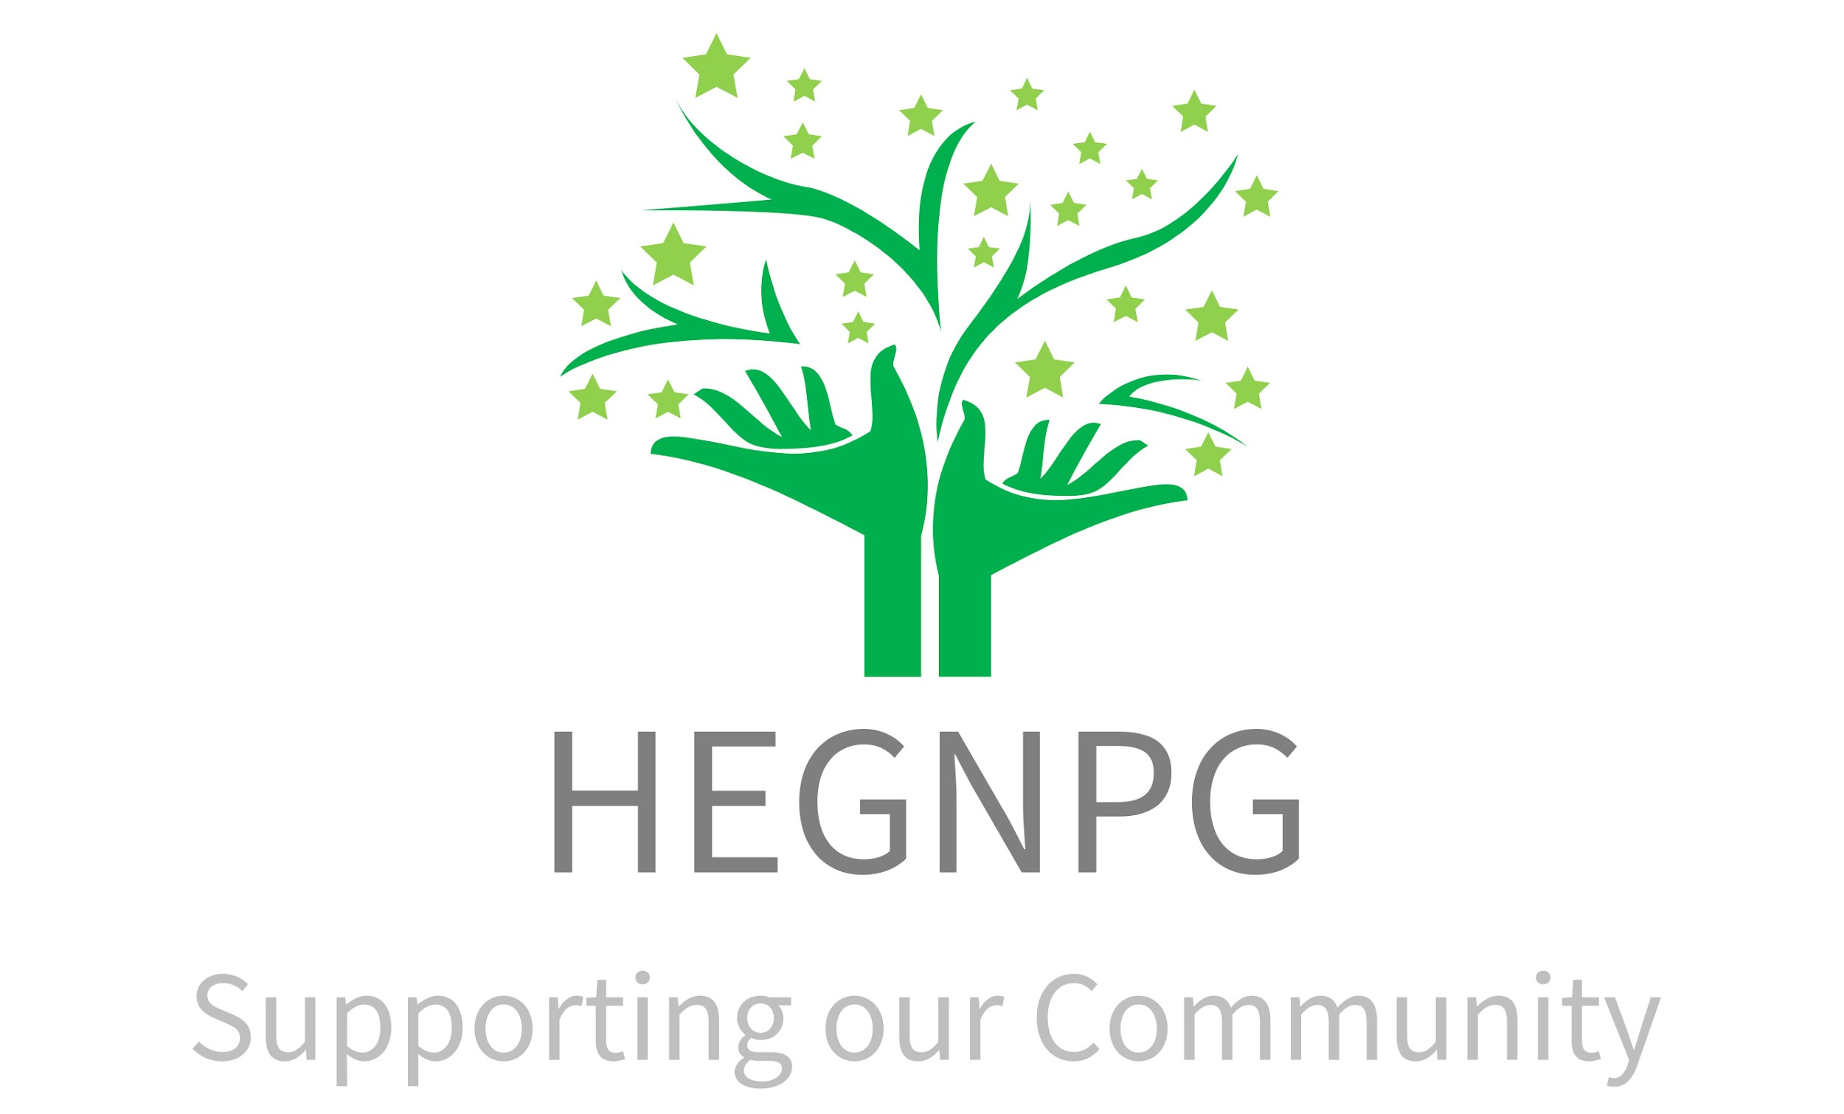
Hunsdon Eastwick and Gilston Neighbourhood Plan Group
℅ Channocks Farm
Gilston
Nr Harlow
CM202RL
https://hegnp.org.uk/

Annual report to Sponsor Parish Councils

1 Introduction

We are pleased to present our annual report and in doing so to thank you as our sponsors for your support for our work, especially your ongoing financial support and collaborative working.

It’s been a year of big decisions made by key players –

The Neighbourhood Plan Group (NPG) has worked with all stakeholders, including local authorities and the media, to best represent and protect the interests of the local communities and Parish Councils, and has commissioned professional support, where necessary, to help achieve this goal.

We continue to work to ensure that proper regard is given to our Neighbourhood Plan at all key phases of development, including the creation of a strategic landscape master plan and village masterplanning, and the creation of bodies and processes for the long term stewardship of the Gilston Area.

It’s been a crucial year with regards to the future of our community, and I am grateful for the staggering amounts of time committed by the members of the NPG, including many who also hold Parish Council or other posts in our community, so are putting in lots of volunteer time to support local residents.

2 Financial

The NPG opened the financial year with a cash balance of £51,880.27 and closed the year with a balance of: £48,828.41, with a suitable closing balance we did not seek further income in the year.

Our expenditure for the year was £3,375.86

£2,100 was spent on consultancy, with the following work done:

- Review and discussion of Position Statement on housing
- Review of draft SLMP, event in Hunsdon and comments
- Discussions about emerging S106 and attendance to online meeting
- Various conversations between May and November on updates
- Review and initial comments on S106 draft

£1,164 was spent on administration and communications costs. £111.86 was for printing, postage, webspace and other similar expenses.

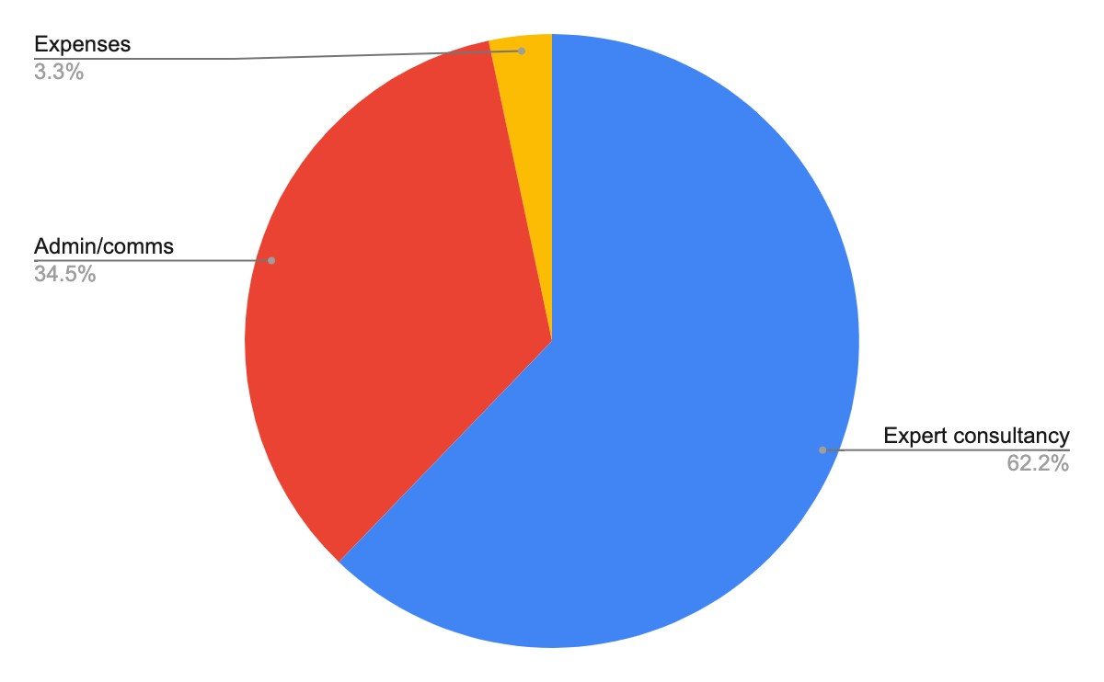

- Our Report - We summarise below our work last year and are happy to attend a Council meeting to elaborate on this report and answer questions.

3.0 Key issues, activities and progress over the last year include:

+ The election of a new Government which has placed a much greater focus on new housing as being a central part of their growth agenda will increase the pressure for delivery of housing alongside the essential infrastructure needed to support new communities.

+ At the turn of the year the S106 agreement between the Developers and EHC was completed so releasing the formal outline planning consents for the Gilston Development.

+ The Developers have committed time and resources to preparing and consulting on the Strategic Landscape Master Plan (SLMP), Village 1 and 7 master plans, hosting community seminars etc. to which we have responded.

+ East Herts Council (EHC) has established Community Forums at which the Developers and EHC Councillors and relevant Officers are in attendance both for formal presentations as well as informal discussions. We have contributed suggestions to optimise the effectiveness of these Forums.

+ Consultation on the long term Stewardship arrangements for Gilston have been initiated.

+ A request for a Judicial Review of EHC’s planning decision has been made, by a resident, the NPG are not a party to the Review.

+ Residents will be well aware that preparatory works for the construction of the enhanced Central Stort Crossing from the Eastwick roundabout into Harlow has commenced with resultant traffic tailbacks and the felling of considerable numbers of trees, etc.

We are grateful to our District Councillor for the time and energy he has put into championing the Community’s views and concerns on a regular basis with Officers.

4 Looking forward

There are many important issues for both parish councils that need review/resolution and making sure the Community's voice is heard as we try to ensure that a high quality of development is achieved and that the construction over a possibly 20/30 years is managed with sensitivity so as to minimise the impacts on existing residents. We also need to ensure that the obligations and commitments made are upheld alongside delivering improvements for residents who will have to put up with decades of building works.

The following key activities/workstreams we anticipate will require our attention and will make an impact on existing residents and our communities:

- The S106 agreement is a complex and long legal agreement between the
Developers and Councils and developed the conditions agreed to by EHC’s Development Management Committee into legal commitments. The NPG was not involved in the preparation of this agreement. Both parish councils have experience of developments being approved subject to such S106 agreements where the commitments are not delivered or delayed. The agreement provides funds for a monitoring Officer at EHC; we will look forward to seeing the summary of the Developers commitments and ensuring that they are delivered/ and undertakings kept.

- Reserved Matter applications are planning applications that develop the principles consented to within the Outline Planning Consent granted by EHC. The first of these should be the SLMP as this is the important document which sets out the principles of how the whole site, rather than the 7 Villages, will be developed. For this reason they have a very direct impact on existing residents. They also identify community facilities which will be delivered which, while supporting the 7 villages, will also support current residents. We are currently reviewing the SLMP documents although have pointed out to EHC that many of the associated and supporting documents required by the outline planning consent have yet to be provided. The process for agreeing these applications appear to be with Officers rather than elected Councillors.

- Stewardship the S106 agreement sets a timetable for agreeing a draft business plan for the Stewardship body. We have not been involved with the work in preparing the business plan and it will cover the long term management of not only the 7 villages but also the spaces between the villages and undeveloped land destined to be passed to the community. The interface between the Parish Councils and the Stewardship body will have a number of sensitivities as will the funding of community assets. The timetable for preparing the Business Plan looks unrealistic.

- Infrastructure works – these are detailed through the consents already granted but the flow of information to residents continues to be something we are encouraging the Developers to working on. Substantial infrastructure needs to be delivered before the housing and other important things delivered by ‘trigger dates’ (like taking through traffic out of Pye Corner).

- Key interfaces – the NPG aims to keep in contact with key influencers and interested parties to ensure that they are aware of the pressures and challenges that might arise from the development. We plan to continue to maintain these contacts.

- Local Developer interfaces – we are delighted that the developers have, after many requests, reinstated periodic meetings to discuss matters of common interest (for example flooding at Hunsdon and in Eastwick and Gilston). We also have championed and continue to champion early works where they might benefit both residents and the Developers.

- Ways of working – we plan to continue our work, as representing both Parish Councils. This has the advantage of pooling expertise and sharing the costs of responding to this development. While one of the Developers initially gave us some funding that has long since been spent. We continue to seek further members of the community to join us to help us with our work.

Anthony Bickmore, Chairman, HEGNPG April 2025

